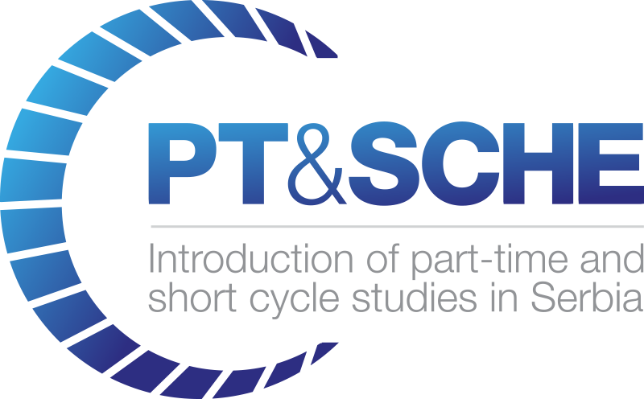

TITLE OF DELIVERABLE: Subtitle

Project Acronym: | PT&SCHE
Project full title: | The Introduction of part‐time and short cycle studies in Serbia
Project No: | 561868-EPP-1-2015-1-EE-EPPKA2-CBHE-SP
Funding Scheme: | ERASMUS+
Coordinator: | Tallinn University, TLU
Project start date: | October 15, 2015
Project duration: | 36 months

Abstract | <a sentence or two describing the objectives and key outcomes of the deliverable>

VERSIONING AND CONTRIBUTION HISTORY

Version | Date | Revision Description | Partner responsible
v.01 | xx/xx/xxxx | First draft version | Org. abbrev. (Name 1; Name 2 etc.)
v.02
v.03
v.04

TABLE OF CONTENT:
1. Heading 1 4
1.1. Heading 2 4
Heading 3 4

Heading 1

Heading 2

Heading 3

