Partners Technical Report

DEVELOPMENT OF CURRICULUM OF SCHE PROGRAM
PROGRAMMING IN JAVA

Project Acronym: | PT&SCHE
Project full title: | Introduction of part-time and short-cycle studies in Serbia
Project No: | 561655-EPP-1-2015-1-EE-EPPKA2-CBHE-SP(2015-3431/001-001)
Funding Scheme: | ERASMUS+
Coordinator: | TLU – Tallinn University
Project start date: | October 15, 2015
Project duration: | 36 months

Abstract | This report provides the information on developed curriculum of the pilot implementation of the online short-cycle in higher education (SCHE) program PROGRAMMING IN JAVA. Its aim is to provide the qualification of a Java Developer after 12 months with 600 online and F2F hours of education and training, It consists of 18 courses (11 core and 7 elective courses) and a Internship lasting two months. The students that successfully submit all assignments and projects for 12 courses and complete it two months internship, is awarded with a Certificate.  As a pilot program, the curriculum and organization of the SCHE program has been developed according to deliverables of  WP2. Development of legal frameworks for implementation for PT&SCHE

DOCUMENT CONTROL SHEET

Title of Document: | D5.1.1 Curriculum development of the short cycle program PROGRAMMING IN JAVA
Work Package: | WP5. Pilot implementation of online PT & SCHE programs
Last version date: | 17/03/2019
Status : | Final
Document Version: | 2.0
File Name | D5.1.1 Development of Online SCHE Programming in Java
Number of Pages | 82
Dissemination Level | Institutional

VERSIONING AND CONTRIBUTION HISTORY

Version | Date | Revision Description | Responsible Partner
0.9 | 1.5.2017 | Concept development | Dragan Domazet, BMU
1.0 | 11.7.2017 | Completed draft version | Dragan Domazet, BMU
1.1 | 16.7.2017 | Modification of curriculum and title of the program. | Dragan Domazet, BMU
1.2 | 20.7.2017 | Modified courses | Dragan Domazet, BMU
2.0 | 17.3.2019 | Updating, adding new stuff and finalization of the document | Dragan Domazet, BMU

TABLE OF CONTENT

1 SPECIFICATION OF THE ICT JOB PROFILE: DEVELOPER 4
1.1 Relevant EU Policy Documents 4
1.1.1 European ICT Professional Profiles 4
1.1.2 The European e-Competence Framework 7
1.2 The role and competences of a Developer 10
1.2.1 The specification of the profile 10
1.2.2 e-competences required 11
1.3 The Body of Knowledge 16
1.3.1 The European Foundational ICT Body of Knowledge 16
1.3.2 The Body of Knowledge for Developer SCHE Programme 26
2 THE SHORT CYCLE PROGRAMME FOR THE PROFILE ICT JAVA DEVELOPER 28
2.1 Organisation structure of a Short Cycle Program 28
2.2 Relationships between e-competences and BMU e-courses 31
2.2.1 Acquiring the e-competence B.1. Design and Development (Level 3) 32
2.2.2 Acquiring the e-competence B.2. System Integration (Level 2) 33
2.2.3 Acquiring the e-competence B.3.Testing (Level 2) 34
2.2.4 Acquiring the e-competence B.5. Documentation Production (Level 3) 34
2.2.5 Acquiring the e-competence C.4. Problem Management (Level 3) 35
2.2.6 The List of BMU e-Courses Related to c-competences Specified for the ICT Profile Developer 36
2.2.7 Mapping of BMU Bachelor Courses into SCHE Programming in Java 37
3 COURSES OF SCHE PROGRAMMING IN JAVA 38
3.1 Sequence of courses of SCHE Programming in Java 38
3.2 Syllabi of Programming Module Courses 38
3.2.1 Course 1: Introduction to IT Systems 39
3.2.2 Course 2: Programming Fundamentals 44
3.2.3 Course 3: JAVA 1: Fundamentals of Programming 46
3.2.4 Course 4: Java 2: Object-oriented programming 52
3.2.5 Course 5: Java 3: GUI Programming 57
3.2.6 Course 6: Java 4: Data Structures and Algorithms – Part A 62
3.2.7 Course 7: Java 5: Data Structures and Algorithms – Part B 66
3.2.8 Course 8: Java 6: Advanced Java Programming 70
3.2.9 Course 9: Java 7: Java Enterprise Edition 73
3.2.10 Course 10: Software Development Process and Methodologies 77
3.2.11 Course 11: Software Construction 82
3.2.12 Course 12: Elective Course 85
4 Pedagogical Approach to SCHE courses 86
5 Plan for implementation of SCHE PROGRAMMING IN JAVA 88

CURRICULUM DEVELOPMENT OF SCHE “PROGRAMMING IN JAVA”

SPECIFICATION OF THE ICT JOB PROFILE: JAVA DEVELOPER

Relevant EU Policy Documents

European ICT Professional Profiles
“European ICT Professional Profiles”, CWA 16458,is the second relevant document that is the CEN Workshop Agreement document (CEN stands for European Committee for Standardization). This Workshop Agreement has been endorsed by the National Members of CEN, but this is not t an official standard developed by CEN and its Members. The following paragraphs are the citations from this document:
“As a response to the huge number of ICT Profile Frameworks and Profile descriptions used today in European ICT Business and Qualification systems, it was decided to create a number of representative ICT Profiles covering, at their level of granularity, the full ICT Business process.
The profiles may be used for reference, or for the basis to develop further profile generations, by European stakeholders. Structured from six main ICT Profile families, these Profiles reflect the top of a European ICT Profiles family tree (Figure 1.1.). The concept devised is broadly analogous to human genetics where the genes of one generation pass down to the next. In the same way it is envisaged that the core components of the 23 Generation 2 Profiles will pass down to profiles constructed to meet specific stakeholder requirements. The 23 Profiles constructed in this CWA combined with e-competences from the e-CF, provide a gene pool for the development of tailored profiles that may be developed by European ICT sector players in specific contexts and with higher levels of granularity.
The 23 multi-stakeholders agreed that ICT Profile descriptions are based on the European e-Competence Framework (e-CF). European ICT Profiles and e-Competence are complementary concepts that can significantly support the development and management of a world class ICT professional community within Europe.
Applied at the same level of granularity as the e-CF, the European ICT Profiles provide generic skeletons of the most representative Profile prototypes currently used in ICT Business structures.”
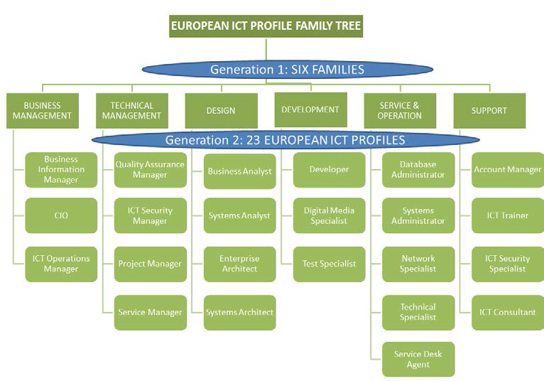

Figure 1.1 European ICT Profile Family Tree – Generation 1 and 2 as a shared European reference
“To add value, the European ICT Profiles must be adaptable to the employment environment. They are not useful if, on the contrary, the employer has to change practices to meet profile descriptions.
The European ICT Profile descriptions are therefore reduced to core components and constructed to clearly differentiate one from each other. Further context-specific elements can be added to the Profiles according to the specific environments in which the Profiles are to be integrated. Clause 4 explains how the European ICT Profiles can be used and adapted by any European stakeholder from a business, qualification or from a research perspective.
The 23 Profiles cover the full ICT Business process; positioning them into the e-CF Dimension 1 demonstrates this. Figure 1.2 below illustrates this together with the ICT Profiles family structure.
The European ICT Profiles build a consistent bridge between existing competence and profile approaches. In some European Countries, job profile creation is deployed as the traditional methodology for identifying and driving both organisational career paths and educational curriculum. Other countries deploy a competence-oriented approach, appreciating that the competence approach provides more flexibility.
In the European ICT Profiles development, the advantages of both approaches have been combined. The European ICT Profiles present e-Competences in an operational context. e-Competences provide the European ICT Profiles with core content in terms of capabilities needed to successfully perform a role. This provides the flexibility to make Profiles applicable EU-wide yet usable in a workplace environment.

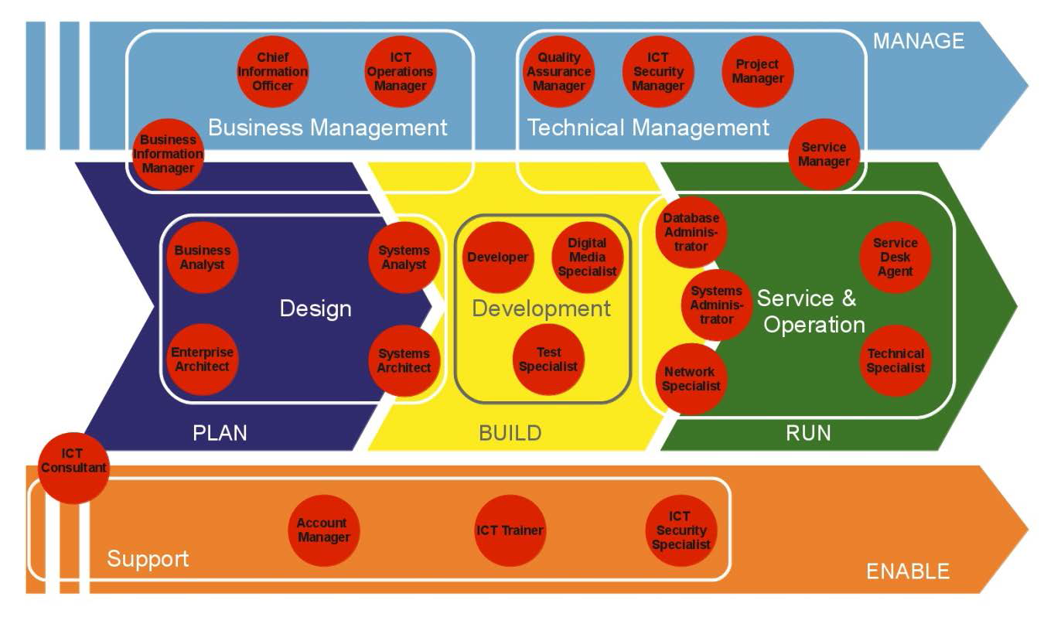
Figure 1.2 European ICT Professional Profiles structured by six families and positioned within the ICT Business Process (e-CF Dimension 1)
By embedding e-Competence within ICT Profiles, which can be readily understood by experts or laymen, the European ICT Profile Family provides a universally applicable solution for communication between stakeholders with interests in ICT skills, knowledge and attitude development.”
ICT Profiles are not totally isolated from each other. Those that interact with each other more closely, create a Profile Cluster. Figure 1.3 shows some of Profiles Clusters from the Design and Development Profile families.
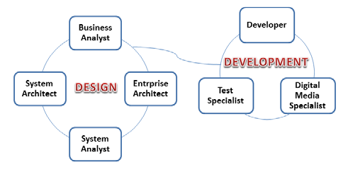
Figure 1.3 ICT Profile Clusters related to Design and Developmenti Profile families.

The European e-Competence Framework
The CWA (CEN Workshop Agreement) document: “The European e-Competence Framework (e-CF) version 3.0” is the result of 8 years continuing effort and commitment by multi-stakeholders from the European ICT sector.
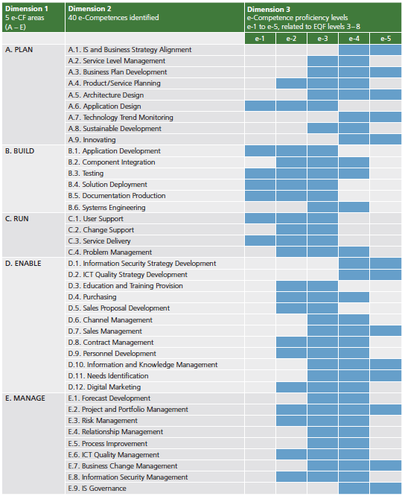
Figure 1.4: 40 e-Competences defined by the European e-Competence Framework

The European e-Competence Framework (e-CF) version 3.0 provides a reference of 40 competences as required and applied at the Information and Communication Technology (ICT) workplace, using a common language for competences, skills and capability levels that can be understood across Europe. As the first sector-specific implementation of the European Qualifications Framework (EQF), the e-CF was created for application by ICT service, user and supply companies, for managers and human resource (HR) departments, for education institutions and training bodies including higher education, for market watchers and policy makers, and other organisations in public and private sectors.
“The e-CF supports the definition of jobs, training courses, qualifications, career paths, formal and non-formal learning paths, certifications etc. in the ICT sector. In this way, local, national, European and global ICT vendor and user companies as well as qualification and certification providers have access to a shared reference.”
The European e-Competence Framework is structured from four dimensions (Figure 1.4). These dimensions reflect different levels of business and human resource planning requirements in addition to job / work proficiency guidelines and are
specified as follows:
Dimension 1: 5 e-Competence areas, derived from the ICT business processes PLAN – BUILD – RUN – ENABLE – MANAGE (see Figure 1.2)
Dimension 2: A set of reference e-Competences for each area, with a generic description for each competence. 40 competences identified in total provide the European generic reference definitions of the e-CF 3.0.
Dimension 3: Proficiency levels of each e-Competence provide European reference level specifications on e-Competence levels e-1 to e-5, which are related to the EQF levels 3 to 8. (Table 1.1)
Dimension 4: Samples of knowledge and skills relate to e-Competences in dimension 2. They are provided to add value and context and are not intended to be exhaustive.
Whilst competence definitions are explicitly assigned to dimension 2 and 3 and knowledge and skills samples appear in dimension 4 of the framework, attitude is embedded in all three dimensions.
Table 1.1.
EQF Levels | EQF | e-CF Levels | e-CF Levels descriptions | Typical Tasks
8 | Knowledge at the most advanced frontier, the most advanced and specialised skills and techniques tosolve critical problems in research and/or innovation, demonstrating substantial authority, innovation, autonomy, scholarly or professional integrity. | e-5 | Principal  Overall accountability and responsibility; recognised inside and outside the organisation for innovative solutions and for shaping the future using outstanding leading edge thinking and knowledge. | IS strategy or programme management
7 | Highly specialised knowledge, some of which is at the forefront of knowledge in a field of work or study, as the basis for original thinking, critical awareness of knowledge issues in a field and at the interface between different fields, specialised problem-solving skills in research and/or innovation to develop new knowledge and procedures and to integrate knowledge from different fields, managing and transforming work or study contexts that are complex, unpredictable and require new strategic approaches, taking responsibility for contributing to professional knowledge and practice and/or for reviewing the strategic performance of teams | e-4 | Lead Professional / Senior Manager  Extensive scope of responsibilities deploying specialised integration capability in complex environments; full  responsibility for strategic development of staff working in unfamiliar and unpredictable situations | IS strategy/ holistic solutions
6 | Advanced knowledge of a field of work or study, involving a critical understanding of theories and principles, advanced skills, demonstrating mastery and innovation in solving complex and unpredictable problems in a specialised field of work or study, management of complex technical or professional activities or projects, taking responsibility for decision-making in unpredictable work or study contexts, for continuing personal and group professional development. | e-3 | Senior Professional / Manager  Respected for innovative methods and use of initiative in specific technical or business areas; providing leadership and taking responsibility for team performances and development in unpredictabl environments. | Consulting
5 | Comprehensive, specialised, factual and theoretical knowledge within a field of work or study and an awareness of the boundaries of that knowledge, expertise in a comprehensive range of cognitive and practical skills in developing creative solutions to abstract problems, management and supervision in contexts where there is unpredictable change, reviewing and developing performance of self and others. | e-2 | Professional  Operates with capability and ndependence in specified boundaries and may supervise others in this environment; conceptual and abstract model building using creative thinking; uses theoretical knowledge and practical skills to solve complex problems within a predictable and sometimes unpredictable context. | Concepts / Basic principles
4 | Factual and theoretical knowledge in broad contexts within a field of work or study, expertise in a range of cognitive and practical skills in generating solutions to specific problems in a field of work or study, self-manageme nt within the guidelines of work or study contexts that are usually predictable, but are subject to change, supervising the routine work of others, taking some responsibility for the evaluation and improvement of work or study activities.
3 | Knowledge of facts, principles, processes and general concepts, in a field of work or study, a range of cognitive and practical skills in accomplishing tasks. Problem solving with basic methods, tools, materials and information, responsibility for completion of tasks in work or study, adapting own behaviour to circumstances in solving problems. | e-1 | Associate  Able to apply knowledge and skills to solve straight forward problems; responsible for own actions; operating in a stable environment. | Support / Service

The role and competences of a Developer

The specification of the profile
ICT Profile Summary statement:
Builds/codes ICT solutions and specifis ICT products according to the customer needs.
Alternative titles:
- Component Developer
- Application Developer
- Programmer
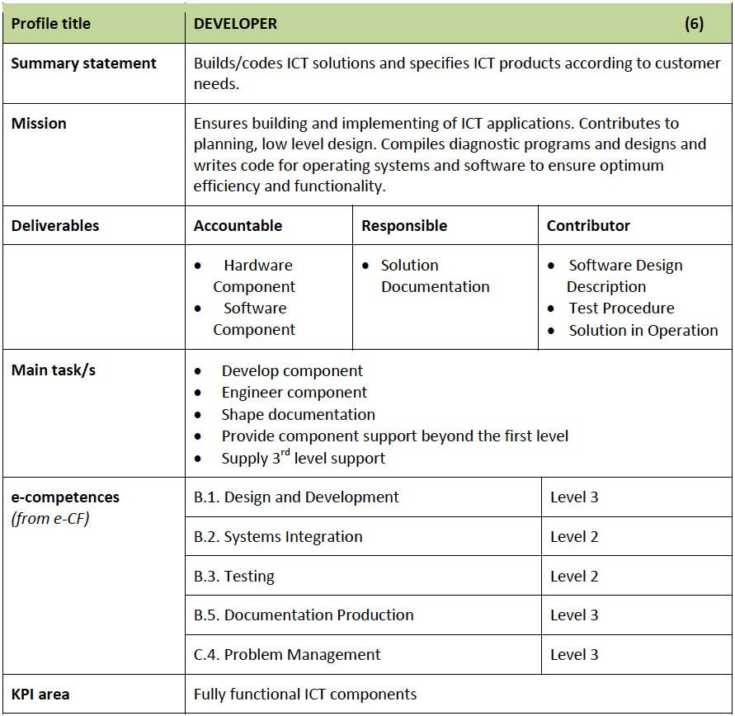
Figure 1.5: Job profile specification of a Developer

e-competences required
A Developer must have the following e-competence specified jn the European e-Competence Framework 3.0:
B.1. Design and Development (Level 3)
B.2. System Integration (Level 2)
B.3.Testing (Level 2)
B.5. Documentation Production (Level 3)
C.4. Problem Management (Level 3)
For each of these e-competences we cite its specification from the document European e-Competence Framework 3.0.
B.1. Design and Development (Level 3)
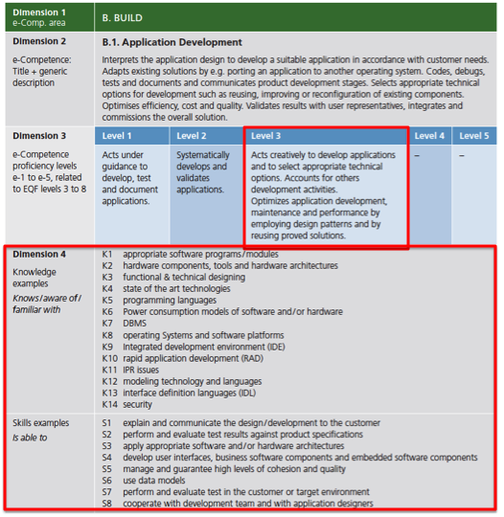
Figure 1.6: Knowledge and skills needed for e-competence B.1. Application Development
B.2. System Integration (Level 2):
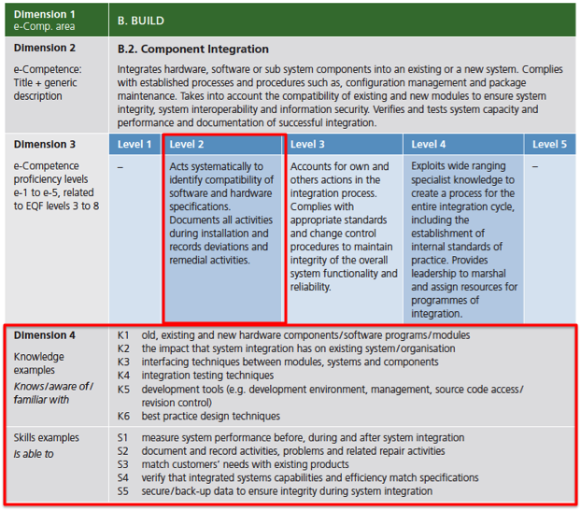
Figure 1.7: Knowledge and skills needed for e-competence B.2. Component Integration

B.3.Testing (Level 2):
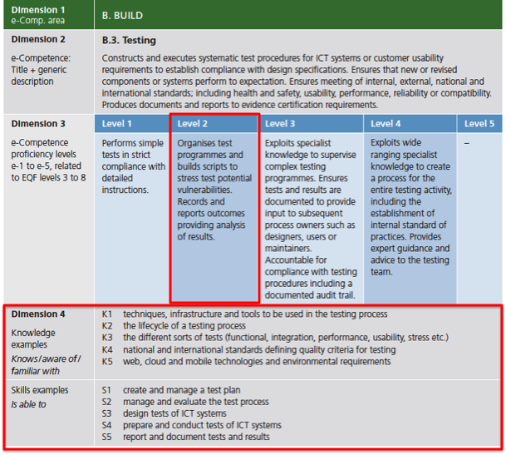
Figure 1.8: Knowledge and skills needed for e-competence B.3. Testing

B.5. Documentation Production (Level 3):
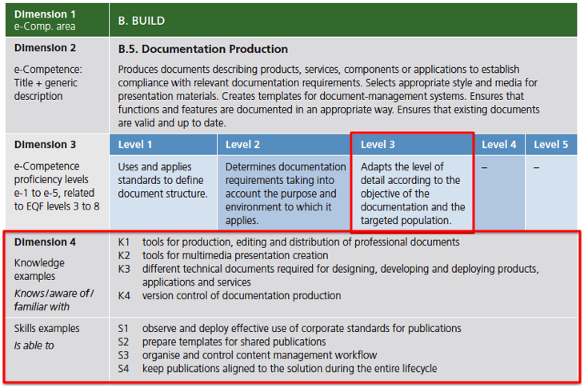
Figure 1.9: Knowledge and skills needed for e-competence B.5. Document Production

C.4. Problem Management (Level 3):
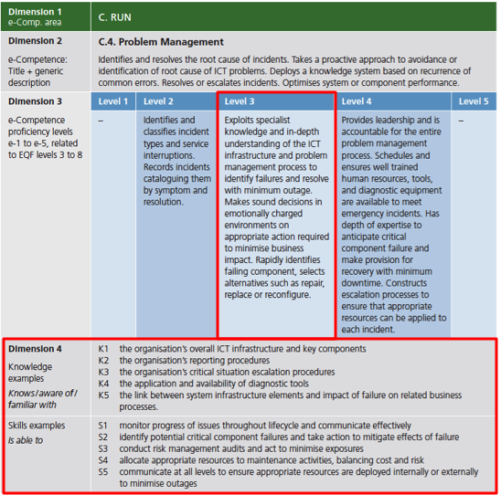
Figure 1.10: Knowledge and skills needed for e-competence B.5. Problem Management

The Body of Knowledge
Specification of knowledge units and skills provided for each e-competence in the previous section is not enough to specify the curriculum for a short cycle program for a profile. The specifies required knowledge and skills are of very high level and need to be specified at lower levels. This is the mission of a Body of Knowledge of a study program. In our case we can use:
- The Foundation ICT Body of Knowledge, Version 1, 22 February 2015, a report prepared for the European Commission, DG Internal Market, Industry, Entrepreneurship and SMEs by the Service Contract: e-Skills: Promotion of ICT Professionalism in Europe | No 290/PP/ENT/CIP/13/C/N01C011 prepared by Capgemini Consulting and Ernst & Young.
- The Software Engineering Body of Knowledge – SWEBOK 3.0, specified by the IEEE Computer Society - see P. Bourque and R.E. Fairley, eds., Guide to the Software Engineering Body of Knowledge, Version 3.0, IEEE Computer Society, 2014; www.swebok.org.

The European Foundational ICT Body of Knowledge
The European Foundational ICT Body of Knowledge is the base-level knowledge required to enter the ICT profession and acts as the first point of reference for anyone interested in working in ICT’.
The ultimate objective is to create a recognised and supported Foundational ICT Body of Knowledge that:
- Serves as an entry point to get into ICT for anyone contemplating a career in ICT and entering from other professions or wanting to digitise their current job;
- Facilitates communication between and understanding of ICT professionals in Europe in whatever sector they are active, thereby reducing risks and strengthening ICT professionalism;
- Increases the supply and pool of ICT professionals and enhances the image of ICT.
The definition of an ICT Professional is defined, as someone who should:
- Possess a comprehensive and up-to-date understanding of a relevant body of knowledge;
- Demonstrate on-going commitment to professional development via an appropriate combination of qualifications, certifications, work experience, non-formal and / or informal education;
- Adhere to an agreed code of ethics / conduct and / or applicable regulatory practices; and
- Through competent practice deliver value for stakeholders.
Some of the key challenges for the near future are to:
- Ensure that as many ICT professionals as possible have the necessary relevant knowledge, skills and competence to deliver professional products and service in today’s digital economy;
- Improve the quality of the ICT profession;
- Close the ICT resource and skills gap;
- Enhance growth in digital jobs in Europe;
- Improve general ICT knowledge among professionals in other fields of expertise.
The nature of ICT jobs is also changing. It is no longer enough to merely be a technical expert. The industry needs professionals with a diversity of ICT knowledge and skillsx. ICT professionals are also required to understand the business, operational and HR management aspects. Industry is looking for multidisciplinary ICT professionals, dual thinkers (i.e. people who have a good understanding of both business and Technology) or T-shaped persons (see below). ICT is no longer a back office support tool or one department within a company but permeates all the layers and units of a company. ICT has moved itself to the forefront and become a key strategic asset in everyday (professional) life. Therefore, it is no longer sufficient only to have knowledge of one specific ICT domain.
The need for a broad IT systems viewpoint is essential, with the ability to understand the possibilities and constraints of the various technologies and to talk a common language with the diversity of people involved. This was expressed as a concept for the first time by David Guest in 1991xi through the use of the T-shape metaphor, which has been widely adopted since (Figure 1.11).
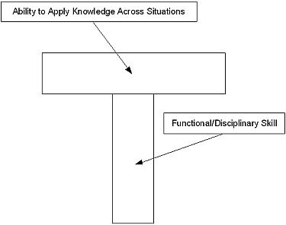
Figure 1.11 Shaped Skills Model

The vertical line of the T represents the depth of related skills and expertise in a single field, whereas the horizontal bar is the ability to collaborate across disciplines with experts in other areas and to apply knowledge in areas of expertise other than one’s own. This model thus differs from another classic type: “I-shaped” – with a deep understanding of one specific discipline, but not necessarily of any other. In the current ICT environment, employers find themselves trying to do a “T” job with “I” people.
However, a professional who combines specialisation in a specific ICT domain with relevant breadth of ICT knowledge is more easily employable and has a competitive position on the market. Given that there has in the past been a particular focus on depth, it is necessary to look more closely at the issue of breadth of knowledge. It is all a matter of creating the right balance between the two.
The objective is to create T-shaped persons with as much as possible the same elements in the horizontal bar. All ICT professionals should have the same DNA. It is however often the case that ICT professionals have much in common, but have different (job) profiles. The objective of a Body of Knowledge (BOK) is to define the ‘chromosomes’, or building blocks of the horizontal bar, in the ICT field and act as a guide to the breadth of ICT knowledge required.
The EU Foundational ICT Body of Knowledge thus aims to provide guidance for individuals, academia and industry, and hence contribute to developing tomorrow’s multidisciplinary ICT professionals.
The structure of the Foundational ICT Body of Knowledge could be described as an ‘inverted T-model’, in which the horizontal axis shows the knowledge areas of the ICT domain running from a predominantly strategic to a predominantly technological perspective. The vertical axis corresponds to specific knowledge and skills an individual should develop to specialise in one domain. We can assume that any ICT professional wanting to go into a field different from that of their existing specialisation should come down to the horizontal bar (the base-level) and find a connection to other knowledge areas in order to expand their breadth of knowledge.
The Foundational ICT Body of Knowledge provides the base-level knowledge that ICT professionals require. However, considering the wide range of knowledge in the ICT field, it has to be intended as a “permissive model” where every ICT professional will acquire as much breadth as possible in terms of knowledge
In addition to the dimension of ICT core knowledge defined above, the European Foundational ICT Body of Knowledge consists of a second dimension of complementary base-level knowledge required to enter the ICT profession. This dimension includes cross-cutting knowledge that cannot be considered purely in relation to one ICT knowledge area but can be referred to, at different levels, in relation to all core knowledge areas, i.e.:
- Legal, ethical, social and professional practices: including this knowledge in the Foundational ICT Body of Knowledge serves to provide key reference points for everyone interested in the ICT profession, as they are strongly linked to the definition of the ICT profession itself. Legal, ethical, social and professional practices need to be addressed at different levels at different stages of professional development. Thevery nature of professional work means that some knowledge and skills are best developed through experience and that an understanding of complex issues, such as ethics, grows with maturity. Further development will be provided at a full professional level through participation in certification programmes.
- Soft skills: including soft skills in the Foundational ICT Body of Knowledge provides a concrete contribution to the evolution of the ICT profession. Soft skills integrate the technical skills, providing a sound basis for developing “dual thinker” profiles, which are oriented towards team building, collaboration, negotiation, e-leadership, etc.
- Emerging / disruptive technologies: given the fast growth in the disruptive technologies of cloud, mobile, social and big data, which are predicted to constitute 40% of the global market and 98% of growth by 2020, and the expected creation of 4.4 million IT jobs globally to support big data – base- level knowledge should be provided to improve an understanding of these technologies and their impacts on business and society.
The BOK illustrated below (Figure 1.12) and expanded on in the following sections presents the taxonomy of the high-level areas of knowledge that represent the base level that starting ICT professionals should understand. These knowledge areas are then broken down and described in further detail, including with a general definition of the knowledge area, a detailed list foundational knowledge, reference to the e-CF, potential job profiles and examples of specific Bodies of Knowledge, certification and training opportunities.
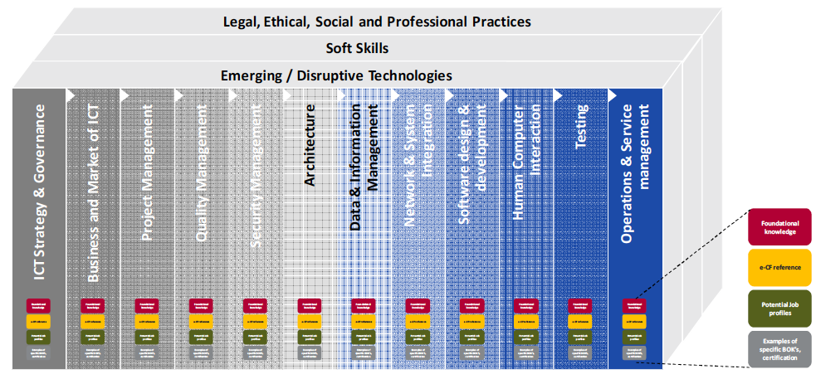
Figure 1.12: Taxonomy of Foundational ICT Body of Knowledge
This Body of Knowledge aims to develop the next generation of ICT professionals, e.g. young, rounded ICT professionals with a significant breadth of base-level knowledge of ICT that allows them to further specialize within a particular discipline.
This Version 1.0 of the European Foundational ICT Body of Knowledge presents the taxonomy of high-level areas of knowledge that represent the base level starting ICT professionals should understand.
The following section presents 12 Knowledge Areas:
- ICT Strategy & Governance
- Business and Market of ICT
- Project Management
- Security Management
- Quality Management
- Architecture
- Data and Information Management
- Network and Systems Integration
- Software Design and Development
- Human Computer Interaction
- Testing
- Operations and Service Management.
Each Knowledge Area is further detailed, including a:
- Definition of the Knowledge Area;
- List of items required as foundational knowledge necessary under this Knowledge Area;
- List of references to the e-Competence Framework (dimension 4: knowledge);
- List of possible job profiles that require having an understanding of the Knowledge Area;
- List of examples of specific Bodies of Knowledge, certification and training possibilities.

Figures 1.13-1.116 summarize the content of few Knowledge Areas, the most relevant for the profile Developer:

- Software Design and Development
- Human Computer Interaction
- Data and Information Management
- Testing

These Knowledge Areas provide broader knowledge then needed for the Developer profile, as it is related only to a part of one of five (Build) phases of the ICT Business Process, as shown in Figure 1.2 earlier.

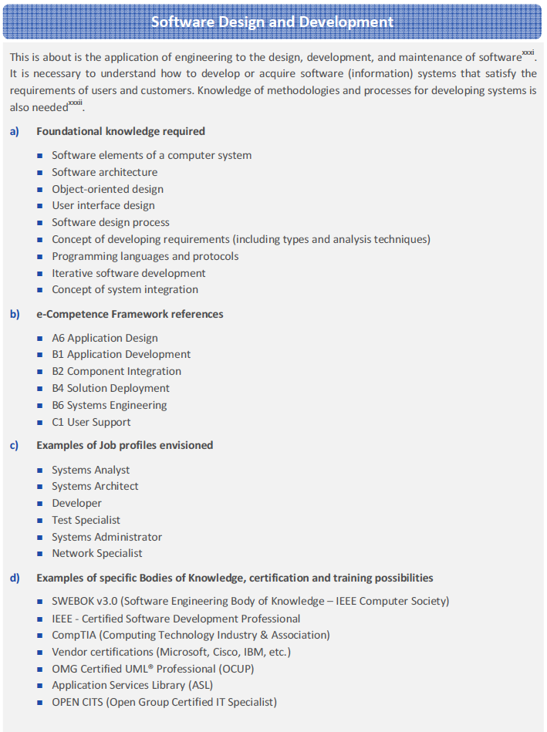
Figure 1.13: Software Design and Development Knowledge Area

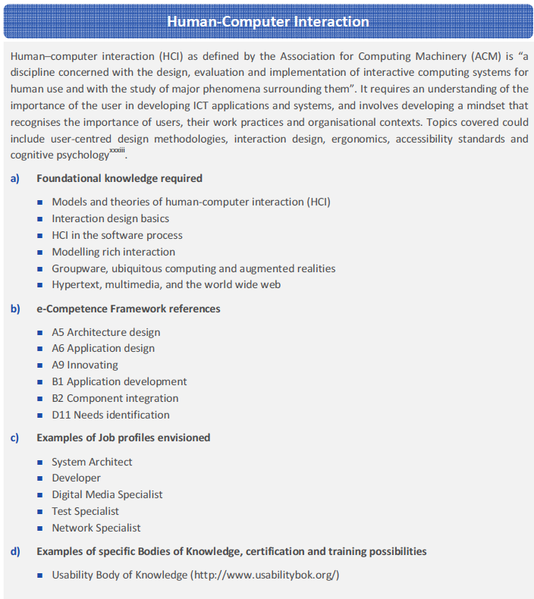
Figure 1.14: Human-Computer Interaction Knowledge Area

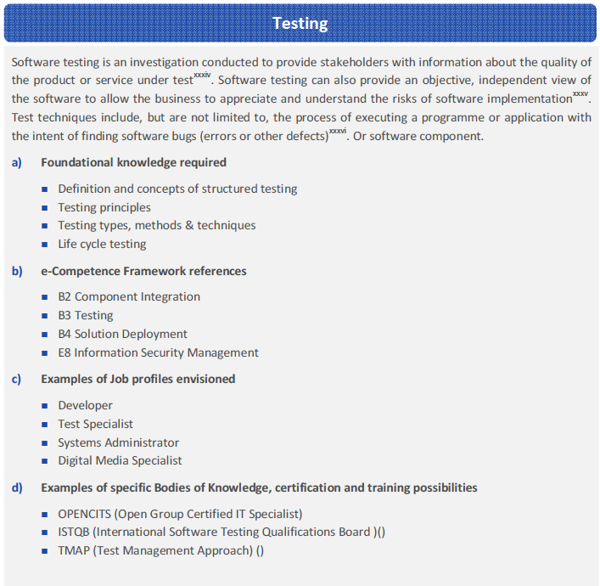
Figure 1.15: Testing Knowledge Area

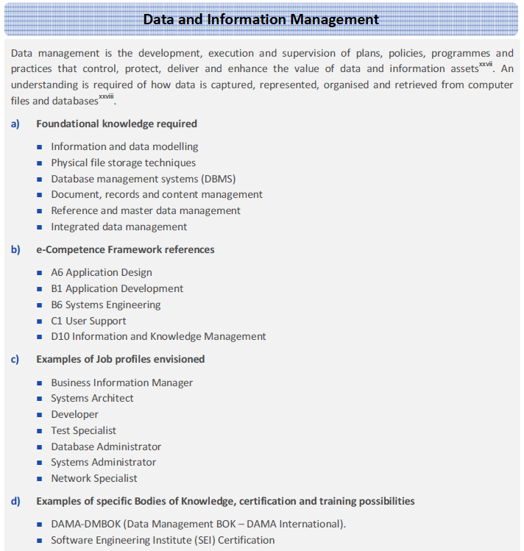
Figure 1.16: Data and Information Management Knowledge Area

As specified earlier, five ICT e-competences are required for the profile Developer:

B.1. Design and Development (Level 3)
B.2. System Integration (Level 2)
B.3.Testing (Level 2)
B.5. Documentation Production (Level 3)
C.4. Problem Management (Level 3)

Figure 1.17 shows relationships of these five e-competences and 10 Knowledge Areas of the ICT Foundation Body of Knowledge. It does nit mean the profile Developer must know everything specified in these 10 Knowledge Areas. In so
me of them it is almost true, but in most of other Knowledge Areas is not the case, as only a small portion of the Knowledge Area is needed. It will be the task of curriculum development to be more specific and specify lower level knowledge units and skills.

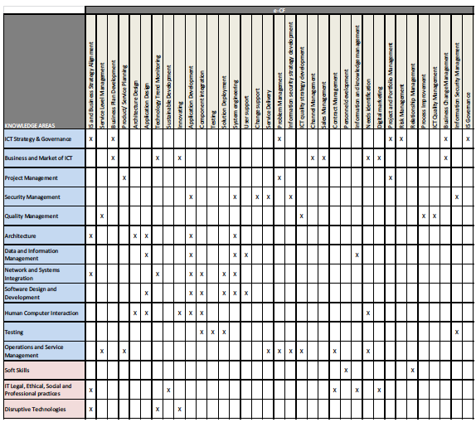

Figure 1.17: Relationships between Developer’s e-competences and Knowledge Areas of the ICT Foundation Body of Knowledge

More specific, four Knowledge Areas of the profile Developer are shown in Figure 1.18 that shows relationships of the European ICT Professional Profiles and Knowledge Areas of the ICT Foundation Body of Knowledge.

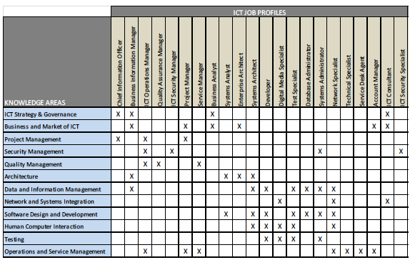

Figure 1.19: Relationships between ICT Job Profiles and Knowledge Areas of the ICT Foundation Body of Knowledge

Unfortunately, the ICT Foundation Body of Knowledge does not provide yet lower levels of knowledge and it is not sufficient for a curriculum development. Therefore, additional extensions (sub-topics) of the Bodies of Knowledge are needed.

The Body of Knowledge for Developer SCHE Programme

IEEE Computer Society specified two Bodies of Knowledge (BOK) that are relevant for ICT Profile Developer:
- Computer Science Curricula 2013 - Curriculum Guidelines for Undergraduate Degree Programs in Computer Science, December 20, 2013, The Joint Task Force on Computing Curricula of Association for Computing Machinery (ACM) and IEEE Computer Society
- SWEBOK 3.0 – Guide to the Software Engineering Body of Knowledge, Editors Pierre Bourque, École de technologie supérieure (ÉTS) and Richard E. (Dick) Fairley, Software and Systems Engineering Associates (S2EA), IEEE Computer Society
Knowledge areas and topics from these two Bodies of Knowledge are to be selected according to specified of Knowledge Areas and e-competences required for ICT Profile Developer specified in previous sections.
Figure 1.1 showed European ICT Profile Family Tree with Generation 1 and 2 of ICT Profiles. 23 in total). As this SCHE Programme aims to educate and train Java developers, i.e. developers of applications written in Java, we will create a Generation 3 ICT Profile – Junior Java Developer and Java Developer. We have to provide all competences specified for ICT Profile Developer specified in previous sections, but extended with specific competences of Java Developers.
Based of above specifications, we summarize in Table 1.1 job descriptions for Junior Java Developer and Java Developer, levels of their e-competences in Table 1.2, knowledge areas required (in Table 1.33) and skills (in Table 1.44) in relation to their five e-competences.
Table 1.1: Job description related to different e-competences
 | JUNIOR JAVA DEVELOPER & JAVA DEVELOPER
e-competences | Job Description with
B.1. Application Development | Interprets the application design to develop a suitable application in accordance with customer needs. Adapts existing solutions by e.g. porting an application to another operating system. Codes, debugs, tests and documents and communicates product development stages. Selects appropriate technical options for development such as reusing, improving or reconfiguration of existing components. Optimises efficiency, cost and quality. Validates results with user representatives, integrates and commissions the overall solution.
B.2. Component Integration | Integrates hardware, software or sub system components into an existing or a new system. Complies with established processes and procedures such as, configuration management and package maintenance. Takes into account the compatibility of existing and new modules to ensure system integrity, system interoperability and information security. Verifies and tests system capacity and performance and documentation of successful integration.
B.3.Testing | Constructs and executes systematic test procedures for ICT systems or customer usability requirements to establish compliance with design specifications. Ensures that new or revised components or systems perform to expectation. Ensures meeting of internal, external, national and international standards; including health and safety, usability, performance, reliability or compatibility. Produces documents and reports to evidence certification requirements.
B.5. Documentation Production | Produces documents describing products, services, components or applications to establish compliance with relevant documentation requirements. Selects appropriate style and media for presentation materials. Creates templates for document-management systems. Ensures that functions and features are documented in an appropriate way. Ensures that existing documents are valid and up to date.
C.4. Problem Management | Identifies and resolves the root cause of incidents. Takes a proactive approach to avoidance or identification of root cause of ICT problems. Deploys a knowledge system based on recurrence of common errors. Resolves or escalates incidents. Optimises system or component performance.

Table 1.2: e -Competence levels
 | JUNIOR JAVA DEVELOPER | JAVA DEVELOPER
e-competences | Level e-2 | Level e-3
B.1. Application Development | Systematically develops and validates applications. | Acts creatively to develop applications and to select appropriate technical options. Accounts for others development activities.  Optimizes application development, maintenance and performance by employing design patterns and by reusing proved solutions.
B.2. Component Integration | Acts systematically to identify compatibility of software and hardware specifications. Documents all activities during installation and records deviations and remedial activities. | As for Level e-2
B.3.Testing | Organises test programmes and builds scripts to stress test potential vulnerabilities. Records and reports outcomes providing analysis of results. | As for Level e-2
B.5. Documentation Production | Determines documentation requirements taking into account the purpose and environment to which it applies. | Adapts the level of detail according to the objective of the documentation and the targeted population.
C.4. Problem Management | Identifies and classifies incident types and service interruptions. Records incidents cataloguing them by symptom and resolution. | Exploits specialist knowledge and in-depth understanding of the ICT infrastructure and problem management process to identify failures and resolve with minimum outage. Makes sound decisions in emotionally charged environments on appropriate action required to minimise business impact. Rapidly identifies failing component, selects alternatives such as repair, replace or reconfigure.

Table 1.3: Knowledge needed related to different e-competences
 | JUNIOR JAVA DEVELOPER & JAVA DEVELOPER
e-competences | KNOWLEDGE: Knows/aware of/ familiar with / familiar with
B.1. Application Development | K1 appropriate software programs/modules  K2 hardware components, tools and hardware architectures  K3 functional & technical designing  K4 state of the art technologies  K5 programming languages  K6 Power consumption models of software and/or hardware  K7 DBMS  K8 operating Systems and software platforms  K9 Integrated development environment (IDE)  K10 rapid application development (RAD)  K11 IPR issues  K12 modeling technology and languages  K13 interface definition languages (IDL)  K14 security
B.2. Component Integration | K1 old, existing and new hardware components/software programs/modules  K2 the impact that system integration has on existing system/organisation  K3 interfacing techniques between modules, systems and components  K4 integration testing techniques  K5 development tools (e.g. development environment, management, source code access / revision control)  K6 best practice design techniques
B.3.Testing | K1 techniques, infrastructure and tools to be used in the testing process  K2 the lifecycle of a testing process  K3 the different sorts of tests (functional, integration, performance, usability, stress etc.)  K4 national and international standards defining quality criteria for testing  K5 web, cloud and mobile technologies and environmental requirements
B.5. Documentation Production | K1 tools for production, editing and distribution of professional documents  K2 tools for multimedia presentation creation  K3 different technical documents required for designing, developing and deploying products, applications and services  K4 version control of documentation production
C.4. Problem Management | K1 the organisation’s overall ICT infrastructure and key components  K2 the organisation’s reporting procedures  K3 the organisation’s critical situation escalation procedures  K4 the application and availability of diagnostic tools  K5 the link between system infrastructure elements and impact of failure on related business processes.

Table 1.4: Skills needed related to different e-competences
 | JUNIOR JAVA DEVELOPER & JAVA DEVELOPER
e-competences | SKILLS: is able to
B.1. Application Development | S1 explain and communicate the design/development to the customer  S2 perform and evaluate test results against product specifications  S3 apply appropriate software and/or hardware architectures  S4 develop user interfaces, business software components and embedded software components  S5 manage and guarantee high levels of cohesion and quality  S6 use data models  S7 perform and evaluate test in the customer or target environment  S8 cooperate with development team and with application designers
B.2. Component Integration | S1 measure system performance before, during and after system integration  S2 document and record activities, problems and related repair activities  S3 match customers’ needs with existing products  S4 verify that integrated systems capabilities and efficiency match specifications  S5 secure/back-up data to ensure integrity during system integration
B.3.Testing | S1 create and manage a test plan  S2 manage and evaluate the test process  S3 design tests of ICT systems  S4 prepare and conduct tests of ICT systems  S5 report and document tests and results
B.5. Documentation Production | S1 observe and deploy effective use of corporate standards for publications  S2 prepare templates for shared publications  S3 organise and control content management workflow  S4 keep publications aligned to the solution during the entire lifecycle
C.4. Problem Management | S1 monitor progress of issues throughout lifecycle and communicate effectively  S2 identify potential critical component failures and take action to mitigate effects of failure  S3 conduct risk management audits and act to minimise exposures  S4 allocate appropriate resources to maintenance activities, balancing cost and risk  S5 communicate at all levels to ensure appropriate resources are deployed internally or externally to minimise outages

All specified competences, related to job description, levels of e-competences, knowledge needs and skills needs are implemented in Java. Due to time limitation specified by Higher Education Low (2017) of only 12 months, and having in mind of the complexity of Java technology and its implementation, BMU decided to develop its fits SCHE program with the aim to train future Junior Java Developer. After appropriate experience, they can enroll to another SCHE program aiming to train future Java Developers.
Based on above, we specified Generation 3 of the ICT Profile Family, as shown in Figure 1.20. It describe two job profiles Junior Java Developer (e-2, EQF Level 5) and Java Developer (e-3, EQF Level 6). Specifications for these Generation 3 job profiles are given in Tables 1-4. The major difference between Generation 2 Developer and Generation 3 Java developer profiles is in area of development. Java Developer uses Java technology to develop an application. The pilot implementation our short (SCHE) program was developed and implemented for the job profile Junior Java Developer.

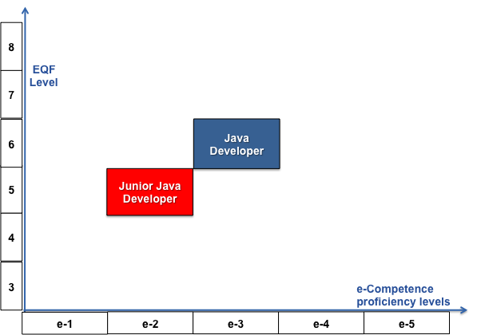
Figure 1.20 : Positioning of Java Junior Developer and Java Developer SCHE programs in relation to EQF levels and e-Competence proficiency levels

In order to distinguish these two Generation 3 job profiles, we cite description elements of EQF Levels and e-CF Levels in Table 5 using the relevant part of the table given in e-CF(2014).

Unfortunately, the ICT Foundation Body of Knowledge does not provide yet lower levels of knowledge and it is not sufficient for a curriculum development. Therefore, additional extensions (sub-topics) of the Bodies of Knowledge are needed. We used two BOKs: SWEBoK 3.0 (2014) and Computer Science BOK (2013), shown in Figure 1.21. BMU is using these two BOKs for its BSc programs: Software Engineering and Information Technology. These BOKs specify required knowledge not only at levels of knowledge areas, but also at lower levels: knowledge units and topics.
Table 5: European e-CF and EQF level table
EQF Level | EQF Levels descriptions | e-CF Levels | e-CF Levels descriptions | Typical Tasks | Complexity | Autonomy | Behaviour
6 | Advanced knowledge of a field of work or study, involving a critical understanding of theories and principles, advanced skills, demonstrating mastery and innovation in solving complex and unpredictable problems in a specialised field of work or study, management of complex technical or professional activities or projects, taking responsibility for decision-making in unpredictable work or study contexts, for continuing personal and group professional development. | e-3 | Senior Professional/Manager  Respected for innovative methods and use of initiative in specific technical or business areas; providing leadership and taking responsibility for team performances and development in unpredictable environments. | Consulting | Structured – unpredictable | Works independently to resolve interactive problems and addresses complex issues. Has a positive effect on team performance. | Planning, making decisions, supervising, building teams, forming people, reviewing performances, finding creative solutions by application of specific technical or business knowledge / skills.
5 | Comprehensive, specialised, factual and theoretical knowledge within a field of work or study and an awareness of the boundaries of that knowledge, expertise in a comprehensive range of cognitive and practical skills in developing creative solutions to abstract problems, management and supervision in contexts where there is unpredictable change, reviewing and developing performance of self and others. | e-2 | Professional  Operates with capability and independence in specified boundaries and may supervise others in this environment; conceptual and abstract model building using creative thinking; uses theoretical knowledge and practical skills to solve complex problems within a predictable and sometimes unpredictable context. | Concepts / Basic principles | Structured – unpredictable | Works under general guidance in an environment where unpredictable change occurs. Independently resolves interactive issues which arise from project activities. | Designing, managing, surveying, monitoring, evaluating, improving, finding non standard solutions.

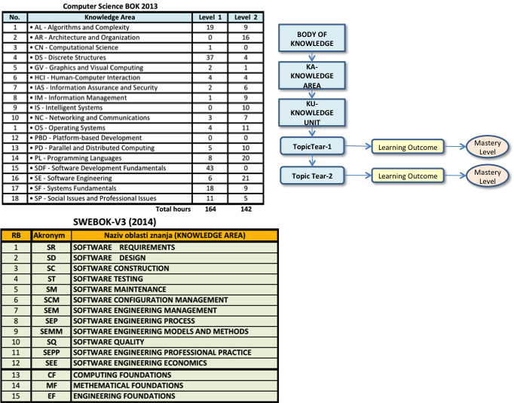

Figure 1.21 Knowledge areas of SWEBOK 3.0 and Computer Science BOK 2013

THE SHORT CYCLE PROGRAMME FOR THE PROFILE ICT JUNIOR JAVA DEVELOPER

Organisation structure of a Short Cycle Program
In order to develop the required competences of a ICT Profile, such as Developer, a learner must learn all knowledge units (such as topics and sub-topics of a Knowledge Area) specified for the Profile and develop necessary skills. A course is the basic set of knowledge and skills that a student must verify that he or she acquired the specified knowledge and skills by passing an exam. To acquire all competences required, a student must complete a number of courses by passing their exams. The granularity of courses my be different and smaller courses are usually preferable, as student can easier complete their assignment specified by their syllabi and pass their exams.
In some cases courses are inter-related and can be grouped in modules. A short cycle program may have any number of courses and modules. Figure 2.1 shows the general structure of a short cycle program.
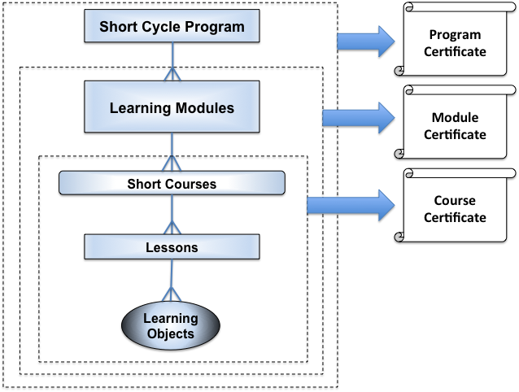
Figure 2.1: A typical organization structure of a Short Cycle Program
A Short Cycle Program must provide students with the required competences and must qualify them for the specified job. In our case here, the job is the job of a Junior Java Developer, specified in the previous chapter. The Short Cycle Courses will be defined in groups (Modules) related to the specific e-competences listed for the ICT Profile Developer. Each Short Course contains a number of Lessons created by Learning Objects (LO). BMU is using LO of fine granularity needed for personalized e-learning (BMU is strategically oriented to develop and implement personalized e-learning). Small size LOs support LO reusability among different courses.
As shown in Figure 2.1, BMU offers three levels of Certificates:
- Course Certificate - for all students that pass the final exams of a course.
- Module Certificate - for all students that pass the final exams of a all course of a Module planned for a SC Program.
- Programme Certificate - for all students that pass the final exams of all modules of a SC course.
If a Short Cycle Programme does no contain modules, it provides only two certificates: Course Certificate and Programme Certificate (Figure 2.2)
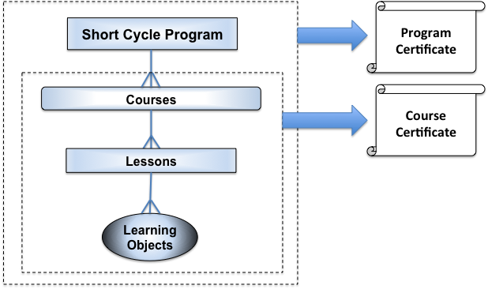
Figure 2.2: A Short-Cycle Programme without modules

Relationships between e-competences and BMU e-courses
At this stage we need to identify the existing BMU e-courses that can be used in Short Cycle HE Program JUNIOR JAVA DEVELOPER (or shorter, SCHE JUNIOR JAVA DEVELOPER) for development of its Courses. It can significantly reduce the effort of developing SCHE Program JUNIOR JAVA DEVELOPER and its courses (Figure 2.3). As BMU bachelor courses are based on SWEBOK, their parts of the Body of Knowledge are to be mapped into BMU SCHE courses
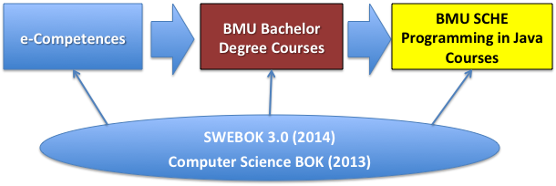
Figure 2.3: Mapping of required e-competences into BMU bachelor courses and courses of the BMU SCHE Java Developer

Acquiring the e-competence B.1. Design and Development (Level 3)
Figure 2.4 shows the list of knowledge areas required for ICT e-competence B.1. Application Development, as well as the BMU e-courses that offer learning objects (learning contents) corresponding to these knowledge areas. Using the Software Engineering Body of Knowledge (SWEBOK 3.0) we will specify all needed learning units that constitute each of the listed learning areas. The listed BMU e-courses were developed to implement SWEBOK 3.0 , they provide learning objects for all knowledge units that are part of SWEBOK 3.0 Knowledge Areas.
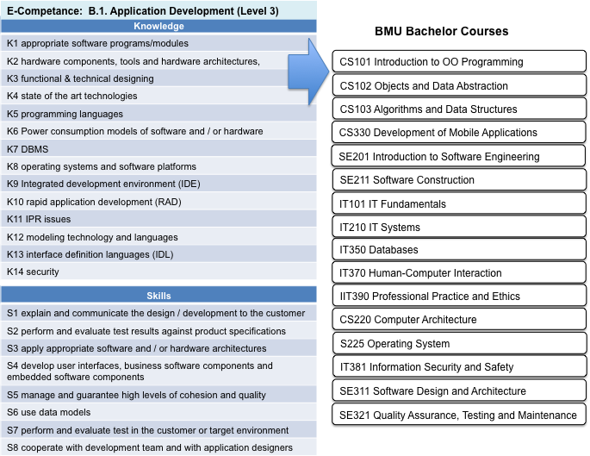
Figure 2.4: Knowledge areas of e-competence B.1. and related BMU e-courses

Acquiring the e-competence B.2. System Integration (Level 2)
Figure 2.5 shows the knowledge areas required for the B.2. System Integration e-competence and the BMU e-courses that provide learning objects corresponding to the learning units of the listed knowledge areas. These learning units are specified in the SWEBOK 3.0 (specified by IEEE Computer Society and AIS) for each learning area.
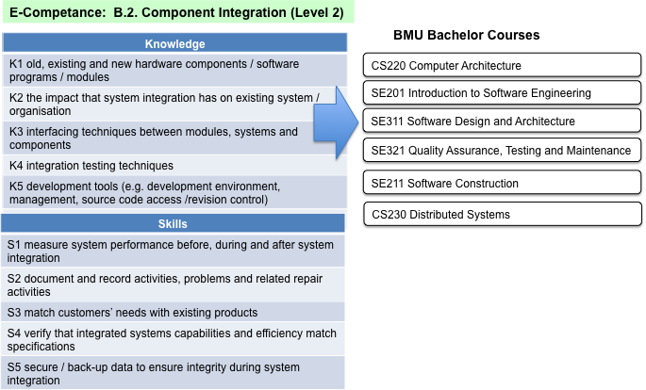
Figure 2.5: The knowledge areas specified for the e-competence B.2. Component Integration and related BMU e-courses.

Acquiring the e-competence B.3.Testing (Level 2)
Figure 2.6 shows the knowledge areas required for the B.3. Testing e-competence and the BMU e-courses that provide learning objects corresponding to the learning units of the listed knowledge areas. These learning units are specified in the SWEBOK 3.0 (specified by IEEE Computer Society and AIS) for each learning area.
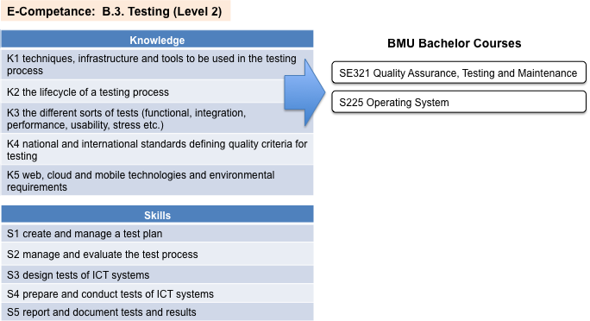
Figure 2.6: The knowledge areas specified for the e-competence B.3. Testing and related BMU e-courses.

Acquiring the e-competence B.5. Documentation Production (Level 3)
Figure 2.7 shows the knowledge areas required for the B.5. Documentation Production e-competence and the BMU e-courses that provide learning objects corresponding to the learning units of the listed knowledge areas. These learning units are specified in the SWEBOK 3.0 (for each learning area.
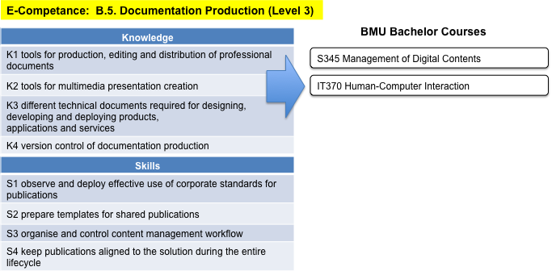
Figure 2.7: The knowledge areas specified for the e-competence B.5. Documentation Production and related BMU e-courses.

Acquiring the e-competence C.4. Problem Management (Level 3)
Figure 2.8 shows the knowledge areas required for the C.4. Problem Management e-competence and the BMU e-courses that provide learning objects corresponding to the learning units of the listed knowledge areas. These learning units are specified in the SWEBOK 3.0 (for each learning area.
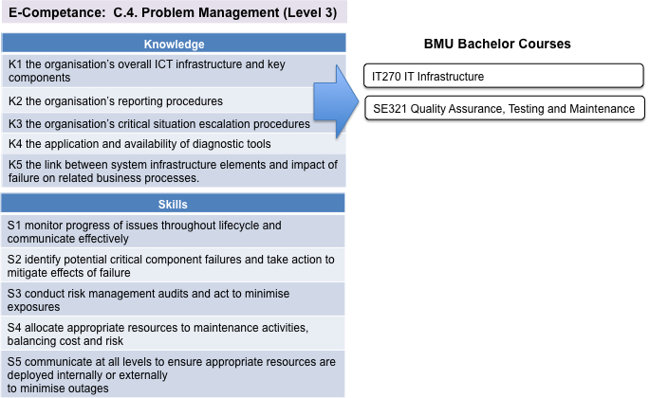
Figure 2.8: The knowledge areas specified for the e-competence C.4. Problem Management and related BMU e-courses.

The List of BMU e-Courses Related to c-competences Specified for the ICT Profile Developer
After analyzing Figures 2.4 -2.8, Figure 2.9 was created showing the BMU e-courses corresponding to all five e-competence specified for the ICT Profile Java Developer.
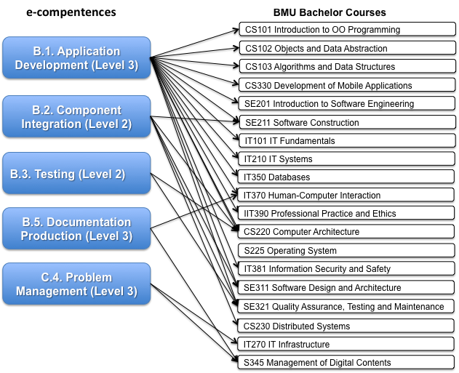
Figure 2.9: The BMU e-courses related to five e-competences specified for the ICT Profile Java Developer

Mapping of BMU Bachelor Courses into SCHE Programming in Java
Next step in development process of SCHE Programming in Java courses if mapping of BMU e-courses into SCHE Programming in Java e-courses (Figure 2.10).
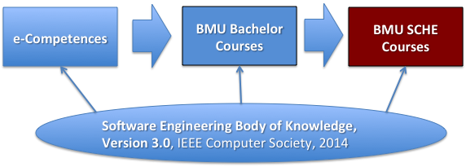
Figure 2.10: Mapping of BMU bachelor courses into SCHE Programming in Java courses
Figure 2.11 shows created SCHE Programming in Java courses. These courses takes into account specifics of SCHE Programming in Java. They have to provide more practical and simpler explanation of programming concepts, more elaborated shown examples, and many assignments for individual exercise of each student. In the next chapter, syllabi of these courses will be specified.

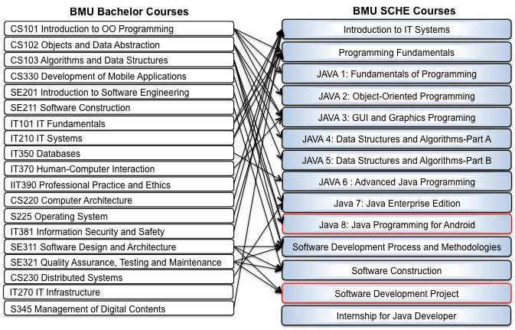
Figure 2.11 Created SCHE Programming in Java courses

COURSES OF SCHE PROGRAMMING IN JAVA

Sequence of courses of SCHE Programming in Java
The curriculum of SCHE program “Programming in Java” is determined by mapping of relevant parts (learning units) of the BMU Bachelor's degree programs. It is implemented in three stages where each of them has one or more courses:
- Preparatory stage – aiming to prepare trainees for programming training, providing the some basic knowledge in IT systems and programming fundamentals. The following courses are included:
  - KI101 Introduction to IT systems
  - KI102 Fundamentals of Programming
- Learning stage – providing programming knowledge and skills to trainees, as well as some basic soft skills that might be useful for their employability. This stage includes:
  - KI103 Java 1: Fundamentals of Programming
  - KI104 Java 2: Object-oriented Programming
  - KI105 Java 3: GUI Programming
  - KI201 Java 4: Data Structures and Algorithms - Part A
  - KI202 Java 5: Data Structures and Algorithms - Part B
  - KI203 Java 6: Advanced Java Programming
  - KI204 Java 7: Java Enterprise Edition
  - KI205 Java 8: Java Programming on the Android platform
  - KI206 Software Development Process and Methodology
  - KI301 Software Construction
- On-the-job training stage – providing trainees one course (KI401) and one internship (KI402):
  - KI401 Software Development Project
  - KI402 Professional Internship - Java Developer
Table 6 shows courses with their course hours of all listed courses and dates of their start.
Table 6: Courses of SCHE Program Java Junior Developer
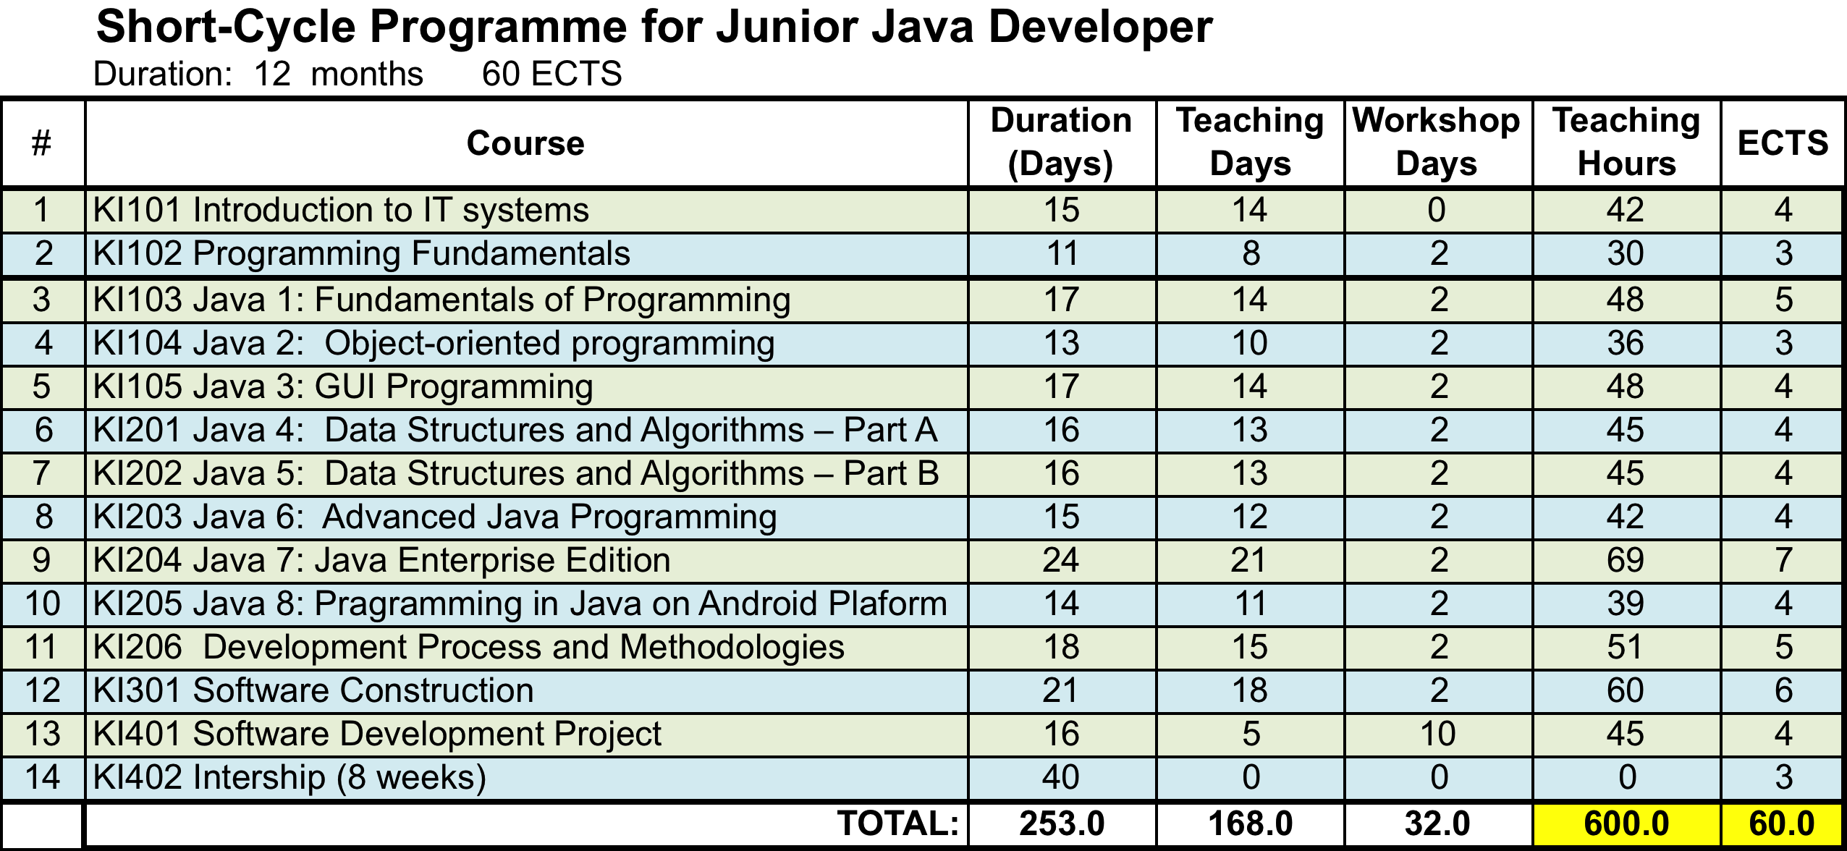

In creating a short program, several IT firms, especially those dealing with software development using Java technology, have been consulted to ensure that this short program is created by "tailor-made employers" who need to hire students who complete this program. The final quality indicator of realized short program is the percentage of student employment in the first three months after the completion of the short program. For each of the above defined courses, program contents and learning outcomes are defined, so in the end, they provide the required competencies for the Java programmer work profile.
The program provides 600 hours of active teaching and 60 ESPB, i.e. credits that can be recognized if the student decides to enroll later on one of four BSC degree programs of BMU: Software Engineering, Information Technology, Computer Games and Information Systems. In the normal duration of the 12 month program, students will have: nine months for active learning, two months of internship and one month for annual leave. Learning is performed in blocks, i.e. according to the "course-by-course" system. It is planned that on each course, a student spends at least three hours a day. Including Saturdays (or 18 hours per week) using the e-Learning System of BMU. Table 8 shows start- and end-days of major groups of training activities of the SCHE program “Programming in Java”, lasting, in total, 12 months and providing 60 ECTS.
The following section specifies syllabi of these courses.

Syllabi of Programming Module Courses

Course 1: Introduction to IT Systems
Duration: 15 days, 12 online teaching days, 2 day workshop days
Number of hours: 3 hours per online/workshop day, Total: 42 hours
ECTS: 4
Day | Hours | Teaching units | Topics | Results – knowledge or skills that the students should receive
1 | 3 | Model of IT Systems | Components of computer systems  Computer system  System software  Operating system  Utilities  Application software  Computer Hardware  Central processing unit  Input / output devices  Memory  Data and information  Input and output devices
2 | 3 | Operating Systems | Overview of the operating system functions  Operating system roles  Types of operating systems and their characteristics  Operating systems of personal computers  Operating systems server  Real-time operating systems  Mainframe operating systems  File system  Comparison of Windows and OS Unis
3 | 3 | Concepts and Fundamentals of Information Management  Architecture of Data Organisation | Information systems: purpose, use, value  Characteristics of data (quality, accuracy, changes with time)  Challenges in data management  Life cycle of data  Database systems  Knowledge management  Data models  Relational model  Normal forms  Functional dependencies  1NF, 2NF, 3NF
4 | 3 | Data Modelling  DDL i basic form of statement SELECT | Conceptual model  Entity Relationship Diagrams  Logical models  Physical models  Standardized modeling in IDEF1 and UML
DDL: CREATE TABLE, CREATE INDEX; ALTER TABLE, DROP TABLE;
Commands CREATE TABLE, CREATE INDEX; ALTER TABLE, DROP TABLE;
Commands: INSERT, UPDATE, DELETE
Examples of DDL commands for creating database elements
Examples of applying the basic form of the SELECT command to display the unchanged table contents
DMS: INSERT, UPDATE, DELETE
Queries over one table showing the unchanged content of the table: SELECT ... FROM;
5  6 | 6 | Web Technologies  Development of Web Sites  Architecture of Information  Digital Media | Preged web technology: HTTP Protocol, HTML / XHTML XML  Web interface  Availability issue  Web Accessibility Initiative  Web services  Hypertext / hypermedia: Effective Communication, Interfaces, Navigation Schemes, Media Types  Web design process: Design by user, Web design templates, Organization of information  Digital libraries  Media formats  Tools for recording, creating and producing  Compression  Broadcast media (Streaming media)  Implementation and integration  Integration with the database
7 | 3 | Inter-Systems Communication | Architecture for System Integration  DCOM, CORBA, RMI  Web Services and Middleware  Network programming  Messaging and routing services  Data transfer to lower.
8 | 3 | Mapping and Exchange of Data | Meta data  Presentation and encoding of data  XML, DTD, XML Schema  XML document parsing  XSL, XSLT and Xpath  Client-server programming
9 | 3 | Integrative  Coding  Scripting Technics  Techics of Code Writing  Integrations | IPT3. Integrated coding: MVC, singleton, factory method, façade, proxy, decorator and observer  Writing a script and the role of a scripting language  Comparative presentation of Adopt and Adapt techniques compared to make  Versions and version management  Components, interfaces and integration  Infrastructure, middleware and platforms
10  11 | 6 | (HCI)Human-Computer Interacion:  Human Factors  Ascpects of HCI of Application Domains  Human-Centered  Evaluation  Development of effective interfaces | Cognitive principles - perception, memory, problem solving  Understanding the users  Design for man  Ergonomics  Types of environment  Cognitive models  Approach  Usability testing  Usability standards  User experience  Interaction styles  Matching interface elements to user requirements  Biometrics  The stress syndrome caused by repetition of the same operations  PHP language. Writing, analysis and testing a script that includes selection, repetition, and forwarding  Create a PHP document for your purpose
12 | 3 | Basics of Computer Networks  Routing  Physical Layer | KStandardization bodies  OSI model  Internet model  Nodes and connections  IEEE 802.1  Routing algorithms  Routing protocols  Wireless and mobile connections  Commuted and packet transfer  Physical media  Satellite communications  Shannon's law  Multimedia technologies WWW  Databases and file servers
13  14 | 6 | Information Security and Safty:  Fundamental Aspects  Security Mechanisms  Ataks  Security  Domains Forensics Information  States Model of Risk Analysis  Security Services | History and terminology  Security way of thinking  Model for information security (threats, vulnerability, attacks, countermeasures)  Cryptography and cryptosystems  Types of attack  Security domains  Give an overview of possible attacks on network and computer resources  Legal system  Digital investigation and its relationship with other investigations  Rules of record  Media analysis  Searching and seizing the device  Transfer  Storage  Processing  Risk assessment  Costs  Availability  Integrity  Secrecy  Authentication  Non-repudiation
15 | 3 | Final examination(in BMU computer rooms) | Students get examination questions and problems  Exam duration - 3 hours | To evaluate knowledge and skills acquired during the course

Course 2: Programming Fundamentals
Duration: 11 days, 8 online teaching days, 2 day workshop days
Number of hours: 3 hours per online/workshop day, Total: 30 hours
ECTS: 3
Day | Hours | Teaching units | Topics | Results – knowledge or skills that the students should receive
1,2 | 6 | Problem Solving Techniques  Programming Fundamentals | What Is a computer?  Definition of Problem Solving  Formulating the Real Problem  Analyze the Problem  Design a Solution Search Strategy  Problem Solving Using Programs  The Programming Process  Programming Paradigms | To formulate and analyse programmimg problems  To design a solution search strategy  To understand the programming process  To understand programming paradigmes
2,3 | 6 | Programming Language Basics | Programming Language Overview  Operating Systems  Syntax and Semantics of Programming Languages  Low-Level Programming Languages  High-Level Programming Languages  Declarative vs. Imperative Programming Languages | To understane the role of operating systems  To difirentiate the syntax and semantics of programming languages  To understabd the difference between low- and high-level languages  To understand the difference between declarative and imperative programming languages
4,5 | 6 | Introduction of algorithms and problem-solving | Problem-solving strategies;  the role of algorithms in the problem-solving process;  implementation strategies for algorithms;  the concept and properties of algorithms | To understabd the roel of algorithms  To implement alogoritmes in porgramming  To understand the concept and properties of algorithms
5,6 | 6 | Implementation of algorithms | Examples of algoritmic problem-solving processes  Exercises and student assignments | To implement algorithms in solving different problems
7 | 3 | F2F Project Workshop  (in BMU computer rooms, optionally -online) | Distribution of projects assignments  Students work on their project tasks with assistance of instructors | To learn how to specify a project  To learn how to organize the project and to break-down tasks  To implement acquired knowledge during the course
8 | 3 | F2F Project Workshop  (in BMU computer rooms, optionally online) | Students work on their project tasks with assistance of instructors | To develop necessary Java programs  To realize all programming tasks of students’ project.  Presentation of the project report
13 | 3 | Final examination  (in BMU computer rooms) | Students get examination questions and problems  Exam duration - 3 hours | To evaluate knowledge and skills acquired during the course

Course 3: JAVA 1: Fundamentals of Programming
Duration: 17 days, 14 online teaching days, 2 day workshop days
Number of hours: 3 hours per online/workshop day, Total: 48 hours
ECTS: 4
Day | Ho-urs | Teaching units | Topics | Objectives – knowledge or skills that the student should receive
1 | 3 | Introduction to Java | What is Java? Specification, API, JDK, and iDE  A simple Java program  Creating, compiling, and executing a java program  Programming style and documentation  Programming errors  Developing java programs using NetBeans  Programming exercises  Programming assignment | To understand computer basics, programs, and operating systems  To describe the relationship between Java and the World Wide Web  To understand the meaning of Java language specification, API, JDK, and IDE  To write a simple Java program  To display output on the console  To explain the basic syntax of a Java program  To create, compile, and run Java programs  To use sound Java programming style and document programs properly  To explain the differences between syntax errors, runtime errors, and logic errors  To develop Java programs using NetBeans
2,3 | 6 | Elementary programming in Java | Writing a simple program  Reading input from the console  Identifiers  Variables  Assignment statements and assignment expressions  Named constants  Naming conventions  Numeric data types and operations  Numeric literals  Evaluating expressions and operator precedence  Case study: displaying the current time  Augmented assignment operators  Increment and decrement operators  Numeric type conversions  Software development process  Case study: counting monetary units  Common errors and pitfalls  Programming exercises  Programming assignment | To write Java programs to perform simple computations  To obtain input from the console using the Scanner class  To use identifiers to name variables, constants, methods, and classes  To use variables to store data  To program with assignment statements and assignment expressions  To use constants to store permanent data  To name classes, methods, variables, and constants by following their naming conventions  To explore Java numeric primitive data types: byte, short, int, long, float, and double  To read a byte, short, int, long, float, or double value from the keyboard  To perform operations using operators +, -, *, /, and %  To perform exponent operations using Math.pow(a, b)  To write integer literals, floating-point literals, and literals in scientific notation (  To write and evaluate numeric expressions  To obtain the current system time using System.currentTimeMillis()  To use augmented assignment operators  To distinguish between postincrement and preincrement and between postdecrement and predecrement  To cast the value of one type to another type  To describe the software development process and apply it to develop the loan payment program  To write a program that converts a large amount of money into smaller units  To avoid common errors and pitfalls in elementary programming
4,5 | 6 | Selections (program branching) | Boolean data type  If statements  Two-way if-else statements  Nested if and multi-way if-else statements  Common errors and pitfalls  Generating random numbers  Case study: computing body mass index  Case study: computing taxes  Logical operators  Case study: determining leap year  Case study: lottery  Switch statements  Conditional expressions  Operator precedence and associativity  Debugging  Programming exercises  Programming assignment | To declare boolean variables and write Boolean expressions using relational operators  To implement selection control using one-way if statements  To implement selection control using two-way if-else statements  To implement selection control using nested if and multi-way if statements  To avoid common errors and pitfalls in if statements  To generate random numbers using the Math.random() method  To program using selection statements for a variety of examples (SubtractionQuiz, BMI, ComputeTax)  To combine conditions using logical operators (!, &&, ||, and ^)  To program using selection statements with combined conditions (LeapYear, Lottery)  To implement selection control using switch statements  To write expressions using the conditional expression  To examine the rules governing operator precedence and associativity  To apply common techniques to debug errors
6,7 | 6 | Loops | The while loop  The do-while loop  The for loop  Which loop to use?  Nested loops  Minimizing numeric errors  Case studies  Keywords break and continue  Case study: checking palindromes  Case study: displaying prime numbers  Programming exercises  Programming assignment | To write programs for executing statements repeatedly using a while loop  To follow the loop design strategy to develop loops  To control a loop with a sentinel value  To obtain large input from a file using input redirection rather than typing from the keyboard  To write loops using do-while statements  To write loops using for statements  To discover the similarities and differences of three types of loop statements  To write nested loops  To learn the techniques for minimizing numerical errors  To learn loops from a variety of examples (GCD, FutureTuition, Dec2Hex)  To implement program control with break and continue  To process characters in a string using a loop in a case study for checking palindrome  To write a program that displays prime numbers
8,9 | 6 | Mathematical functions, characters and strings | Common mathematical functions  Character data type and operations  The string type  Case studies  Formatting console output  Programming exercises  Programming assignment | To solve mathematical problems by using the methods in the Math class  To represent characters using the char type  To encode characters using ASCII and Unicode  To represent special characters using the escape sequences  To cast a numeric value to a character and cast a character to an integer  To compare and test characters using the static methods in the Character class.  To introduce objects and instance methods  To represent strings using the String object  To return the string length using the length() method  To return a character in the string using the charAt(i) method  To use the + operator to concatenate strings  To return an uppercase string or a lowercase string and to trim a string  To read strings from the console  To read a character from the console  To compare strings using the equals method and the compareTo methods  To obtain substrings  To find a character or a substring in a string using the indexOf method  To program using characters and strings (GuessBirthday)  To convert a hexadecimal character to a decimal value (HexDigit2Dec)  To revise the lottery program using strings (LotteryUsingStrings)  To format output using the System.out.printf method
10  11 | 6 | Methods | Defining a method  Calling a method  void method example  Passing arguments by values  Modularizing code  Case study: converting hexadecimals to decimals  Overloading methods  The scope of variables  Case study: generating random characters  Method abstraction and stepwise refinement  Programming exercises  Programming assignment | To define methods with formal parameters  To invoke methods with actual parameters (i.e., arguments)  To define methods with a return value  To define methods without a return value  To pass arguments by value  To develop reusable code that is modular, easy to read, easy to debug, and easy to maintain  To write a method that converts hexadecimals to decimals  To use method overloading and understand ambiguous overloading  To determine the scope of variables  To apply the concept of method abstraction in software development  To design and implement methods using stepwise refinement
12  13 | 6 | Single-Dimensional Arrays | Array basics  Case study: analyzing numbers  Case study: deck of cards  Copying arrays  Passing arrays to methods  Returning an array from a method  Case study: counting the occurrences of each letter  Variable-length argument lists  Searching arrays  Sorting arrays  The arrays class  Command-line arguments  Programming exercises  Programming assignment | To describe why arrays are necessary in programming  To declare array reference variables and create arrays  To obtain array size using arrayRefVar.length and know default values in an array  To access array elements using indexes  To declare, create, and initialize an array using an array initializer  To program common array operations (displaying arrays, summing all elements, finding the minimum and maximum elements, random shuffling, and shifting elements)  To simplify programming using the for each loops  To apply arrays in application development (AnalyzeNumbers, DeckOfCards)  To copy contents from one array to another  To develop and invoke methods with array arguments and return valueTo define a method with a variable-length argument list  To search elements using the linear or binary search algorithm.  To sort an array using the selection sort approach  To use the methods in the java.util.Arrays class  To pass arguments to the main method from the command line
14 | 3 | Multi-Dimensional Arrays | Two-dimensional array basics  Processing two-dimensional arrays  Passing two-dimensional arrays to methods  Case study: grading a multiple-choice test  Case study: finding the closest pair  Case study: sudoku  Multidimensional arrays  Programming exercises  Programming assignment | To give examples of representing data using two-dimensional arrays  To declare variables for two-dimensional arrays, create arrays, and access array elements in a two-dimensional array using row and column indexes  To program common operations for two-dimensional arrays (displaying arrays, summing all elements, finding the minimum and maximum elements, and random shuffling)  To pass two-dimensional arrays to methods  To write a program for grading multiple-choice questions using twodimensional arrays  To solve the closest-pair problem using two-dimensional arrays  To check a Sudoku solution using two-dimensional arrays  To use multidimensional arrays
15 | 3 | F2F Project Workshop  (in BMU computer rooms, optionally -online) | Distribution of projects assignments  Students work on their project tasks with assistance of instructors | To learn how to specify a project  To learn how to organize the project and to break-down tasks  To implement acquired knowledge during the course
16 | 3 | F2F Project Workshop  (in BMU computer rooms, optionally -online) | Students work on their project tasks with assistance of instructors | To develop necessary Java programs  To realize all programming tasks of students’ project.  Presentation of the project report
17 | 3 | Final examination  (in BMU computer rooms) | Students get examination questions and problems  Exam duration - 3 hours | To evaluate knowledge and skills acquired during the course

Course 4: Java 2: Object-oriented programming
Duration: 13 days, 10 online teaching days, 2 day workshop days
Number of hours: 3 hours per online/workshop day, Total: 36 hours
ECTS: 3
Day | Ho-urs | Teaching units | Topics | Objectives – knowledge or skills that the student should receive
1,2 | 6 | Classes and objects | Defining classes for objects  Example: defining classes and creating objects  Constructing objects using constructors  Accessing objects via reference variables  Using classes from the java library  Static variables, constants, and methods  Visibility modifiers  Data field encapsulation  Passing objects to methods  Array of objects  Immutable objects and classes  The scope of variables  The this reference  Programming exercises  Programming assignment | To describe objects and classes, and use classes to model objects  To use UML graphical notation to describe classes and objects  To demonstrate how to define classes and create objects  To create objects using constructors  To access objects via object reference variables  To define a reference variable using a reference type  To access an object’s data and methods using the object member access operator (.)  To define data fields of reference types and assign default values for an object’s data fields  To distinguish between object reference variables and primitive data type variables  To use the Java library classes Date, Random, and Point2D  To distinguish between instance and static variables and methods  To define private data fields with appropriate getter and setter methods  To encapsulate data fields to make classes easy to maintain  To develop methods with object arguments and differentiate between primitive-type arguments and object-type arguments  To store and process objects in arrays  To create immutable objects from immutable classes to protect the contents of objects  To determine the scope of variables in the context of a class  To use the keyword this to refer to the calling object itself
3,4 | 6 | Object-oriented thinking | Class abstraction and encapsulation  Thinking in objects  Class relationships  Case study: designing the course class  Case study: designing a class for stacks  Processing primitive data type values as objects  Automatic conversion between primitive types and Wrapper class types  The BigInteger and BigDecimal classes  The String class  The StringBuilder and StringBuffer classes  Programming exercises  Programming assignment | To apply class abstraction to develop software  To explore the differences between the procedural paradigm and object-oriented paradigm  To discover the relationships between classes  To design programs using the object-oriented paradigm  To create objects for primitive values using the wrapper classes (Byte, Short, Integer, Long, Float, Double, Character, and Boolean)  To simplify programming using automatic conversion between primitive types and wrapper class types  To use the BigInteger and BigDecimal classes for computing very large numbers with arbitrary precisions  To use the String class to process immutable strings  To use the StringBuilder and StringBuffer classes to process mutable strings
5,6 | 6 | Inheritance and Polymorphism | Superclasses and subclasses,  Superclasses and subclasses methods  Using super keyword  Overriding methods Overriding vs overloading, Polymorphism  Dynamic binding  Casting objects and the instanceof operator.  The Object’s equals method  The ArrayList class  Case study: a custom stack  The protected data and methods  Preventing extending and overriding  Programming exercises  Programming assignment | To define a subclass from a superclass through inheritance  To invoke the superclass’s constructors and methods using the super keyword  To override instance methods in the subclass  To distinguish differences between overriding and overloading  To explore the toString() method in the Object class  To discover polymorphism and dynamic binding  To describe casting and explain why explicit downcasting is necessary  To explore the equals method in the Object class  To store, retrieve, and manipulate objects in an ArrayList  To construct an array list from an array, to sort and shuffle a list, andto obtain max and min element from a list  To implement a Stack class using ArrayList  To enable data and methods in a superclass accessible from subclasses using the protected visibility modifier  To prevent class extending and method overriding using the final
7,8 | 6 | Exception Handling and Text I/O | Exception-Handling Overview  Exception types  More on exception handling  The finally clause  When to use exceptions  Rethrowing exceptions  Chained exceptions  Defining custom exception classes  The File class  File input and output  Reading data from the Web  Case study: Web Crawler  Programming exercises  Programming assignment | To get an overview of exceptions and exception handling  To explore the advantages of using exception handling  To distinguish exception types: Error (fatal) vs. Exception (nonfatal)and checked vs. unchecked  To declare exceptions in a method header  To throw exceptions in a method  To write a try-catch block to handle exceptions  To explain how an exception is propagated  To obtain information from an exception object  To develop applications with exception handling  To use the finally clause in a try-catch block  To use exceptions only for unexpected errors  To rethrow exceptions in a catch block  To create chained exceptions  To define custom exception classes  To discover file/directory properties, to delete and rename files/ directories, and to create directories using the File class  To write data to a file using the PrintWriter class  To use try-with-resources to ensure that the resources are closed automatically  To read data from a file using the Scanner class  To understand how data is read using a Scanner  To develop a program that replaces text in a file  To read data from the Web  To develop a Web Crawler
9  10 | 6 | Abstract Classes and Interfaces | Abstract classes  Case study: the AbstractNumber Class  Case study: Calendar and GregorianCalendar  Interfaces  The Comparable interface  The Cloneable interface  Interfaces vs. abstract classes  Case Study: the Rational class  Class design guidelines  Programming exercises  Programming assignment | To design and use abstract classes  To generalize numeric wrapper classes, BigInteger, and BigDecimal using the abstract Number class  To process a calendar using the Calendar and GregorianCalendar classes  To specify common behavior for objects using interfaces  To define interfaces and define classes that implement interfaces  To define a natural order using the Comparable interface  To make objects cloneable using the Cloneable interface  To explore the similarities and differences among concrete classes, abstract classes, and interfaces  To design the Rational class for processing rational numbers  To design classes that follow the class-design guidelines
11 | 3 | F2F Project Workshop  (in BMU computer rooms, optionally -online) | Distribution of projects assignments  Students work on their project tasks with assistance of instructors | To learn how to specify a project  To learn how to organize the project and to break-down tasks  To implement acquired knowledge during the course
12 | 3 | F2F Project Workshop  (in BMU computer rooms, optionally -online) | Students work on their project tasks with assistance of instructors | To develop necessary Java programs  To realize all programming tasks of students’ project.  Presentation of the project report
13 | 3 | Final examination  (in BMU computer rooms) | Students get examination questions and problems  Exam duration - 3 hours | To evaluate knowledge and skills acquired during the course

Course 5: Java 3: GUI Programming
Duration: 17 days, 14 online teaching days, 2 day workshop days
Number of hours: 3 hours per online/workshop day, Total: 48 hours
ECTS: 4
Day | Hours | Teaching units | Topics | Objectives – knowledge or skills that the student should receive
1,2 | 6 | Swing Graphical User Interfaces Basics (GUI) | Swing vs. AWT  The Java GUI API  Frames  Layout Managers  Using Panels as Subcontainers  The Color Class  The Font Class  Common Features of Swing GUI Components  Image Icons  JButton  JCheckBox  JRadioButton  Labels  Text Fields  Programming exercises  Programming assignment | To distinguish between Swing and AWT  To describe the Java GUI API hierarchy  To create user interfaces using frames, panels, and simple GUI components .  To understand the role of layout managers and use the FlowLayout, GridLayout, and BorderLayout managers to lay out components in a container  To use JPanel to group components in a subcontainer  To create objects for colors using the Color class  To create objects for fonts using the Font class  To apply common features such as borders, tool tips, fonts, and colors on Swing components  To decorate the border of GUI components  To create image icons using the ImageIcon class.To create and use buttons using the JButton class.  To create and use check boxes using the JCheckBox class  To create and use radio buttons using the JRadioButton class  To create and use labels using the JLabel class  To create and use text fields using the JTextField class
3,4 | 6 | Graphics in Java | The Graphics class  Drawing Strings, Lines, Rectangles, and Ovals  Case study: The FigurePanel class  Drawing Arcs  Drawing Polygons and Polylines  Centering a String using the FontMetrics class  Case study: The MessagePanel class  Case study: The StillClock class  Displaying images  Case study: The ImageViewer class  Programming exercises  Programming assignment | To draw graphics using the methods in the Graphics class  To override the paintComponent method to draw graphics on a GUI component  To use a panel as a canvas to draw graphics  To draw strings, lines, rectangles, ovals, arcs, and polygons  To obtain font properties using FontMetrics and to display a text centered in a panel  To display an image on a GUI component  To develop the reusable GUI components FigurePanel, MessagePanel, StillClock, and ImageViewer
5,6 | 6 | Java FX - Basics | JavaFX vs Swing and AWT  The basic structure of a JavaFX program  Panes, UI Controls, and Shapes  Property binding  Common properties and methods for Nodes  The Color class  The Font class  The Image and ImageView classes  Layout Panes  Shapes  Case study: The ClockPane class  Programming exercises  Programming assignment | To distinguish between JavaFX, Swing, and AWT  To write a simple JavaFX program and understand the relationship among stages, scenes, and nodes  To create user interfaces using panes, UI controls, and shapes  To update property values automatically through property binding  To use the common properties style and rotate for nodes  To create colors using the Color class  To create fonts using the Font class  To create images using the Image class and to create image views using the ImageView class  To layout nodes using Pane, StackPane, FlowPane, GridPane, BorderPane, HBox, and VBox  To display text using the Text class and create shapes using Line,Circle, Rectangle, Ellipse, Arc, Polygon, and Polyline  To develop the reusable GUI component ClockPane for displaying an analog clock
7,8 | 6 | Event Driven Programming | Events and Event Sources  Registering Handlers and Handling Events  Inner classes  Anonymous Inner class handlers  Simplifying Event Handling Using Lambda Expressions  Case study: Loan Calculator  Mouse events  Key events  Listeners for Observable Objects  Animation  Case study: Bouncing ball  Programming exercises  Programming assignment | To get a taste of event-driven programming  To describe events, event sources, and event classes  To define handler classes, register handler objects with the source object, and write the code to handle events  To define handler classes using inner classes  To define handler classes using anonymous inner classes  To simplify event handling using lambda expressions  To develop a GUI application for a loan calculator  To write programs to deal with MouseEvents  To write programs to deal with KeyEvents  To create listeners for processing a value change in an observable object  To use the Animation, PathTransition, FadeTransition, and Timeline classes to develop animations  To develop an animation for simulating a bouncing ball
9  10  11  12 | 12 | JavaFX UI Controls and Multimedia | Labeled and Label  Button  CheckBox  RadioButton  TextField  TextArea  ComboBox  ListView  ScrollBar  Slider  Case study: Developing a Tic-Tac-Toe game  Video and Audio  Case study: National Flags and Anthems  Programming exercises  Programming assignment | To create graphical user interfaces with various user-interface controls  To create a label with text and graphic using the Label class and explore properties in the abstract Labeled class  To create a button with text and graphic using the Button class and set a handler using the setOnAction method in the abstract ButtonBase class (§16.3).  To create a check box using the CheckBox class  To create a radio button using the RadioButton class and group radio buttons using a ToggleGroup  To enter data using the TextField class and password using the PasswordField class  To enter data in multiple lines using the TextArea class  To select a single item using ComboBox  To select a single or multiple items using ListView  To select a range of values using ScrollBar  To select a range of values using Slider and explore differences between ScrollBar and Slider  To develop a tic-tac-toe game  To view and play video and audio using the Media, MediaPlayer, and MediaView  To develop a case study for showing the national flag and playing anthem
13 | 3 | Binary I/O | How is text I/O handled in Java?  Text I/O vs. binary I/O  Binary I/O classes  Case study: Copying files  Object I/O  Random-access files  Programming exercises  Programming assignment | To discover how I/O is processed in Java  To distinguish between text I/O and binary I/O  To read and write bytes using FileInputStream and FileOutputStream  To filter data using the base classes FilterInputStream and FilterOutputStream  To read and write primitive values and strings using DataInputStream and DataOutputStream  To improve I/O performance by using BufferedInputStream and BufferedOutputStream  To write a program that copies a file  To store and restore objects using ObjectOutputStream and ObjectInputStream  To implement the Serializable interface to make objects serializable  To serialize arrays  To read and write files using the RandomAccessFile class
14 | 3 | Software Testing with JUnit | Software unit testing.  JUnit test  Metods of assertions validation  Testing of aggregations.  Pameters in testing.  Testing of exceptions.  Use of @Rule  Programming exercises  Programming assignment | To understand what is unit testing.  To learn how to use JUnit test  To learn how to validate assertions.  To learn how to test aggregations.  To understand what are parameters in testing.  To learn how to test exceptions.  To learn to use @Rule.
15 | 3 | F2F Project Workshop  (in BMU computer rooms, optionally -online) | Distribution of projects assignments  Students work on their project tasks with assistance of instructors | To learn how to specify a project  To learn how to organize the project and to break-down tasks  To implement acquired knowledge during the course
16 | 3 | F2F Project Workshop  (in BMU computer rooms, optionally -online) | Students work on their project tasks with assistance of instructors | To develop necessary Java programs  To realize all programming tasks of students’ project.  Presentation of the project report
17 | 3 | Final examination  (in BMU computer rooms) | Students get examination questions and problems  Exam duration - 3 hours | To evaluate knowledge and skills acquired during the course

Course 6: Java 4: Data Structures and Algorithms – Part A
Duration: 17 days, 14 online teaching days, 2 day workshop days, 4 ECTS
Number of hours: 3 hours per online/workshop day, Total: 45 hours
Day | Ho-urs | Teaching units | Topics | Objectives – knowledge or skills that the student should receive
1,2 | 6 | Recursion | Recursion Definition,  Case Study: Computing Factorials,  Case Study: Computing Fibonacci Numbers, Problem Solving Using Recursion,  Recursive Helper Methods.  Case Study: Tower of Hanoi,  Recursion vs. Iteration, Tail Recursion.  Programming exercises  Programming assignment | To describe what a recursive method is and the benefits of usingrecursion  To develop recursive methods for recursive mathematical functions  To explain how recursive method calls are handled in a call stack  To solve problems using recursion  To use an overloaded helper method to design a recursive method  To implement a selection sort using recursion  To implement a binary search using recursion  To get the directory size using recursion  To solve the Tower of Hanoi problem using recursion  To draw fractals using recursion  To discover the relationship and difference between recursion and iteration  To know tail-recursive methods and why they are desirable
3,4 | 6 | Generics | Motivations and benefits  Defining generic classes and interfaces  Generic methods  Case study: sorting an array of objects  Raw types and backward compatibility  Wildcard generic types  Erasure and restrictions on generics  Case study: generic matrix class  Programming exercises  Programming assignment | To describe the benefits of generics  To use generic classes and interfaces  To define generic classes and interfaces  To explain why generic types can improve reliability and readability  To define and use generic methods and bounded generic types  To develop a generic sort method to sort an array of Comparableobjects To use raw types for backward compatibility  To explain why wildcard generic types are necessary  To describe generic type erasure and list certain restrictions and limitations on generic types caused by type erasure  To design and implement generic matrix classes
5,6 | 6 | List, Stack, Queue and PriorityQueue | Collections,  Iterators,  Lists,  The Comparator Interface,  Static Methods for Lists and Collections  Case Study: Bouncing Balls,  Vector and Stack Classes  Programming exercises  Programming assignment | To explore the relationship between interfaces and classes in the Java Collections Framework hierarchy  To use the common methods defined in the Collection interface for operating collections  To use the Iterator interface to traverse the elements in a collection  To use a foreach loop to traverse the elements in a collection  To explore how and when to use ArrayList or LinkedList to store a list of elements  To compare elements using the Comparable interface and the Comparator interface  To use the static utility methods in the Collections class for sorting, searching, shuffling lists, and finding the largest and smallest element in collections  To develop a multiple bouncing balls application using ArrayList  To distinguish between Vector and ArrayList and to use the Stack class for creating stacks  To explore the relationships among Collection, Queue, LinkedList, and PriorityQueue and to create priority queues using the PriorityQueue class  To use stacks to write a program to evaluate expressions
7,8 | 6 | Set and Map | Sets,  Comparing the performance of Sets and Lists,  Case study: counting keywords  Maps.  Case study: Occurrences of words,  Singleton and Unmodifiable Collections and Maps  Programming exercises  Programming assignment | To store unordered, nonduplicate elements using a set  To explore how and when to use HashSet LinkedHashSet or TreeSet to store a set of elements.  To compare the performance of sets and lists  To use sets to develop a program that counts the keywords in a Java source file  To tell the differences between Collection and Map and describe when and how to use HashMap, LinkedHashMap, or TreeMap to store values associated with keys  To use maps to develop a program that counts the occurrence of the words in a text  To obtain singleton sets, lists, and maps, and unmodifiable sets, lists, and maps, using the static methods in the Collections class
9  10  11  12 | 12 | Developing Efficient Algorithms | Measuring algorithm efficiency using big o notation  Examples: determining big O  Analyzing algorithm time complexity  Finding Fibonacci numbers using dynamic programming  Finding greatest common divisors using Euclid’s algorithm  Efficient algorithms for finding prime numbers  Finding the closest pair of points using divide-and-conquer  Solving the eight queens problem using backtracking  Computational geometry: finding a convex hull  Programming exercises  Programming assignment | To estimate algorithm efficiency using the Big O notation  To explain growth rates and why constants and nondominating terms can be ignored in the estimation  To determine the complexity of various types of algorithms).  To analyze the binary search algorithm  To analyze the selection sort algorithm  To analyze the Tower of Hanoi algorithm  To describe common growth functions (constant, logarithmic, loglinear, quadratic, cubic, exponential)  To design efficient algorithms for finding Fibonacci numbers using dynamic programming  To find the GCD using Euclid’s algorithm  To find prime numbers using the sieve of Eratosthenes  To design efficient algorithms for finding the closest pair of points using the divide-and-conquer approach  To solve the Eight Queens problem using the backtracking approach  To design efficient algorithms for finding a convex hull for a set of  points
13  14 | 6 | Sorting | Insertion Sort  Bubble Sort  Merge Sort  Quick Sort  Heap Sort  Bucket Sort and Radix Sort  External Sort  Programming exercises  Programming assignment | To study and analyze time complexity of various sorting algorithms  To design, implement, and analyze insertion sort  To design, implement, and analyze bubble sort  To design, implement, and analyze merge sort  To design, implement, and analyze quick sort  To design and implement a binary heap  To design, implement, and analyze heap sort  To design, implement, and analyze bucket sort and radix sort  To design, implement, and analyze external sort for files that have a large amount of data
15 | 3 | F2F Project Workshop  (in BMU computer rooms, optionally -online) | Distribution of projects assignments  Students work on their project tasks with assistance of instructors | To learn how to specify a project  To learn how to organize the project and to break-down tasks  To implement acquired knowledge during the course
16 | 3 | F2F Project Workshop  (in BMU computer rooms, optionally -online) | Students work on their project tasks with assistance of instructors | To develop necessary Java programs  To realize all programming tasks of students’ project.  Presentation of the project report
17 | 3 | Final examination  (in BMU computer rooms) | Students get examination questions and problems  Exam duration - 3 hours | To evaluate knowledge and skills acquired during the course

Course 7: Java 5: Data Structures and Algorithms – Part B
Duration: 16 days, 13 online teaching days, 2 day workshop days, 4 ECTS
Number of hours: 3 hours per online/workshop day, Total: 45 hours

Day | Ho-urs | Teaching units | Topics | Objectives – knowledge or skills that the student should receive
1,2 | 6 | Implementing Lists, Stacks, Queues,  and Priority Queues | Common Features for Lists  Array Lists  Linked Lists  Stacks and Queues  Priority Queues  Programming exercises  Programming assignment | To design common features of lists in an interface and provide skeleton implementation in a convenience abstract class  To design and implement an array list using an array  To design and implement a linked list using a linked structure  To design and implement a stack class using an array list and a queue class using a linked list  To design and implement a priority queue using a heap
3,4 | 6 | Binary Search Trees | Binary search srees  Deleting elements from a BST  Tree visualization and MVC  Iterators  Case study: data compression  Programming exercises  Programming assignment | To design and implement a binary search tree  To represent binary trees using linked data structures  To search an element in a binary search tree  To insert an element into a binary search tree  To traverse elements in a binary tree  To design and implement the Tree interface, AbstractTree class, and the BST class  To delete elements from a binary search tree  To display a binary tree graphically  To create iterators for traversing a binary tree  To implement Huffman coding for compressing data using a binary tree
5,6 | 6 | AVL Trees | Rebalancing Trees  Designing Classes for AVL Trees  Overriding the insert Method  Implementing Rotations  Implementing the delete Method  The AVLTree Class  Testing the AVLTree Class  AVL Tree Time Complexity Analysis  Programming exercises  Programming assignment | To know what an AVL tree is  To understand how to rebalance a tree using the LL rotation, LR rotation, RR rotation, and RL rotation  To design the AVLTree class by extending the BST class  To insert elements into an AVL tree  To implement tree rebalancing  To delete elements from an AVL tree  To implement the AVLTree class  To test the AVLTree class  To analyze the complexity of search, insertion, and deletion operations in AVL trees
7,8 | 6 | Hashing | What Is Hashing?  Hash Functions and Hash Codes  Handling Collisions Using Open Addressing  Handling Collisions Using Separate Chaining  Load Factor and Rehashing  Implementing a Map Using Hashing  Implementing Set Using Hashing  Programming exercises  Programming assignment | To understand what hashing is and what hashing is used for  To obtain the hash code for an object and design the hash function to map a key to an index  To handle collisions using open addressing  To know the differences among linear probing, quadratic probing, and double hashing (§27.4).  To handle collisions using separate chaining  To understand the load factor and the need for rehashing  To implement MyHashMap using hashing  To implement MyHashSet using hashing
9  10  11 | 9 | Graphs and Applications | Basic Graph Terminologies  Representing Graphs  Modeling Graphs  Graph Visualization  Graph Traversals  Depth-First Search (DFS)  Case Study: The Connected Circles Problem  Breadth-First Search (BFS)  Case Study: The Nine Tails Problem  Programming exercises  Programming assignment | To model real-world problems using graphs and explain the SevenBridges of Königsberg problem  To describe the graph terminologies: vertices, edges, simple graphs, weighted/unweighted graphs, and directed/undirected graphs  To represent vertices and edges using lists, edge arrays, edge objects, adjacency matrices, and adjacency lists  To model graphs using the Graph interface, the AbstractGraph class, and the UnweightedGraph class  To display graphs visually  To represent the traversal of a graph using the AbstractGraph.Tree class  To design and implement depth-first search  To solve the connected-circle problem using depth-first search  To design and implement breadth-first search  To solve the nine-tail problem using breadth-first search
12  13 | 6 | Weighted Graphs and Applications | Representing Weighted Graphs  The WeightedGraph Class  Minimum Spanning Trees  Finding Shortest Paths  Case Study: The Weighted Nine Tails Problem  Programming exercises  Programming assignment | To represent weighted edges using adjacency matrices and adjacency lists  To model weighted graphs using the WeightedGraph class that extends the AbstractGraph class  To design and implement the algorithm for finding a minimum spanning tree  To define the MST class that extends the Tree class  To design and implement the algorithm for finding single-source shortest paths  To define the ShortestPathTree class that extends the Tree class  To solve the weighted nine tails problem using the shortest-path algorithm
13 | 3 | F2F Project Workshop  (in BMU computer rooms, optionally -online) | Distribution of projects assignments  Students work on their project tasks with assistance of instructors | To learn how to specify a project  To learn how to organize the project and to break-down tasks  To implement acquired knowledge during the course
14 | 3 | F2F Project Workshop  (in BMU computer rooms, optionally -online) | Students work on their project tasks with assistance of instructors | To develop necessary Java programs  To realize all programming tasks of students’ project.  Presentation of the project report
15 | 3 | Final examination  (in BMU computer rooms) | Students get examination questions and problems  Exam duration - 3 hours | To evaluate knowledge and skills acquired during the course

Course 8: Java 6: Advanced Java Programming
Duration: 15 days, 12 online teaching days, 2 day workshop days, 4 ECTS
Number of hours: 3 hours per online/workshop day, Total: 42 hours

Day | Ho-urs | Teaching units | Topics | Objectives – knowledge or skills that the student should receive
1  2  3  4 | 12 | Multithreading and Parallel Programming | Thread Concepts  Creating Tasks and Threads  The Thread Class  Case Study: Flashing Text  Thread Pools  Thread Synchronization  Synchronization Using Locks  Cooperation among Threads  Case Study: Producer/Consumer  Blocking Queues  Semaphores  Avoiding Deadlocks  Thread States  Synchronized Collections  Parallel Programming  Programming exercises  Programming assignment | To get an overview of multithreading  To develop task classes by implementing the Runnable interface  To create threads to run tasks using the Thread class  To control threads using the methods in the Thread class  To control animations using threads and use Platform.runLater to run the code in the application thread  To execute tasks in a thread pool  To use synchronized methods or blocks to synchronize threads to avoid race conditions  To synchronize threads using locks  To facilitate thread communications using conditions on locks  To use blocking queues (ArrayBlockingQueue, LinkedBlockingQueue, PriorityBlockingQueue) to synchronize access to a queue  To restrict the number of concurrent tasks that access a shared resource using semaphores  To use the resource-ordering technique to avoid deadlocks  To describe the life cycle of a thread  To create synchronized collections using the static methods in the Collections class  To develop parallel programs using the Fork/Join Framework
5,6 | 6 | Network programming | Client/Server Computing  The InetAddress Class  Serving Multiple Clients  Sending and Receiving Objects  Case Study: Distributed Tic-Tac-Toe Games  Programming exercises  Programming assignment | To explain terms: TCP, IP, domain name, domain name server, streambased communications, and packet-based communications  To create servers using server sockets and clients using client sockets  To implement Java networking programs using stream sockets  To develop an example of a client/server application  To obtain Internet addresses using the InetAddress class  To develop servers for multiple clients  To send and receive objects on a network  To develop an interactive tic-tac-toe game played on the Internet
7,8 | 6 | Database programming (JDBC) | Relational Database Systems  SQL  JDBC  PreparedStatement  CallableStatement,  Retrieving Metadata  Programming exercises  Programming assignment | Understanding relational databases concept and RDBMS systems. Understanding the relational model, relational data structure, restrictions and language.  SQL use in working with relational databases. Set up and usage of JDBC.  Application of memorized SQL procedures and functions.  Work with metadata about a database.
9  10 | 6 | Java Persistence API | Entity Relations,  Automated generation of JPA entities  Programming exercises  Programming assignment | Understanding ORM and complete mastery of the application of ORM tools in working with databases.
11  12 | 6 | Java Hibernate ORM | Hibernate ORM –  Mapping objects in database  Example of creation of a persistent class  Hibernate Annotations  Hibernate Query Language - HQL  Criteria of selection of objects in HQL query  Using SQL in Hibernate environment  Hibernate cashing  Hibernate batch processing  Hibernate interceptors  Programming exercises  Programming assignment | To implement Java Hibernate ORM in Java applications.
13 | 3 | F2F Project Workshop  (in BMU computer rooms, optionally -online) | Distribution of projects assignments  Students work on their project tasks with assistance of instructors | To learn how to specify a project  To learn how to organize the project and to break-down tasks  To implement acquired knowledge during the course
14 | 3 | F2F Project Workshop  (in BMU computer rooms, optionally -online) | Students work on their project tasks with assistance of instructors | To develop necessary Java programs  To realize all programming tasks of students’ project.  Presentation of the project report
15 | 3 | Final examination  (in BMU computer rooms) | Students get examination questions and problems  Exam duration - 3 hours | To evaluate knowledge and skills acquired during the course

Course 9: Java 7: Java Enterprise Edition
Duration: 24 days, 21 online teaching days, 2 day workshop days, 7 ECTS
Number of hours: 3 hours per online/workshop day, Total: 69 hours

Day | Ho-urs | Teaching units | Topics | Objectives – knowledge or skills that the student should receive
1  2 | 6 | Java EE - Servlets | Java EE Platform  Introduction to Servlets  Creating and Deploying Servlets  Data Flow  Servlet and Sessions  GlassFish Server  Programming exercises  Programming assignment | To understand the concept of distributed systems and Java Enterprise Edition platform basics.  Ability to create and use servelts in Java enterprise applications.
3  4  5  6 | 12 | Java Server Pages (JSP) | JSP Architecture  JSP Life Cycle  JSP Syntax  JSP Directives  JSP Actions  JSP Imlicit Objects  Form Processing  JSP Filters  Cookies Handling in JSP  File Upload in JSP  Date Handling in JSP  Redirection in JSP  JSTL - JavaServer Pages Standard Tag Library  JSP - Databases  JSP - JavaBean  JSP – Expression Language  JSP Internationalization  Programming exercises  Programming assignment | Using JavaServer Pages (JSP), web pages’ development technologies supporinng dynamic content application, and enabling Java code insertion into HTML documents.  Mastering the advanced concept of application principles of JSP pages in JAVA web applications.
7  8  9  10 | 12 | Java Server Faces (JSF) | Introduction to JavaServer Faces  Forms in JSF  Creating CDI named bean, Implementing the confirmation page,  JSF Validation.  Facelets templating, Resource library contracts, PrimeFaces Component Library,  ICEFaces Component Library,  RichFaces Component Library  Programming exercises  Programming assignment | Using JSF technology for Java web application development. Developing advanced JSF applications, with simplified approach through application of JSF component libraries.
11  12 | 6 | RESTFul Web Services with JAX – RS | Generating a RESTful web service from an existing database  Testing RESTful web service  Generating RESTful Java client code  Generating RESTful JavaScript clients  for our RESTful web services  Programming exercises  Programming assignment | Understanding and use of RESTFul Web Services with JAX – RS.
13  14 | 6 | Context and Dependency Injection | Introduction to CDI,  Qualifiers,  Sterotypes,  Interceptor Binding  Types ,  Custom CDI  Scopes  Programming exercises  Programming assignment | Understanding and use of CDI concepts and techniques in Java EE applications.
15  16 | 6 | JMS and Message Driven Beans | Introduction to JMS,  Creating JMS resources,  Implementing a JMS message producer,  Consuming JMS messages with message-driven beans  Programming exercises  Programming assignment | Understanding and use of Java Messaging System and message driven beans in Java EE applications.
17  18 | 6 | Java API for JSON processing | JSON-P object model API,  Generating JSON data with the JSON-P object  model API ,  Parsing JSON data with the JSON-P object  model API ,  JSON-P streaming API,  Generating JSON data with the JSON-P  streaming API,  Parsing JSON data with the JSON-P streaming API  Programming exercises  Programming assignment | Understanding and use of Java EE mechanisms for JSON processing
19 | 3 | Java API for WebSocket | Examining the WebSocket code using samples included with NetBeans,  Echo Application,  Examining the generated Java code , Building our own WebSocket  applications,  Java EE, WebSocket, JS i HTML 5 – Case Study  Programming exercises  Programming assignment | Competence to create individual WebSocket applications.
20  21 | 6 | Implementing the Business Tier with Session Beans | Introducing session beans  Creating a session bean,  Accessing the bean from a client,  Session bean transaction management  Implementing aspect-oriented programming with interceptors  EJB Timer servis  Generating session beans from JPA entities  Programming exercises  Programming assignment | To implement Session beans in Java EE applications.
22 | 3 | F2F Project Workshop  (in BMU computer rooms, optionally -online) | Distribution of projects assignments  Students work on their project tasks with assistance of instructors | To learn how to specify a project  To learn how to organize the project and to break-down tasks  To implement acquired knowledge during the course
23 | 3 | F2F Project Workshop  (in BMU computer rooms, optionally -online) | Students work on their project tasks with assistance of instructors | To develop necessary Java programs  To realize all programming tasks of students’ project.  Presentation of the project report
24 | 3 | Final examination  (in BMU computer rooms) | Students get examination questions and problems  Exam duration - 3 hours | To evaluate knowledge and skills acquired during the course

Course 10 Java 8: Java Programming on the Android platform
Duration: 14 days, 11 online teaching days, 2 day workshop days, 5 ECTS
Number of hours: 3 hours per online/workshop day, Total: 39 hours

Day | Ho-urs | Teaching units | Topics | Objectives – knowledge or skills that the student should receive
1 | 3
2  3 | 6
4  5 | 6
6  7 | 6
8  9 | 6
10 | 3
11  12  13 | 9
14 | 3
15 | 3
16 | 3 | F2F Project Workshop  (in BMU computer rooms, optionally online) | Distribution of projects assignments  Students work on their project tasks with assistance of instructors | To learn how to specify a project  To learn how to organize the project and to break-down tasks  To implement acquired knowledge during the course
17 | 3 | F2F Project Workshop  (in BMU computer rooms, optionally online) | Students work on their project tasks with assistance of instructors | To develop necessary Java programs  To realize all programming tasks of students’ project.  Presentation of the project report
18 | 3 | Final examination  (in BMU computer rooms) | Students get examination questions and problems  Exam duration - 3 hours | To evaluate knowledge and skills acquired during the course

Course 11: Software Development Process and Methodologies
Duration: 18 days, 15 online teaching days, 2 day workshop days, 5 ECTS
Number of hours: 3 hours per online/workshop day, Total: 21 hours

Day | Ho-urs | Teaching units | Topics | Objectives – knowledge or skills that the student should receive
1 | 3 | Introduction | Professional software development  Software engineering ethics  Case studies  Programming exercises  Programming assignment | To understand what software engineering is and why it is important;  To understand that the development of different types of software  systems may require different software engineering techniques;  To understand some ethical and professional issues that are important  for software engineers;  To have been introduced to three systems, of different types, that will be  used as examples throughout the book.
2  3 | 6 | Software Processes | Software process models  Process activities  Coping with change  The Rational Unified Process  Programming exercises  Programming assignment | To understand the concepts of software processes and software process  models;  To have been introduced to three generic software process models and  when they might be used;  To know about the fundamental process activities of software  requirements engineering, software development, testing, and  evolution;  To understand why processes should be organized to cope with changes  in the software requirements and design;  To understand how the Rational Unified Process integrates good software  engineering practice to create adaptable software processes.
4  5 | 6 | Agile Software Development | Agile methods  Plan-driven and agile development  Extreme programming  Agile project management  Scaling agile methods  Programming exercises  Programming assignment | To understand the rationale for agile software development methods, the agile manifesto, and the differences between agile and plan-driven  development;  To know the key practices in extreme programming and how these relate to the general principles of agile methods;  To understand the Scrum approach to agile project management;  To be aware of the issues and problems of scaling agile development methods to the development of large software systems.
6  7 | 6 | Requirements  engineering | Functional and non-functional requirements  The software requirements document  Requirements specification  Requirements engineering processes  Requirements elicitation and analysis  Requirements validation  Requirements management  Programming exercises  Programming assignment | To understand the concepts of user and system requirements and  why these requirements should be written in different ways;  To understand the differences between functional and nonfunctional  software requirements;  To understand how requirements may be organized in a software  requirements document;  To understand the principal requirements engineering activities of  elicitation, analysis and validation, and the relationships between  these activities;  To understand why requirements management is necessary and how  it supports other requirements engineering activities
8  9 | 6 | System modeling | Context models  Interaction models  Structural models  Behavioral models  Model-driven engineering  Programming exercises  Programming assignment | To understand how graphical models can be used to represent  software systems;  To understand why different types of model are required and the  fundamental system modeling perspectives of context, interaction,  structure, and behavior;  To have been introduced to some of the diagram types in the Unified  Modeling Language (UML) and how these diagrams may be used in  system modeling;  To be aware of the ideas underlying model-driven engineering, where a  system is automatically generated from structural and behavioral  models.
10 | 3 | Architectural design | Architectural design decisions  Architectural views  Architectural patterns  Application architectures  Programming exercises  Programming assignment | To understand why the architectural design of software is important;  To understand the decisions that have to be made about the system  architecture during the architectural design process;  To have been introduced to the idea of architectural patterns, well-tried  ways of organizing system architectures, which can be reused in  system designs;  To know the architectural patterns that are often used in different types  of application system, including transaction processing systems and  language processing systems.
11  12  13 | 9 | Design and  implementation | Object-oriented design using the UML  Design patterns  Implementation issues  Open source development  Programming exercises  Programming assignment | To understand the most important activities in a general, objectoriented  design process;  To understand some of the different models that may be used to  document an object-oriented design;  To know about the idea of design patterns and how these are a way  of reusing design knowledge and experience;  To have been introduced to key issues that have to be considered when  implementing software,
14 | 3 | Software testing | Development testing  Test-driven development  Release testing  User testing  Programming exercises  Programming assignment | To understand the stages of testing from testing, during development  to acceptance testing by system customers;  To have been introduced to techniques that help you choose test  cases that are geared to discovering program defects;  To understand test-first development, where you design tests before  writing code and run these tests automatically;  To know the important differences between component, system,  and release testing and be aware of user testing processes and  techniques.
15 | 3 | Software evolution | Evolution processes  Program evolution dynamics  Software maintenance  Legacy system management  Programming exercises  Programming assignment | To understand that change is inevitable if software systems are to remain useful and that software development and evolution may be integrated in a spiral model;  To understand software evolution processes and influences on these  processes;  To have learned about different types of software maintenance and  the factors that affect maintenance costs; and  To understand how legacy systems can be assessed to decide whether they should be scrapped, maintained, reengineered,  or replaced.
16 | 3 | F2F Project Workshop  (in BMU computer rooms, optionally online) | Distribution of projects assignments  Students work on their project tasks with assistance of instructors | To learn how to specify a project  To learn how to organize the project and to break-down tasks  To implement acquired knowledge during the course
17 | 3 | F2F Project Workshop  (in BMU computer rooms, optionally online) | Students work on their project tasks with assistance of instructors | To develop necessary Java programs  To realize all programming tasks of students’ project.  Presentation of the project report
18 | 3 | Final examination  (in BMU computer rooms) | Students get examination questions and problems  Exam duration - 3 hours | To evaluate knowledge and skills acquired during the course

Course 12: Software Construction
Duration: 21 days, 18 online teaching days, 2 day workshop days, 6 ECTS
Number of hours: 3 hours per online/workshop day, Total: 60 hours

Day | Ho-urs | Teaching units | Topics | Objectives – knowledge or skills that the student should receive
1  2 | 6 | Software Construction Fundamentals | 1.1. Minimizing Complexity  1.2. Anticipating Change  1.3. Constructing for Verification  1.4. Reuse  1.5. Standards in Construction | To understand what is software construction.
3  4 | 6 | Managing Construction | 2.1. Construction in Life Cycle Models  2.2. Construction Planning  2.3. Construction Measurement | To be able to manage software construction.
5  6  7 | 9 | Practical Considerations | 3.1. Construction Design  3.2. Construction Languages  3.3. Coding  3.4. Construction Testing  3.5. Construction for Reuse  3.6. Construction with Reuse  3.7. Construction Quality  3.8. Integration | To implement software construction technics in design, coding, testing, software reusing, quality and insoftware integration
8  9 | 6 | Construction Technologies | 4.1. API Design and Use  4.2. Object-Oriented Runtime Issues  4.3. Parameterization and Generics  4.4. Assertions, Design by Contract, and Defensive Programming | To learn to implement design API  To understand OO runtime issues  To implement parameterization and generics  To implement assertions, design by contract and defensive programming
10  11 | 6 |  | 4.5. Error Handling, Exception Handling, and Fault Tolerance  4.6. Executable Models  4.7. State-Based and Table-Driven Construction Techniques | To implement error handling, exeption handling and fault tolerance  To use executable models  To implement state-based and table-driven construction techniques
12  13 | 6 |  | 4.8. Runtime Configuration and Internationalization  4.9. Grammar-Based Input Processing  4.10. Concurrency Primitives  4.11. Middleware | To implement runtime configuration and internationalization  To implement grammar-based input processing  To implement concurrency primitives  To implement middleware
14  15 | 6 |  | 4.12. Construction Methods for Distributed Software  4.13. Constructing Heterogeneous Systems  4.14. Performance Analysis and Tuning  4.15. Platform Standards  4.16. Test-First | To implement construction methods for distributed software  To implement constructing of heterogeneous systems  To use performance analysis and tunng  To implement platform standards  To implement test/first approach
17  18 | 6 | Software Construction  Tools | 5.1. Development Environments  5.2. GUI Builders  5.3. Unit Testing Tools  5.4. Profiling, Performance Analysis, and Slicing Tools  Matrix of Topics vs. Reference Material | To be able to use development environments and tools, such as GUI builders, unit testing tools, profiling, performance analysis and slicing tools
19 | 3 | F2F Project Workshop  (in BMU computer rooms, optionally -online) | Distribution of projects assignments  Students work on their project tasks with assistance of instructors | To learn how to specify a project  To learn how to organize the project and to break-down tasks  To implement acquired knowledge during the course
20 | 3 | F2F Project Workshop  (in BMU computer rooms, optionally -online) | Students work on their project tasks with assistance of instructors | To develop necessary Java programs  To realize all programming tasks of students’ project.  Presentation of the project report
21 | 3 | Final examination  (in BMU computer rooms) | Students get examination questions and problems  Exam duration - 3 hours | To evaluate knowledge and skills acquired during the course

Course 13 Software Development Project
Duration: 16 days, 5 online teaching days, 10 day workshop days, 4 ECTS
Number of hours: 3 hours per online/workshop day, Total: 45 hours

This course is final, the final act of preparing a student for concrete work on software development, first in the company where the professional practice will work, and then in the company where he will be employed as a Java programmer. In this sense, the object is designed to be implemented in two parts.
In the first part, for a period of five days, students are studying through teaching materials that partly repeat parts of the program from certain subjects that are necessary for organized, project-driven software development, and partly enables them to get acquainted with teaching materials, which are not covered previous items of this short program.
In the second part, for a duration of 10 days, students in teams work on the realization of project tasks, in the computer classrooms of the university (3 hours a day). Students who are prevented from implementing this part of the lessons in computer classrooms will be able to work on project tasks from home because virtual project teams will be formed, working together on a project task, but communicating over the Internet.
This course aims to simulate more precisely the work in software development projects that are being implemented in software development companies, in order to prepare students better for working in such firms.

The course program contains the following teaching units:
- Project management.
- The organization of the team and the communication of the wives in the interim, and with the external actors.
- Project planning.
- Software quality management.
- Software configuration management.
- Object-oriented software engineering.
- Workshop: Team Development Software (10 days)

Pedagogical Approach to SCHE courses
BMU SCHE Programming in Java targets the following categories of students:
- Bachelor degree holders with or without job, willing to change their profession and job
- Master degree holders interested to learn Java programming, as they need for their jobs
- Individuals that abandoned their bachelor studies and are seeking to get a quick qualification of a Java Developer (in 12 months) and find a job as soon as possible
- Fresh graduates from secondary schools not interested to get bachelor degrees and planning to get a Java Developer job
Some of students may be employed and they cannot be full-time students following F2F (face-to-face) courses. The same is the case with students not living in Belgrade or Niš, towns where BMU has campuses. Therefore, BMU decided to implement SCHE program providing (Figure 4.1):
- Online courses,
- F2F or online two days workshops at the end of each course, allowing students to realize their project assignments, and
- An exam after each course and its workshop.
Figure 4.1: Three components of a SCHE Programming in Java course
Instead of academic organization of courses (4-5 courses per semester realized in parallel during 15 weeks), it is expected that a SCHE program may be more effective if courses are sequentially thought, as shown in Figure 4.2. Exams should demonstrated students’ ability to implement what they learnt. If they fail, they will have one additional exam. If they fall again, they cannot proceed with the SCHE program and must wait a new group of students of the SCHE Job Developer, and continue their program with the course that didn’t pass.
Figure 4.2: Sequential implementation of courses of SCHE Programming in Java
Students will be organized in groups of 20, having their own tutor (one per group). Tutor will communicate with online students every days monitoring their work and giving them consultations. Tutors will also check results of given assignments to students and of their testing. Tutors will organize F2F or online workshops ( for those not being able to participate in F2F workshops), aiming the course projects. Each student will get his project assignment that he must to complete by the end of workshop and before the exam, planned for the next day.
Figure 3.3 shows the organization of an online lesson. It consists of a number of topics and sub-topics. A topic or sub-topic consist of one or more sections that contain contents in form of multimedia web pages created by mDita Editor developed by BMU.
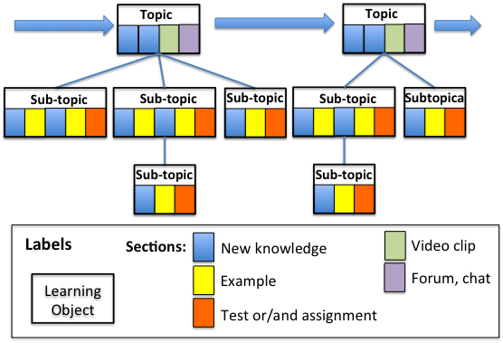
Figure 4.3 : Organization of an online lesson with learning objects, related to topics and sub-topics using sections of different kindsF
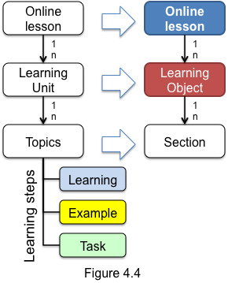
Figure 4.4 shows the structure of an online lesson, consisting of learning units and topics. Students learn each topic by using many small sub-steps: Learning-Example-Task. Mapping of learning units into learning objects (LO) and topics into sections, we get an online lesson. An online lessons contains a number of learning objects with one or more sections. Sections may provide now knowledge concepts, examples, assignments, tests, video clips, forums or chats. First order learning objects (or LO) contains topic sections or/and sub/topic sections. Each section is multimedia web page that contains textual information, video and audio clips, listings of Java codes and evaluation sections, such as different kind of tests and assignments. Authors of coursesorganize online lessons as hierarchy of learning objects related to topics and sub-topics. Online lessons, topics and subtopics are specified according to knowledge units and topics defined in BOM (the Body of Knowledge) of the SCHE Programming in Java. Hours on online lessons are rough estimation of durations of online lessons, but the focus is on lessons’ content, not in their durations.
Figure 4.5 specifies a learning unit and its steps. Authors decide the granularity of their learning objects. A learning units could be implemented with one learnimg objects, but, may be implemented with more that one learining units. Leraning sub-steps are usually implemented with sections (web pages).
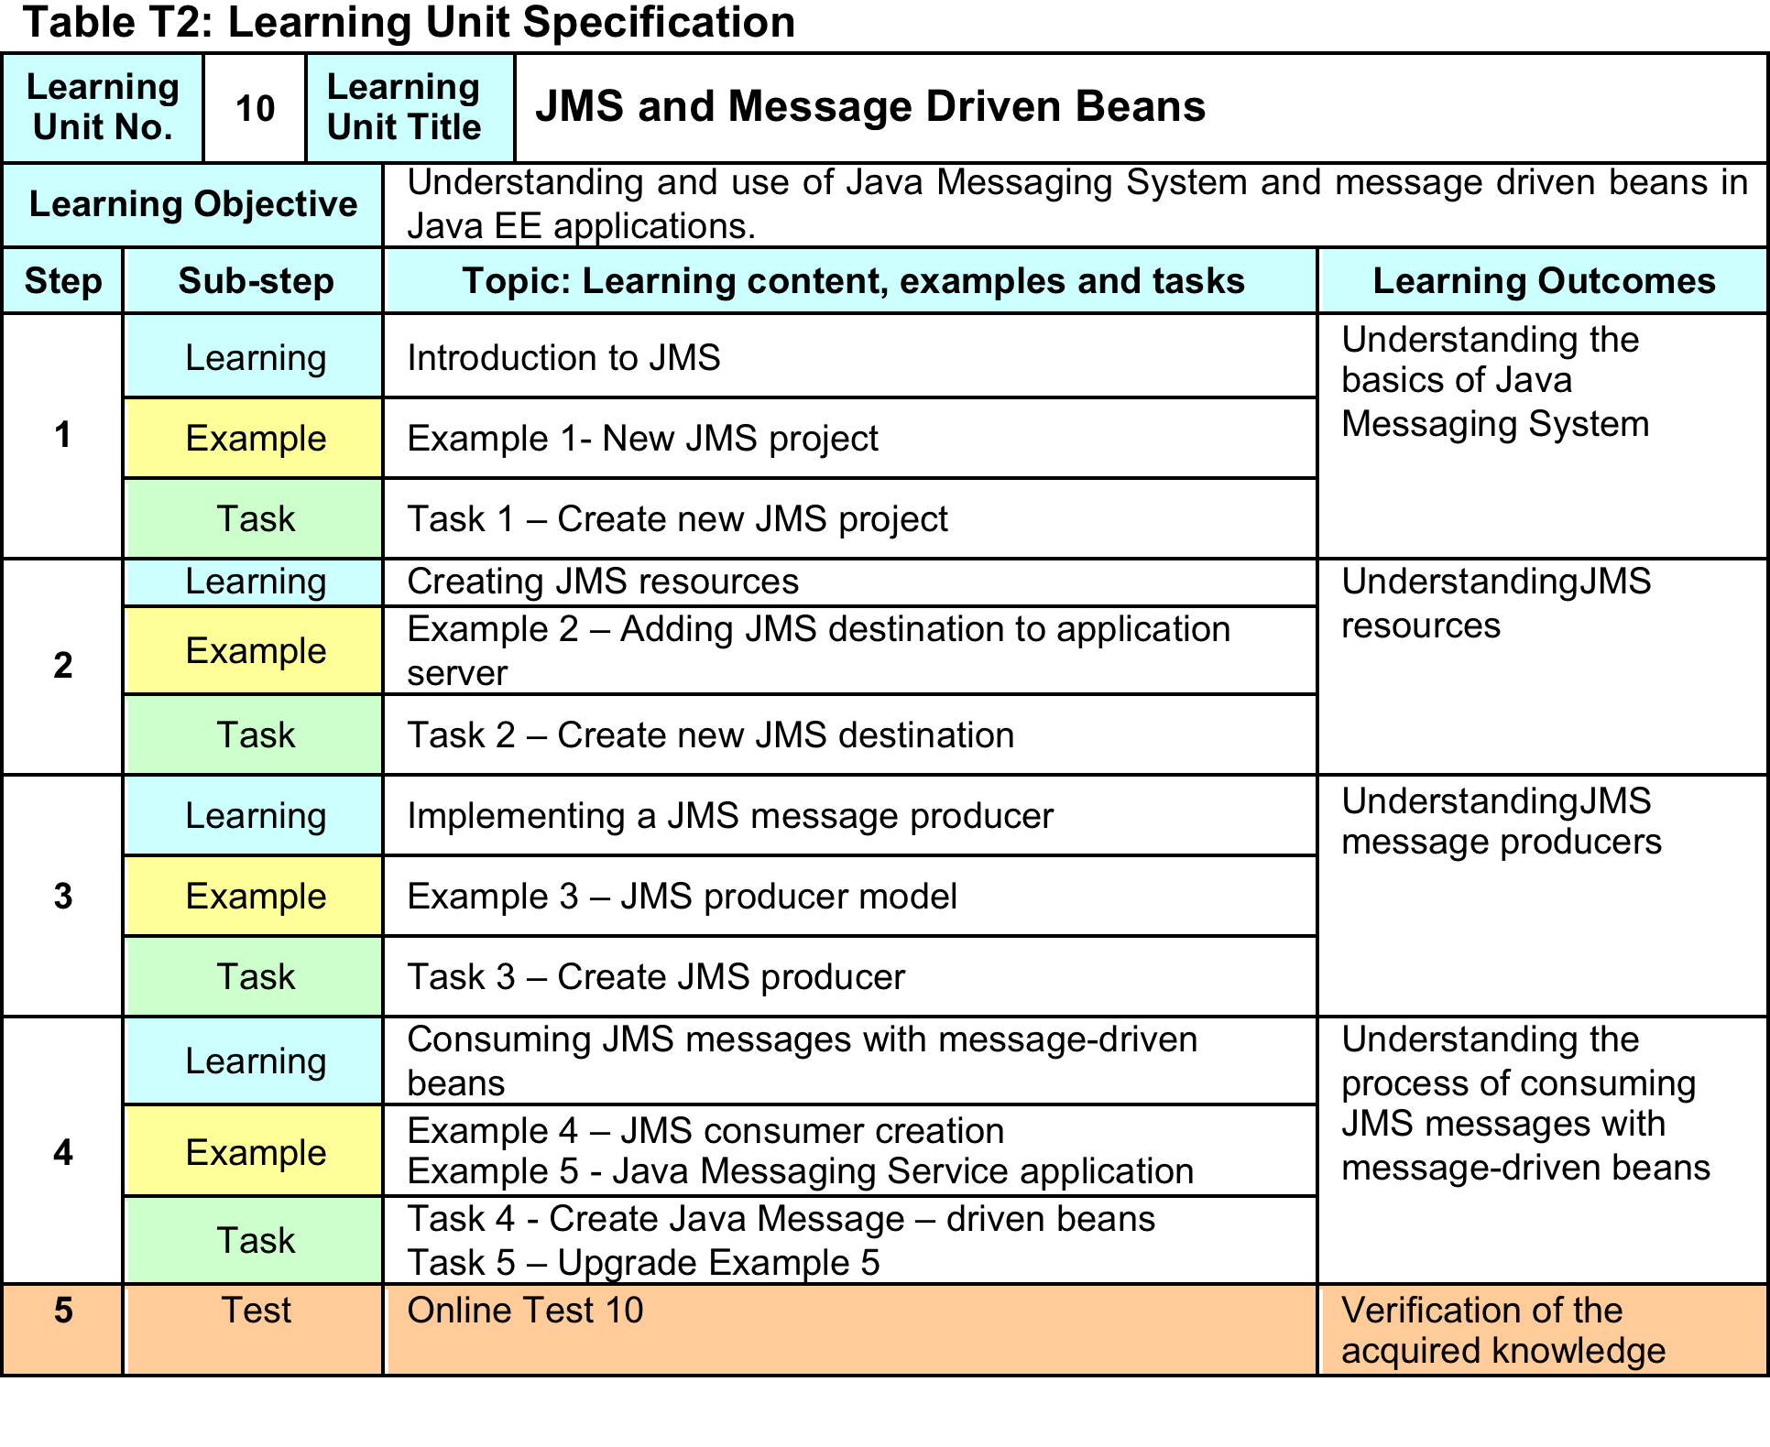
Figure 4.5 Specification of a learning units
Delivery of online lessons id managed by LAMS (Learning Activity Management System). It was chosen as it supports the concepts of learning objects and learning activities, organized in processes with branching. It is necessary for achieving a kind of personalization of e-learning, as different learning content may be offered to different students or group of students, based on their ability to learn and their knowledge levels.
Figure 4.6 shows one section (web page) created by mDita editor.

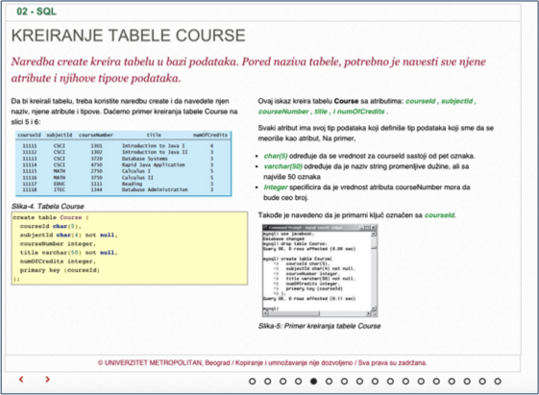
Figure 4.5: A section with learning content as shown to students by LAMS

The number of topics (first order LOs) may be different, depending of its content. The same is valid for topics and their sub-topics and sections. So, a course may have different number of lessons, with different number of learning objects for its topics, sub-topics and sections.
When planning the duration of each course, it is assumed that student can use online lessons provided by BMU e-Learning System, six day a week, and at least three learning hours per day (reading or watching video clips and listening the content of a lesson). Besides these three “learning hours”, it is expected that student spend one or more hours for doing tests and assignments related to a topic.

Plan for implementation of SCHE PROGRAMMING IN JAVA
The following Table 5.1 shows the plan for pilot implementation of SCHE PROGRAMMING IN JAVA, created according to the presented curriculum and adopted pedagogical approach.
