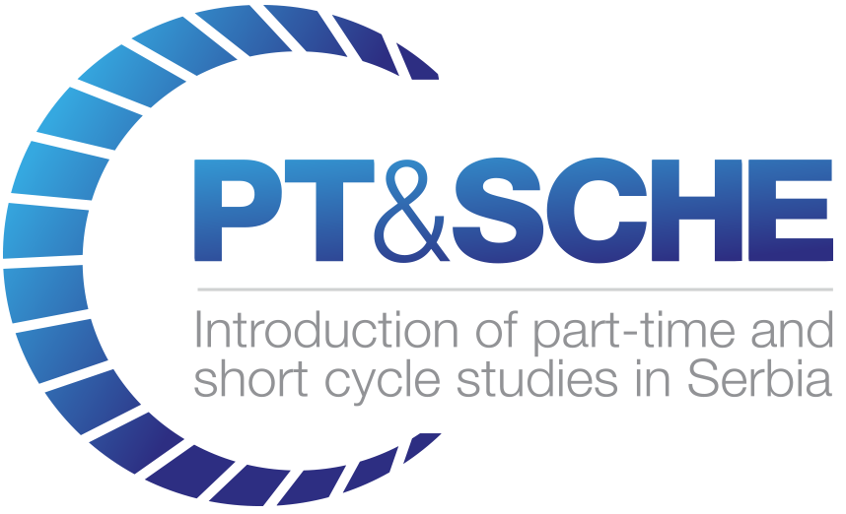

Partners Technical Report

D5.5.1

REPORT ON IMPLEMENTATION OF SCHE PROGRAM
PROGRAMMING IN JAVA

Project Acronym: | PT&SCHE
Project full title: | Introduction of part-time and short-cycle studies in Serbia
Project No: | 561655-EPP-1-2015-1-EE-EPPKA2-CBHE-SP(2015-3431/001-001)
Funding Scheme: | ERASMUS+
Coordinator: | TLU – Tallinn University
Project start date: | October 15, 2015
Project duration: | 36 months

Abstract | This report provides the information on developed curriculum of the pilot implementation of the online short-cycle in higher education (SCHE) program PROGRAMMING IN JAVA. Its aim is to provide the qualification of a Java Developer after 12 months with 600 online and F2F hours of education and training, It consists of 18 courses (11 core and 7 elective courses) and a Internship lasting two months. The students that successfully submit all assignments and projects for 12 courses and complete it two months internship, is awarded with a Certificate.  As a pilot program, the curriculum and organization of the SCHE program has been developed according to deliverables of  WP2. Development of legal frameworks for implementation for PT&SCHE
"The European Commission support for the production of this publication does not constitute an endorsement of the contents which reflects the views only of the authors, and the Commission cannot be held responsi­ble for any use which may be made of the information contained therein."

DOCUMENT CONTROL SHEET

Title of Document: | D5.5.1 Report on implementation of SCHE program PROGRAMMING IN JAVA
Work Package: | WP5. Pilot implementation of online PT & SCHE programs
Last version date: | 17.03.2019
Status : | Final
Document Version: | 1.0
File Name | D5.5.1 Report on implemented online SCHE PROGRAMMING IN JAVA at BMU
Number of Pages | 11
Dissemination Level | Institutional

VERSIONING AND CONTRIBUTION HISTORY

Version | Date | Revision Description | Responsible Partner
1.0 | 17.03.2019 | Writing final version of the report. | Dragan Domazet, BMU

TABLE OF CONTENT

1 Plan for implementation of SCHE PROGRAMMING IN JAVA 4
2 Selection and enrollment of trainees 6
3 Students’ results 6
4 Survey of trainees 7
5 Conclusions 9
6 References 10

REPORT ON IMPLEMENTATION OF SCHE PROGRAM
PROGRAMMING IN JAVA

Implementation Plan of SCHE Programming in Java
Table 1.1 shows all courses of SCHE program Programming in Java with their start days during the academic year 2017/18.

Table1.1. List of courses of SCHE program Programming in Java
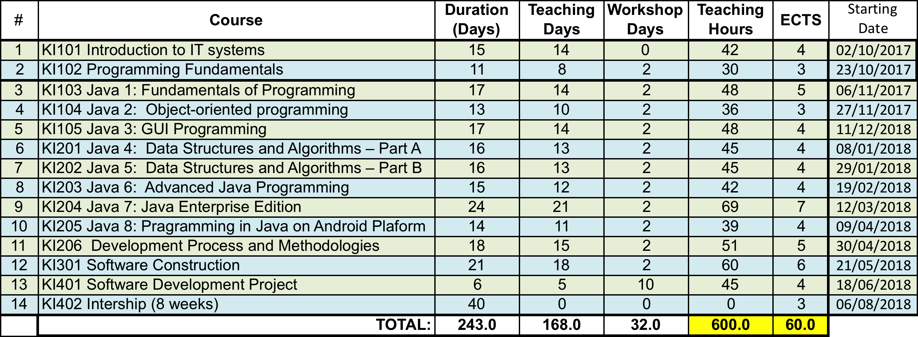

Table 1.2 shows the detail plan for pilot implementation of SCHE Programming in Java. All courses were realized online, but each had two F2F workshops (two days) with 2 hours of exercises in computer classrooms. Only the course Software Development Project had 10 workshops, as trainees had to do their joint project assignment working together in a computer classroom.
Students had six days per week, to read and view learning materials, and mostly tree weeks per course. Number of teaching days were determined with daily plan od 3 hours of online learning and 3 hours for additional reading learning materials (textual, videos, snippets with codes etc.) and for doing assignments (tests, homework). After training days, students had two days for F2F workshops. Last day (generally, on Saturdays) was planned for the exam.
Trainees had 9 months of training, one week for exams (not passed before), 3 weeks of summer holidays and 8 weeks of internship in software development companies.

Table 1.2 Teaching plan
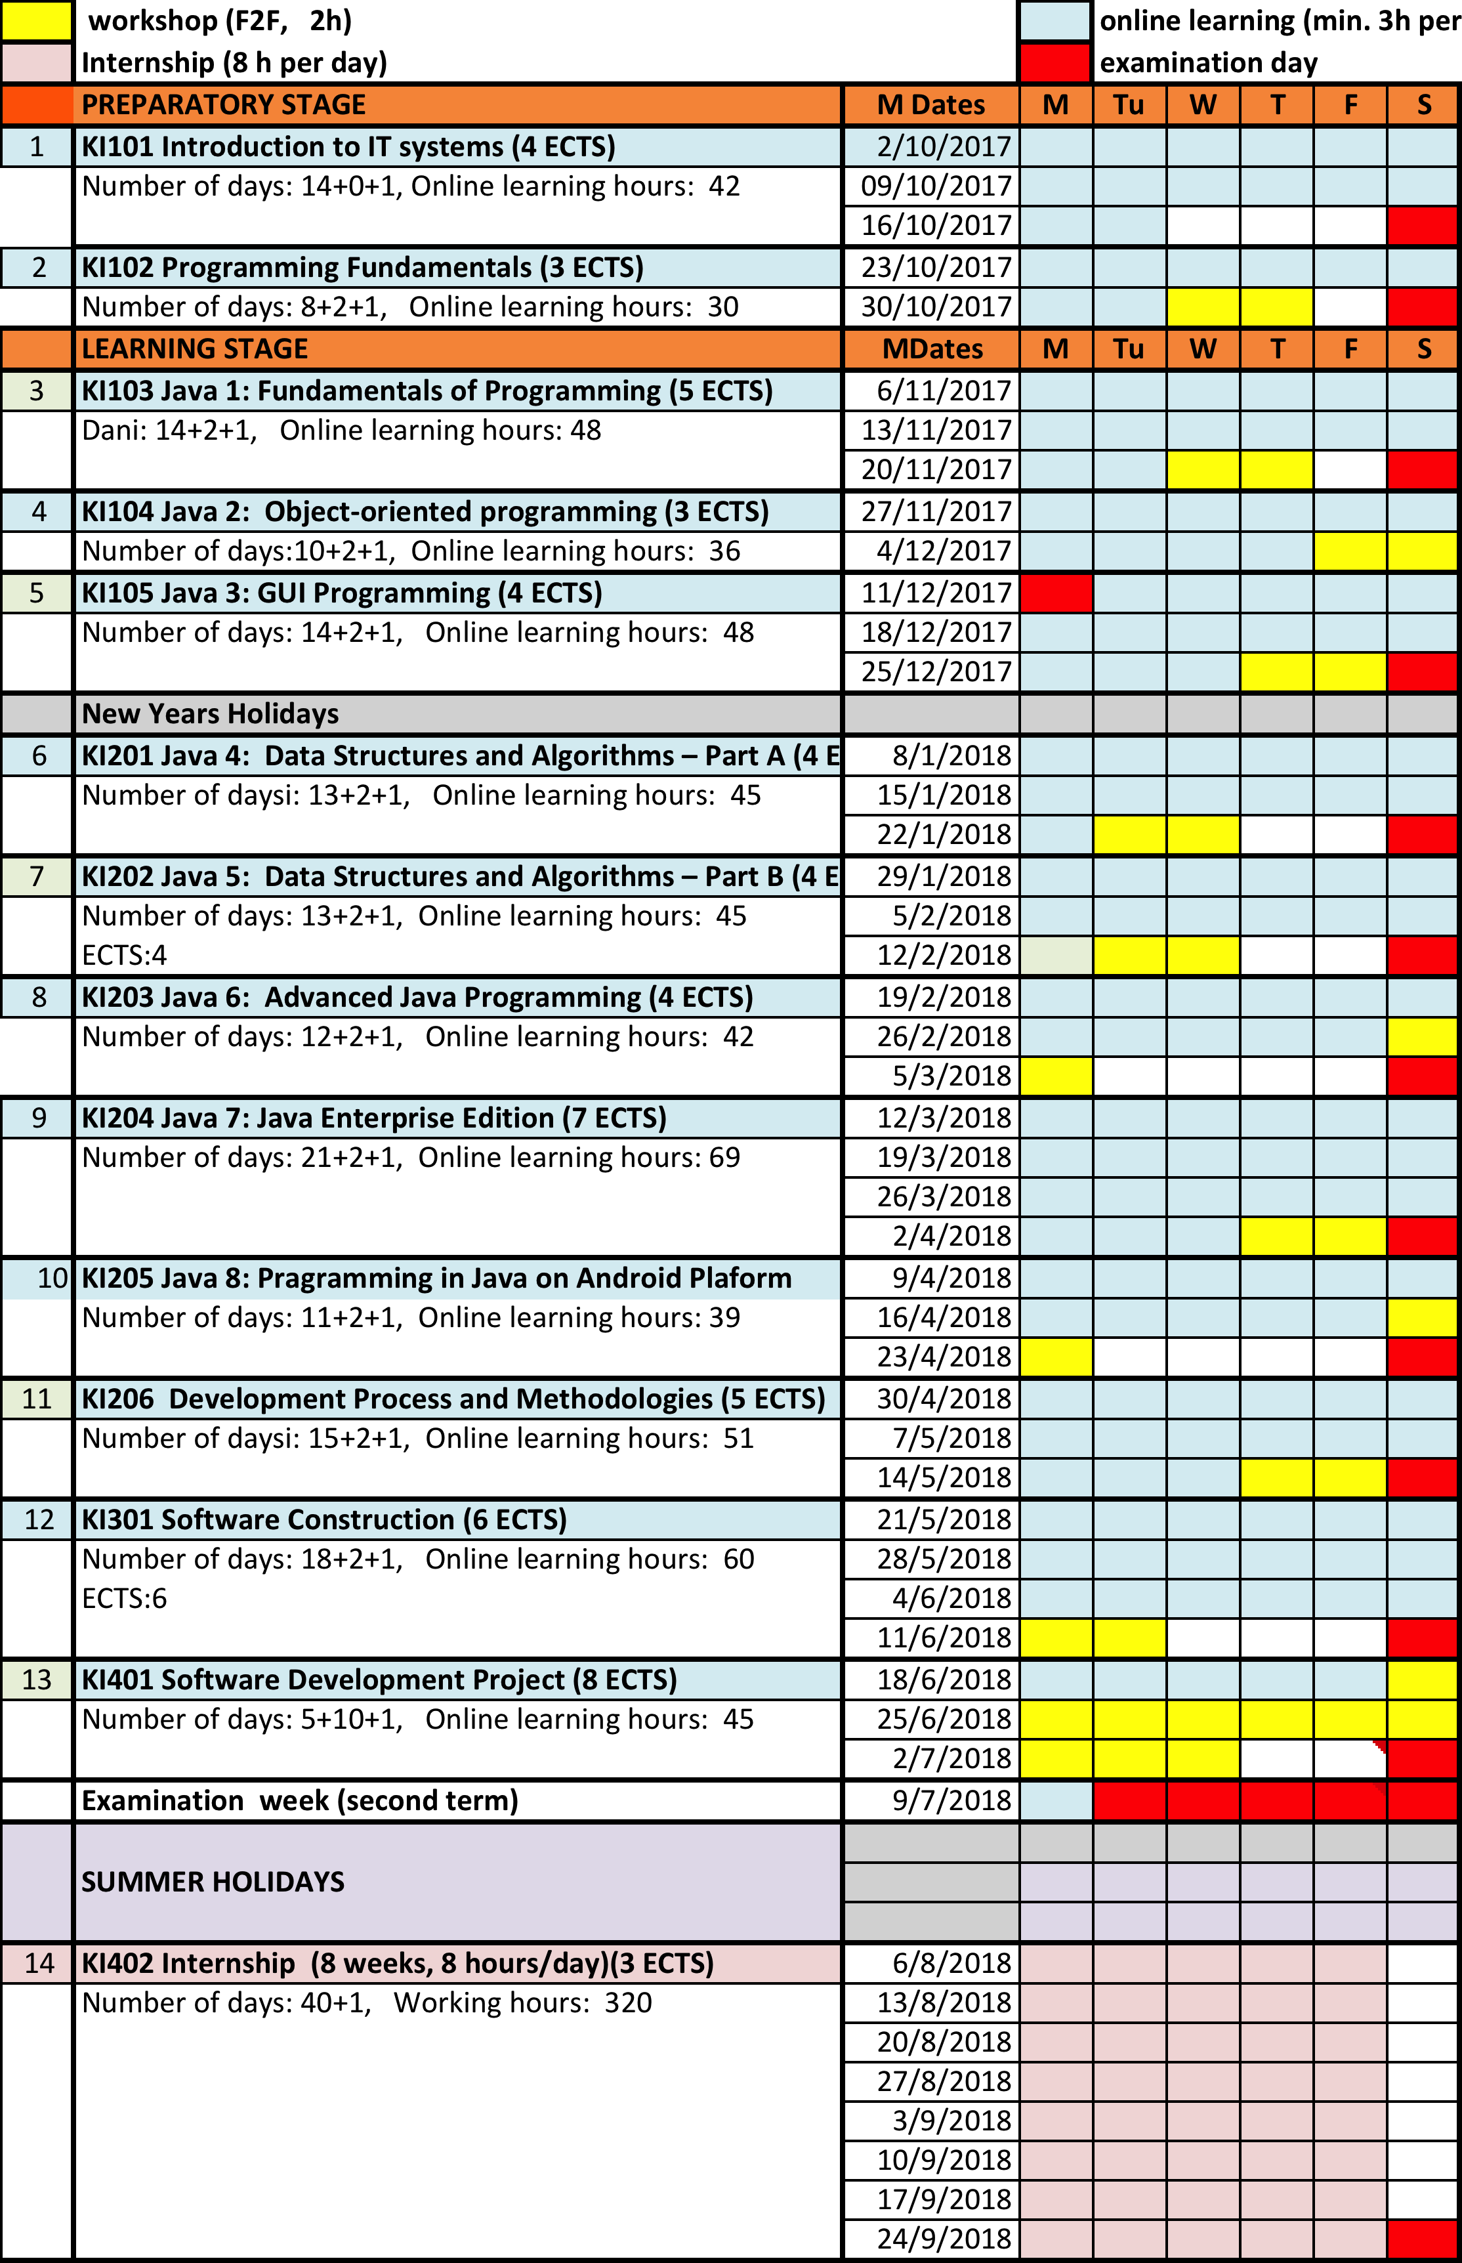

Selection and Enrollment of Trainees

BMU published two Student Enrollment Contests (in July and September 2017, see project web site). 550 candidates applied for the pilot programme planned for 10 trainees (see the list of candidates in project web side). A short list of candidates was created after implementing a selection procedure implementing selection criteria given in project web site. After testing and evaluating the candidates, the short list was created (see the project web site). The best 18 trainees were invited for final interview, to select 10 trainees. BMU and the enrolled trainees signed the contract. According to the contract (see the contract template in the project web site), trainees are exempt from tuition fees (its value is 2.000 EUR per trainee)

Students’ Results
During the pilot phase, through all courses, learning activities were logged in the eLearning system (LAMS v3.0) including: time spent on learning online materials, the number of solved tasks and assessments, as well as other interactions with the resources provided by the eLearning system. The information system of BMU (ISUM) tracks all marks and other data about progress of students by course, such as: number of points per tests and projects, the number of points scored in the exam and the final grade. 8 trainees are included who passed the entire training process are included in the process of evaluation (Table 3.1).
Five trainees dropped out at the beginning of the course. Their reasons for dropping out are of personal nature, so we will not take them into account during the analysis. It is important to note that at the time this paper was written (September 2018), only two students successfully passed all the exams in the first test period, and six more have to pass the correction exams. In order to analyze the relatively poor results in the first test period (only 25% successfully passed all exams), we analyzed the use of learning materials and other activities provided by the eLearning system in order to determine the extent to which the system was used and what resources were most used.
Comparing the time spent in learning and number of failed exams, it is evident that trainees T3 and T8 spent less time in learning from others who have fewer failed exams. In this part, it is very important to motivate students to use the e-learning system to a greater extent somehow.
Table 3.1 Time spent in e-learning by trainees
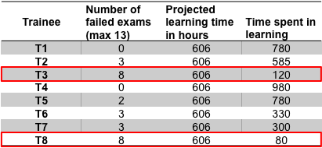
Finally, Table 3.2 shows the achieved results (in ECTS) of trainees of SCHE Programming in Java, enrolled 2nd of October 2017 with duration of 12 months. The results are taken on 11th of March 2019.
Table 3.2 Achieved results of students expressed with ECTS gained
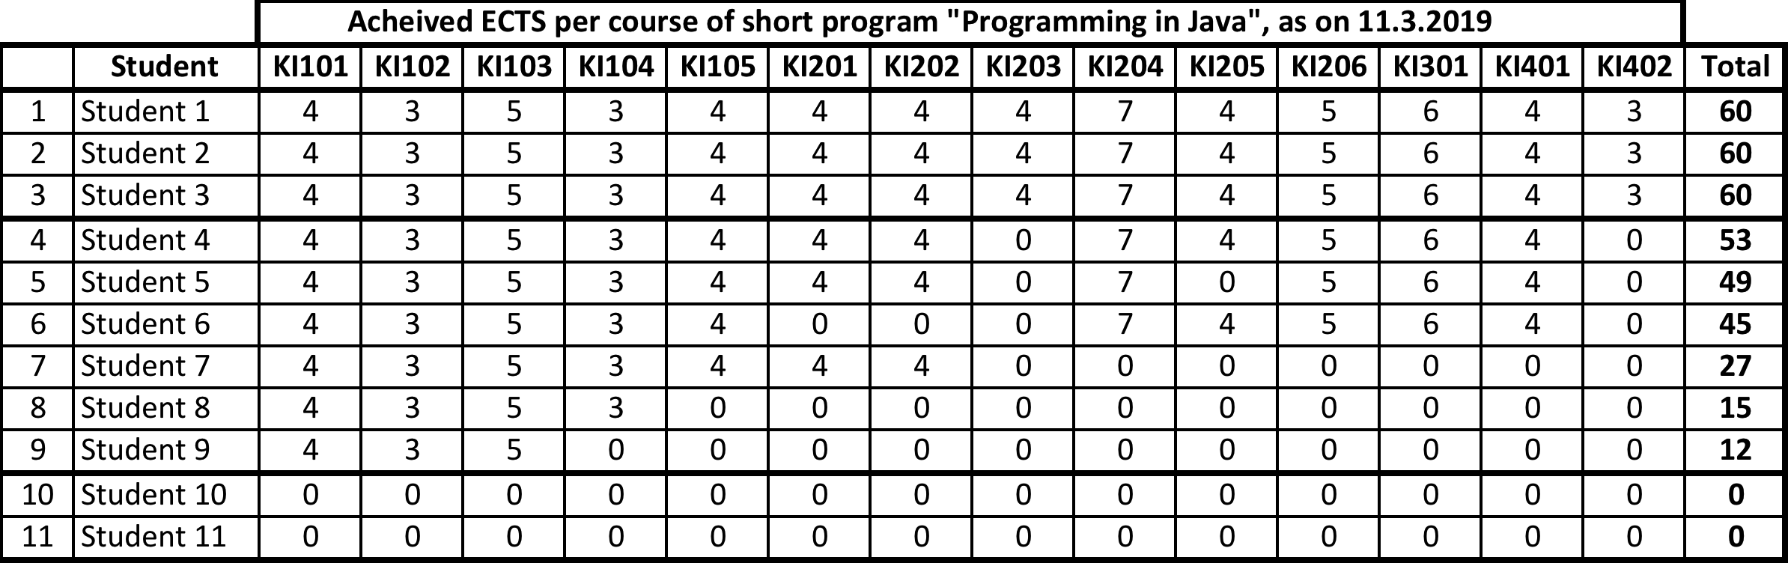
As it can be seen, only 3 of 11 trainees successfully completed the program on time, as they achieved 60 ECTS. Two trainees left the program at the beginning, and 3 more did it during the program. We expect that 6 of 11 trainees will pass al exams and will get the Certificate of Completing SCHE program Programming in Java.

Survey of Trainees
At the end of the evaluation, trainees were asked to complete a questionnaire shown in Table 4.1. Eight trainees responded and gave us their answers. Prior to the questionnaire, the participant had to mark the place where the workshops were held (Nis or Belgrade). We identified 5 trainees from Belgrade and three trainees from Nis.
Table 4.1 Trainee satisfactory questionnaire
QUESTIONS | MEDIAN ±STD
Q1: How satisfied are you with the work of the instructor during the duration of the course? | 4 ± 1.05
Q2: How satisfied are you with the realization of the course? | 4 ± 1.09
Q3: How satisfied are you with the level of knowledge that you acquired after completing the course? | 4 ± 1.11
Q4: How satisfied are you with the quality of teaching materials? | 4 ± 0.99
Q5: How satisfied are you with the organization of teaching materials by the "step by step" rule? | 4 ± 1.09
Q6: How much is the weight of the teaching material adequately distributed? | 3.5 ± 0.7
Q7: How satisfied are you with the LAMS system? | 5 ± 0.99
Q8: How satisfied are you with the use of the LAMS system in the form of tests and other learning activities? | 5 ± 0.48
Q9: To what extent are practical examples relevant to the material? | 4 ± 0.83
Q10: To what extent is it necessary to add materials to external resources? | 3.5 ± 0.83
Q11: If it is necessary to add resources to the teaching materials that would be? | /
Q12: Assess the adequacy of teaching materials in line with the latest IT developments | 3.5 ± 0.99
Q13: Assess the quality of the applicability of the acquired knowledge after the course passed? | 3 ± 1.11
Q14: How satisfied are you with the quality of the skype consultation? | 4 ± 0.93
Q15: How satisfied are you with the quality of mail consultation? | 4 ± 1.16
Q16: How satisfied are you with the quality of the workshops held during the course? | 5 ± 0.7
Q17: How satisfied are you with the number of classes scheduled for the course during the course? | 3 ± 0.86
Q18: Choose the model that you find most suitable for the realization of workshops (once a week, once in two weeks, half and at the end of the course, at the end of the course, other) | /
Q20: How satisfied with the compatibility of exams tasks and teaching material | 5 ± 0.7
Q21: Choose the model that you find most appropriate for the course that you attended (a longer course, a less intensive course or a more intensive course, a shorter period of time) | /
Q22: How satisfied are you with the support of the services of Belgrade Metropolitan University? | 4 ± 1.4
Q23: Which areas in this course do you consider necessary to be improved further: | /
Q24: Here you can write your suggestions, positive feedback or possible comments about the course | /

The questionnaire used the five-point Likert scale, ranging from the lowest point (1) to the highest (5), and additional essay questions. The questionnaire also provided an option to enter comments in order to allow students to give their suggestions and comments in the form of an open-ended question. Questions Q1-3, Q14-17 and Q22 had the goal to give answers to the questions about the satisfaction of the course, instructors, organization and support from BMU services during the course. Analyzing those results students expressed that are satisfied with instructors (Q1) 4 ± 1.05 (with the median 4.00) and with realization (Q2) and level of knowledge (Q3) that are acquired after completing the course (respectively 4 ± 1.09 and 4 ± 1.11 with the median 4.0). Also, the participants answered that they are satisfied with the method of carrying out Skype consultations (Q14), 4 ± 0.93 (with the median 4.0) and a little less mail consultation (Q15) 4 ± 1.16 (with the median 4.0), which is logical in relation to the type of course where it is sometimes difficult to explain the problem in writing. Trainees consider the workshops as very useful especially that they were organized in the traditional way in classrooms (Q16), 5 ± 0.7 (with the median 5.0), but consider that there is insufficient number of traditional classes of workshops that are necessary for an adequate understanding of the material (Q17), 3 ± 0.86 (with the median 3.0).
Some questions have a relatively high standard deviation due to the limited number of trainees, but at this stage we can conclude that trainees are satisfied with quality (4 ± methodology (4 ± 1.09) of learning materials thru Q4 and Q5, but also the trainees opinion is that the difficulty of the teaching material is not adequately distributed, 3.5 ± 0.7 (with the median 3.0), although they think that the examples (Q9) and exams (Q20) are relevant to teaching material 4 ± 0.83 (with the median 4.0). Trainees are absolutely satisfied with the BMU eLearning system (Q8) 5 ± 0.99 and they agreed that tests and other learning activities are of the great help in the learning process (Q9) 5 ± 0.48 (both with the median 5.0).
Lower satisfaction of the students is observed in the assessment of the conformity of learning materials with IT trends (Q12) 3.5 ± 0.99 and the applicability of the acquired knowledge after the course (Q13) 3 ± 1.11. We believe that such results may be due to insufficient practice of the participants and overloading information that needs to be channeled through practical work. Certainly, BMU has the task of further improving the teaching materials in order to increase the adequacy.
Students responded positively to “Programming in Java” short cycle program even through their comments through Q11, Q18, Q221, Q23 and Q24. Students considered the course to be useful and interesting:
- “Program is good”,
- “It's a good and interesting course”,
- “The program is very useful and provides a lot of practical knowledge for future employment.”
Additional comments and suggestions point to other questions of an essay questionnaire are generally similar and we can conclude that it is necessary to improve:
- “Everything is good, but there is a lack of traditional work in the classroom with instructors”,
- “More teamwork is needed”,
- “The course needs to be slower and less intense.”
Comment such as: ”Links to online resources would be helpful” indicate that learners also consider that additional online resources would be helpful if they were linked to LO.
Conclusions that can be made for the improvements of short cycle “Programming in Java” program from the given results are the following:
- Workshops must be organized more often and should be longer
- It is important to provide additional resources to LOs or assigned problems, such as Internet resources and
- The extent of the course and its intensity should be re-examined.

Conclusions
The achieved results might suggest that the curriculum was too demanding for trainees, but it will allow them to find a job of Junior Java Programmer more easily, as they have a needed set of knowledge and skills. BMU is aiming to satisfy employers and their expectations. Trainees must understand that programming is a serious and demanding job. They need to be ready for serious tests when future employers will ask them to demonstrate what they can perform.
Therefore, future analyzes and improvements will be directed at what is considered by trainees as a lack in the current implementation of program, such as the intensity of the course with the increasing of the work with instructors. The following modifications of the SCHE program Programming in Java are recommended:
- The curriculum is acceptable, but is demanding. Therefore, in order to reduce its intensity to trainees, the training period should be extended to 10 months, instead of nine months, as it was in the pilot implementation. Therefore, internship should be reduced to one month, as the overall duration of the program is restricted by the low to 12 months. Other option is to avoid time for summer holydays.
- F2F workshops should be organized one day per week with at least three hours, according to suggestions of trainees of our pilot implementation.
- The learning materials need to be updated every year according to latest technology trends. This a regular practice at BMU, but, it seams that some of learning objects were not modified accordingly.
- The program could be split into two smaller programs,as two parts of the SCHE program Programming in Java, such as Basic Java Programming and Advanced Java Programming. There are trainees that want to learn Java, not to become programmers, but just to use it on their existing jobs. Basic Java programming programme will be enough for them. Those trainees that plan to find a job of professional junior Java programmers, will enroll the second part of the SCHE programme – Advanced Java Programming. The official certificate , after completing the first part, of SCHE programme Programming in Java will be given only to trainees that successfully completed also the second part of the overall programme, i.e. Advanced Java Programming.
Java is a very complex technology and mostly used in development of complex, enterprise-level software systems. After talking to Java professional developers, we are pretty sure that the curriculum of the developed SCHE program Programming in Java, aiming to train future Java junior programmers , is appropriate, as it has been developed according to European ICT job profile specifications and according internationally recognized bodies of knowledge, such as SWEBOK 3.0 and Computer Science BOK of IEEE Computer Society.
Trainees that plan to find a job as junior Java developers need to know that they must learn appropriate knowledge and trained with required programming skills, in order to get a job. Software development companies test them in detail, implementing a trial working period of 4 to 8 weeks. They have to deliver what is expected to them. As BMU aims to satisfy needs of employers, the developed curriculum will not be modified aiming to be easier for trainees. There are such Java courses on the market, but BMU wants to offer its SCHE program Programming in Java as a serious and professional short programme, that provides what employers needs.

References
- Higher Education Act (2017), The Higher Educatio Act, Republic of Serbia, “, Službeni glasnik RS, No. 88/17, Belgrade, 29 September 2017.
- EQF (2008), The European Qualifications Framework for Lifelong Learning (EQF)“, European Commission, Office for Official Publications of the European Communities, Luxembourg, 2008, Available: https://www.eurashe.eu/. [Accessed: 24-Sep-2018].
- “European ICT Professional Profiles” (2017), CEN ICT Skills Workshop „European ICT Professional Profiles in action“, INTERIM REPORT, June 2017
- e-CF(2014), “The European e-Competence Framework (e-CF) version 3.0 – A common European Framework for ICT Professionals in all industry sectors. CWA 16234:2014 Part 1. © CEN, http://www.ecompetences.eu/e-cf-3-0-download/ [Accessed 10/03/19]
- Domazet (2017), Development of curriculum of the pilot online SCHE program PROGRAMMING IN JAVA, Deliverable 5.1.1, Partners Technical Report, Erasmus + project “Introduction of part-time and short-cycle studies in Serbia/PT&SCHE”, 20.07.2017, www.pt-sche.metropolitan.ac.rs
- The Foundation ICT BOK (2015), The Foundation ICT Body of Knowledge, Version 1, 22 February 2015, a report prepared for the European Commission, DG Internal Market, Industry, Entrepreneurship and SMEs by the Service Contract: e-Skills: Promotion of ICT Professionalism in Europe | No 290/PP/ENT/CIP/13/C/N01C011 prepared by Capgemini Consulting and Ernst & Young, https://ec.europa.eu/docsroom/documents/21342/attachments/1/translations/en/renditions/pdf
- SWEBOK 3.0 (2014), SWEBOK 3.0 – Guide to the Software Engineering Body of Knowledge, Editors Pierre Bourque, École de technologie supérieure (ÉTS) and Richard E. (Dick) Fairley, Software and Systems Engineering Associates (S2EA), IEEE Computer Society, https://www.computer.org/education/bodies-of-knowledge/software-engineering
- Computer Science Curricula 2013, Curriculum Guidelines for Undergraduate Degree Programs in Computer Science, December 20, 2013, The Joint Task Force on Computing Curricula Association for Computing Machinery (ACM) IEEE Computer Society, https://dl.acm.org/citation.cfm?id=2534860

