Partners Technical Report

Deliverable 5.5.2

Report on Pilot Implementation of the Part-Time Online Bachelor Program INFORMATION SYSTEMS

Project Acronym: | PT&SCHE
Project full title: | Introduction of part-time and short-cycle studies in Serbia
Project No: | 561655-EPP-1-2015-1-EE-EPPKA2-CBHE-SP(2015-3431/001-001)
Funding Scheme: | ERASMUS+
Coordinator: | TLU – Tallinn University
Project start date: | October 15, 2015
Project duration: | 36 months

Abstract | This report provides the information on the pilot implementation of the online part-time bachelor program INFORMATION SYSTEMS. The program provides 240 ECTS and may last up to 8 years, as it is dedicated to part-time students.They have to achieve min. 30 ECT per year.  .
"The European Commission support for the production of this publication does not constitute an endorsement of the contents which reflects the views only of the authors, and the Commission cannot be held responsi­ble for any use which may be made of the information contained therein."

DOCUMENT CONTROL SHEET

Title of Document: | D5.2.2. Report on pilot implementation of the part-time online bachelor program INFORMATION SYSTEMS
Work Package: | WP5. Pilot implementation of online PT & SCHE programs
Last version date: | 17.03.2019
Status : | Final
Document Version: | 1.0
File Name | D5.2.2 Report on pilot implementation of the PT online bachelor program Information Systems
Number of Pages
Dissemination Level | Institutional

VERSIONING AND CONTRIBUTION HISTORY

Version | Date | Revision Description | Responsible Partner
1.0 | 17.03.2019 | Writing the report after analysis of survwey and other implementation results | Dragan Domazet, BMU

TABLE OF CONTENT

1 Introduction 3
2 Selection and Enrollment of Students 4
3 Students’ Accademic Results After the First Year 4
4 Survey Results 4
5 Comclusions 4
6 References 4
7 Introduction 5
8 List of Courses 6
9 Enrollment of Students 8

Report on Pilot Implementation of the Part-Time Online Bachelor Program INFORMATION SYSTEMS

Introduction
Higher education institutions (HEIs) offer part-time programs to employed students who cannot attend regular face-to-face (F2F) lectures and tutorials. They usually offer evening or Saturday classes, or online courses. The major problem in Serbia was that employed students had no option to have special part-time programs, allowing them longer period for their studying. They had to get 60 ECTS per academic year as regular F2F students. Belgrade Metropolitan University (BMU) has been offering all its bachelor program in three learning modes:
• Traditional, F2F learning
• Online, or e-learning
• Blended learning (flipped classroom approach).
Online learning is the most appropriate and is used as the mode of learning by employed students. However, they complained that they couldn’t meet the requirements to earn 60 ECTS per year. In many countries, employed students have an option to choose part-time programs with 50% to 100% longer duration. The Government of Serbia agreed with the proposal of our PT&SCHE project to introduce part-time studies also in Serbia with the extended study period for employed students. Higher Education Act (2017) introduced for the first-time part-time studies to have only 30 ECTS or more per year. Thus, instead of studying 3 or 4 years in the first cycle (bachelor programs), part-time students now can study 6 or 8 years, if they are employed.
In order to evaluate effects of the introduction of part-time studies in Serbia, Belgrade Metropolitan University got the task within the PT&SCHE project to initiate the pilot implementation of part-time studies within its existing online bachelor program in Information Systems with 240 ECTS. In this paper we report our findings after the first year of program’s implementation.
The curriculum for PT bachelor program Information Systems is specified in D5.1.2 Development of curriculum of the pilot part-time online bachelor program INFORMATION SYSTEMS at BMU (see project web site)

Selection and Enrollment of Students
BMU published two Student Enrollment Contest, in July and September 2017 (see project web site) for enrolment of 16 online students for part-time online program Information Systems with 240 ECTS. 115 candidates applied for enriollment on the PT program Information Systems. They were ranked according to specified and published criteria (see project web site). The best ranked 24 canidates listed in the ranking list of all candidates (see project web site), are listed in ranking list of canidates to be interviewed (see project web site). Finally, top 16 candidates are selected and enrolled ofter interviews. The ranking list after interviews is given in project web site. BMU and enrolled students signed the contract (see project web site) specifying tha all students are exempt from paying a tuition fee for four academic years (240 ECTS), up to 8 years of studyng.

Students’ Accademic Results After the First Year
Table 3.1 presents achieved results of students from 1st of October 2017 until 11th of March 2019, i.e. after 17 months. The program was realized 100% online and the students had six exam terms to pass their exams.
Table 3.1 Academic results of students on PT online program Information Systems after 17 months
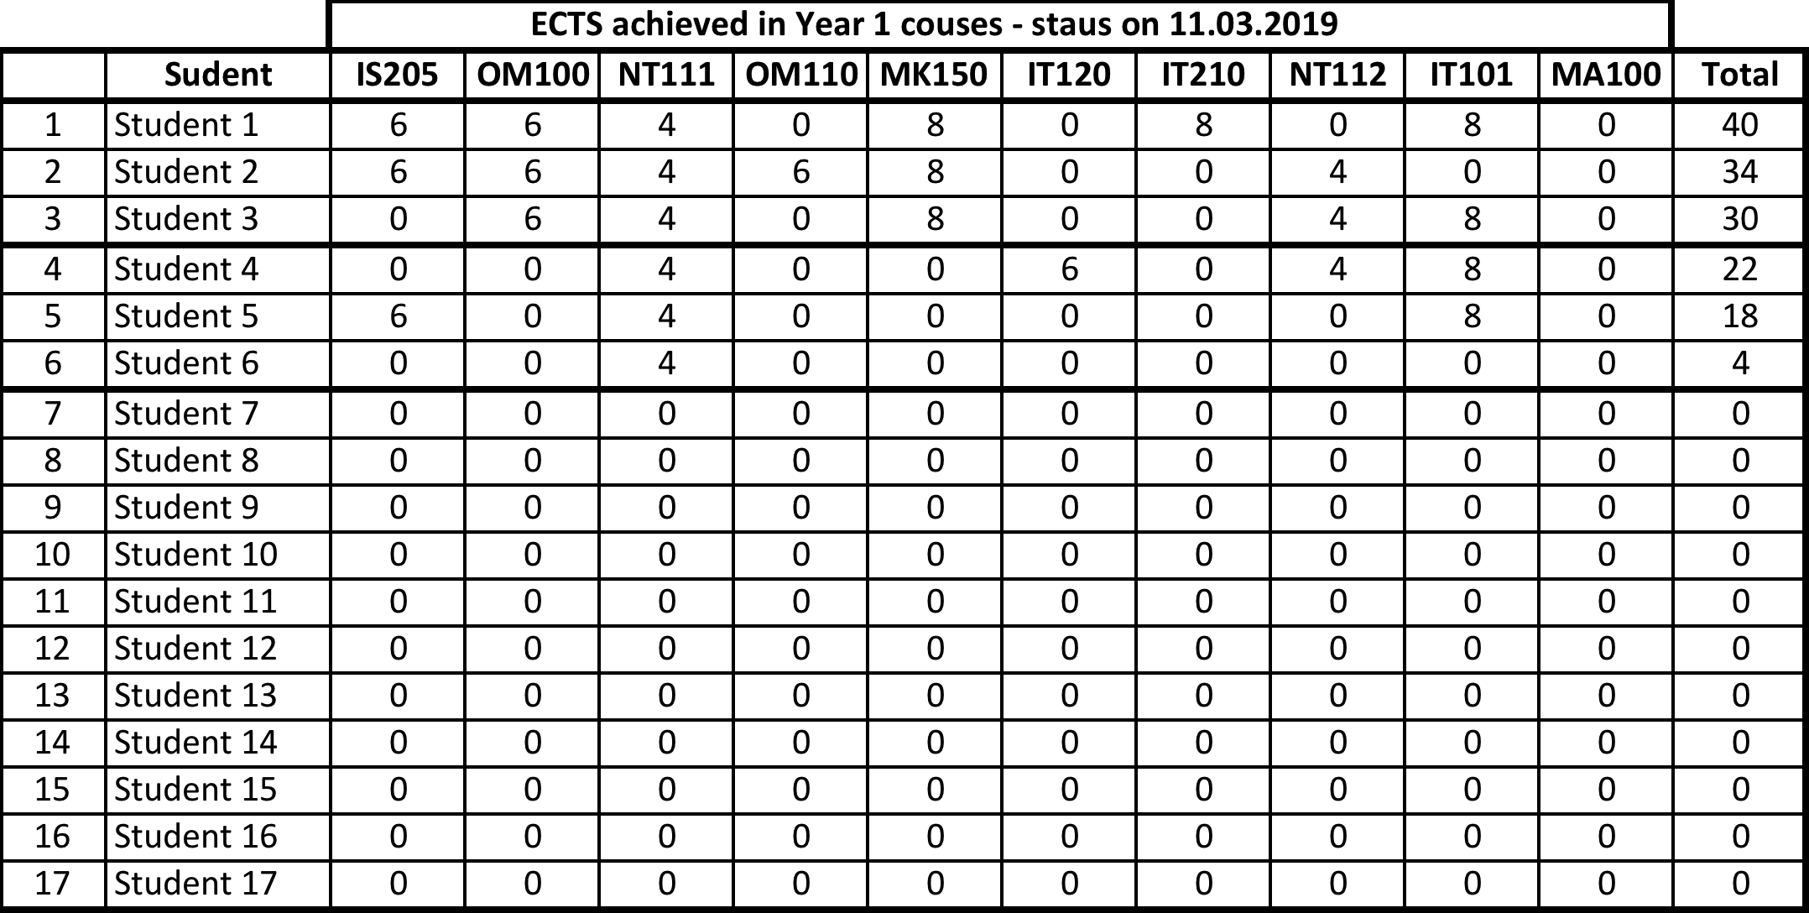

The students have two years to achieve 60 ECTS. So far only 3 of 17 students achieved 30 or more ECTS. Three more students had some success, but remaining 11 students had no success. They were not active. These results show that working students still have problems with their studies, despite the reduced yearly ECTS requirements (30 ECTS per year, instead of 60 ECTS per year). BMU will further analyze results and evaluate the program in more detail, and try to make it more affordable for online employed students, without reducing its academic quality standards. The emphasis will be on improvement of learning materials and communications with online students. We will also introduce optional F2F workshops on Saturdays, few times in each semester for all courses.
On the other hand, employed students should raise their motivation for studies and allocate more time for learning. We will organize focus groups to find out all problems they face and try to help them to solve them.

Survey Results
BMU distributed the questionnaire to students of the pilot BSc program in Information Systems enrolled in the academic year 2017/18. The questionnaire was distributed in March 2019.

Questions
Eleven students responded to the following questions of the survey:
- Do you think that the extension period of studies (60 ECTS for 2 years) is more appropriate for employed students? (Free textual answer is allowed)
- Do you agree that online modes of learning provide as equal knowledge as traditional, in-class (face-to-face) learning mode? (Free textual answer is allowed)
- Would you prefer to have evening classes and Saturday classes instead of online lessons? (Free textual answer is allowed)
- What are the most common obstacles that you faced during your online studies? (Free textual answer is allowed)
- What are the advantages of online learning in your opinion? (Free textual answer is allowed)
- Do you have adequate contacts with teaching and administrative staff as a support of your studies? (Free textual answer is allowed)
- Are you satisfied with your professors? Are you satisfied with your teaching assistants? (Free textual answer is allowed)
- Evaluate the quality of teaching materials. If necessary, give your explanation. (Marks from 1 to 5, 1-very unsatisfied, 5-very satisfied, students may give their explanation in a free textual form)
- How much are you satisfied with the organization of the learning material? If necessary, give your explanation. (Marks from 1 to 5, 1-very unsatisfied, 5-very satisfied, students may give their explanation in a free textual form)
- Is the learning material adequate for you to follow and does it have practical applications?
(Marks from 1 to 5, 1-very unsatisfied, 5-very satisfied, students may give their explanation in a free textual form)
- How much are you satisfied with the Learning Activity Management System (LAMS)? (Marks from 1 to 5, 1-very unsatisfied, 5-very satisfied, students may give their explanation in a free textual form)
- What are the shortcomings of the LAMS system? (Free textual answer is allowed)
- How do you evaluate given examples? Are they corresponding to the presented theoretical concepts? (Free textual answer is allowed)
- Do you recommend extension of the learning material with the external recourses? (Free textual answer is allowed)
- If you suggest the extension of the learning materials, can you propose such external resources? (Free textual answer is allowed)
- Are you satisfied with the quality of professor's office hours with professors and assistants? (Marks from 1 to 5, 1-very unsatisfied, 5-very satisfied, students may give their explanation in a free textual form)
- Are you satisfied with the support of BMU administration and its services? (Marks from 1 to 5, 1-very unsatisfied, 5-very satisfied, students may give their explanation in a free textual form)
- Please specify your suggestions, remarks or possible observations about the program. (Free textual answer is allowed)

Answers
The following answers were obtained by the students who participated in the survey:
- Do you think that the extension period of studies (60 ECTS for 2 years) is more appropriate for employed students?
7 answers: 6 positive and one negative.
  - Yes
  - Yes
  - Yes
  - We were unprepared for new lessons when we were near the end of courses
  - I agree with conditions and that they are appropriate for us.
  - Due to a lot of assignments, it is very difficult to obtain requested number of points.
  - I think that it is an adequate mode od studying for working students.
- Do you agree that online modes of learning provide as equal knowledge as traditional, in-class (face-to-face) learning mode?
10 answers: 6 positive, 2 negative and 2 have betting positions.
  - No.
  - It is difficult to say. Sometimes learning materials are not very clear, and, sometimes we cannot know what is essential. Both this issues would be solved with traditional learning.
  - Yes, mostly.
  - Yes in most of cases, demanding of student’s effort and wish to exercise and motivation to learn. In case of practical training, it is a little bit inadequate, but it is not irrecoverable.
  - Yes, totally.
  - No. Students without any prior knowledge from this field have no opportunity to ask questions during an online lecture.
  - Yes, if access to video archive of recorded lectures and exercises.
  - Yes
  - Yes
- Would you prefer to have F2F evening classes and Saturday classes instead of online lessons?
9 answers: 6 is not for F2F learning, 2 are for a combination of both, and only one would prefer traditional 2F2 learning.
  - No.
  - No.
  - The best would be a combination. When we have time to have the right to attend F2F lectures. I live outside Belgrade and work from 7 am to 9 pm, and it is impossible for me to attend F2F lectures.
  - No, online learning is more suitable for me.
  - No, due to my job, I cannot have traditional education.
  - It would not be convenient to me.
  - I would prefer to have tutorials and traditional teaching on weekends.
  - Yes.
  - No, as most employed students, I work in different shifts, including weekends.
- What are the most common obstacles that you faced during your online studies?
11 answers: Most comments are related to assignments that are time consuming and related to learning materials.
  - We have too many assignments as preconditions for exam.
  - This way of learning allows my procrastination (to postpone my obligations and duties), but this is my problem.
  - Reduced level of learning practical knowledge in compassion with traditional, F2F learning.
  - No obstacles. Unfortunately, I was ill, and was unable to study. Fortunately, we have now two years to accomplish 60 ECTS and I will have more opportunity to realize this.
  - None. All is accessible, and all milestones are achieved by the faculty.
  - Project assignments require a lot of time, so, besides working, I have little time for learning.
  - Lack of enough information in learning materials. It is not explained in more details.
  - Video clips are in English. Lack of an archive of recorded F2F lectures and exercises. Students are not informed about annual leaves and absents of professors and assistants, and may wait too long to contact them for review of their assignments.
  - Lack of more intensive communication with lecturers and other students.
  - Too many assignments and inappropriate distribution of their points.
  - Exercises in some courses are too big and are very time consuming, especially if there is an error in the learning material.
- What are the advantages of online learning in your opinion? (Free textual answer is allowed)
11 answers. Most student see the advantage of online learning in time organization and easier harmonization with their job obligations.
  - A student decides how fast he wants to study, determines his milestones for his assignments.
  - We can plan our time and can continue to develop our careers.
  - Free to plan our free time.
  - Without e-learning, I would not be able to work and study.
  - We can do other businesses and organize our learning time when it is suitable to us.
  - Opportunity to have total freedom to organize our learning time.
  - It is an advantage that we can harmonize our learning with other obligations.
  - This way of learning is the only one possible for some students. Thank you for allowing us to continue our education.
  - Flexibility. Extreme flexibility.
  - Only that you don’t need to be physically in the class.
  - Time management.
- Do you have adequate contacts with teaching and administrative staff, as a support of your studies?
10 answers: 7 are positive, 3 have some remarks, regarding contacts with teaching and administrative staff, or they had to wait too long for feedbacks from assistants.
  - Yes.
  - We waited for answers from assistants too long in some courses. Too little communication with professor and assistant related to learning. It is mainly related to evaluation of our assignments.
  - Yes.
  - Yes, it is adequate.
  - Yes. Students should be informed about annual leaves and absents of professors and assistants. They should get contacts of their replacements.
  - Not totally satisfied.
  - Yes.
  - Yes.
- Are you satisfied with your professors? Are you satisfied with your teaching assistants?
11 answers: 8 are positive and 3 have some remarks, mainly related to lack of enough communication with professors and assistants.
  - I am satisfied.
  - Very much.
  - I am satisfied.
  - Totally satisfied.
  - So far, I give maximum marks 10/10.
  - Only communication with e-mails, no other contacts.
  - All is professional.
  - I am very satisfied. All respect to professors and assistants.
  - So/so, something between positive and negative experience. I didn’t like that I had to contact a person to get some materials, but I didn’t get instructions how to contact her. If we discuss different topics for term papers, we should get a list of all topics in advance.
  - Very much.
  - Mark 4 of 5.
- Evaluate the quality of teaching materials. If necessary, give your explanation.
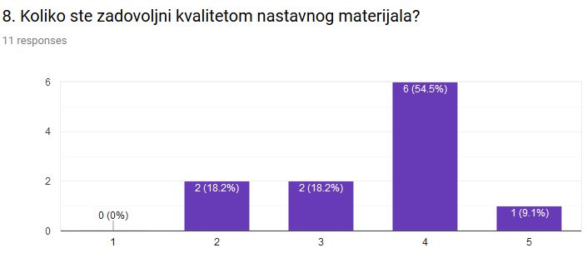
Figure 1.
In textual comments, students mostly have complained regarding technical aspect of learning materials (textual errors, or wrong use of terminology and translations). Here are some of the responses:
  - In case of some IT courses, learning materials are too short and incomprehensible. To do assignments, we need to search Internets to find appropriate explanations.
  - I some cases, learning material is not well written, and is difficult to identify what is important what is not.
  - I would like more practical examples that the theory, but I know that both are necessary.
  - Much of the learning material is not structured appropriately and, in some cases, use wrong translations. Some are written for more advance students. Too much theory, without practical examples. We need exercises for exams.
  - Without a prior knowledge, it is hard to learn from the learning materials.
  - In the learning materials of some IT courses, there are errors and we need to have consultations with teachers to overcome them. It advisable to have a video archive of F2F lectures and tutorials.
  - There is an imbalance between the learning materials and assignments in some cases.
- How much are you satisfied with the organization of the learning material? If necessary, give your explanation.
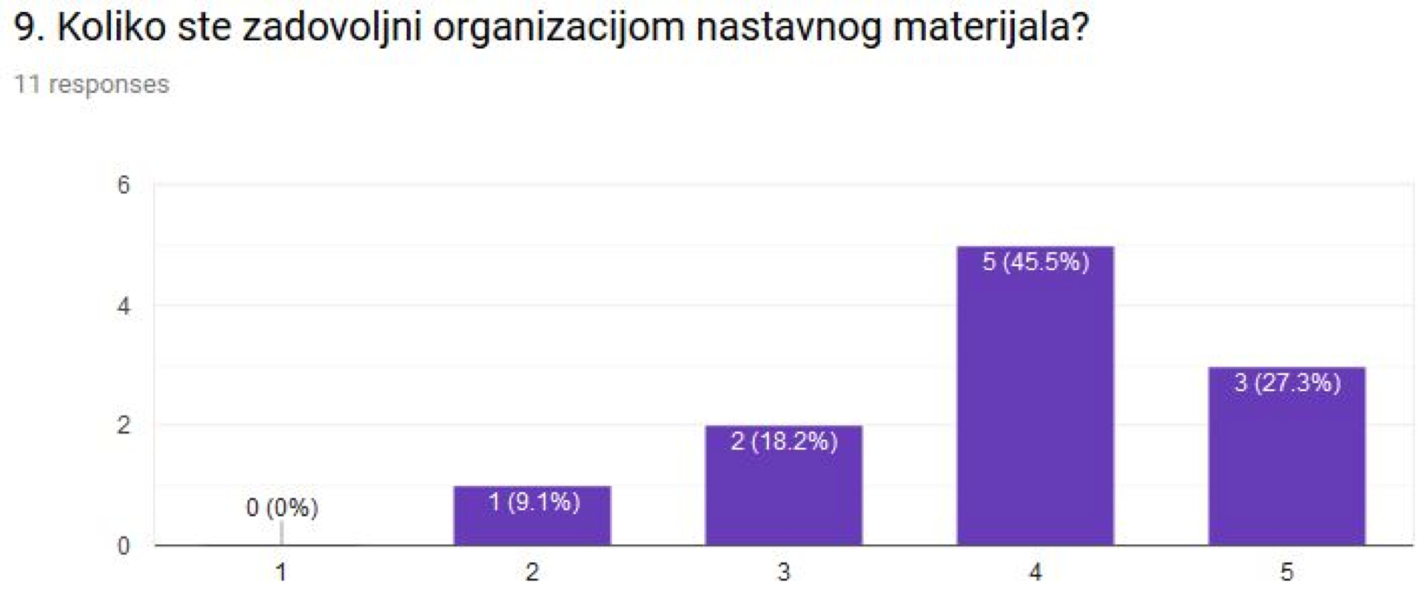
Figure 2.
There was only one comments regarding this question: “The same reason as given above”.
- Is the learning material adequate for you to follow and does it have practical applications?
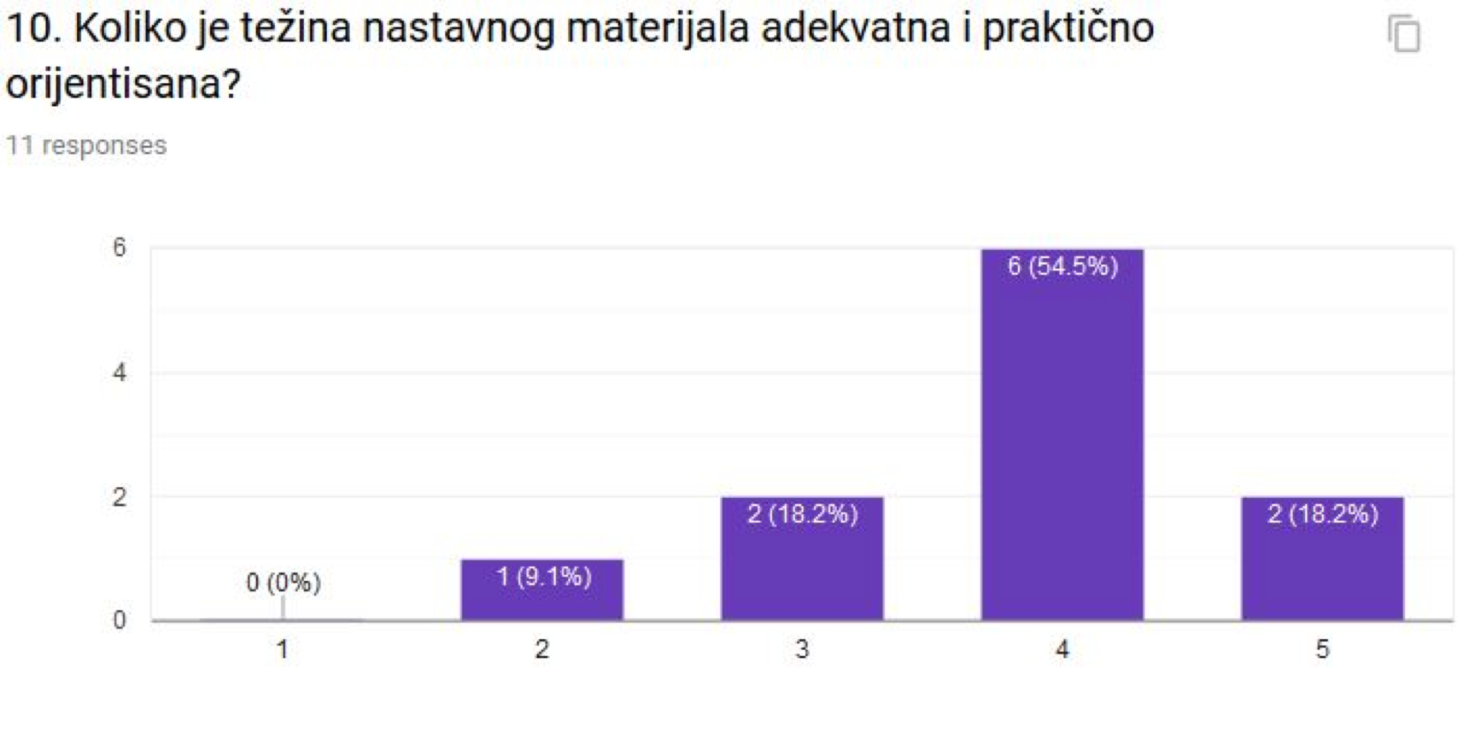
Figure 3.
Only few descriptive answers were given:
  - We are in Year 1 of the program. I believe the practicality will be higher in the years to come.
  - In most of courses, how to practically do something was poorly explained. Problems for individual exercise were given without any explanation how to solve them, and we even do not know if we solved them properly.
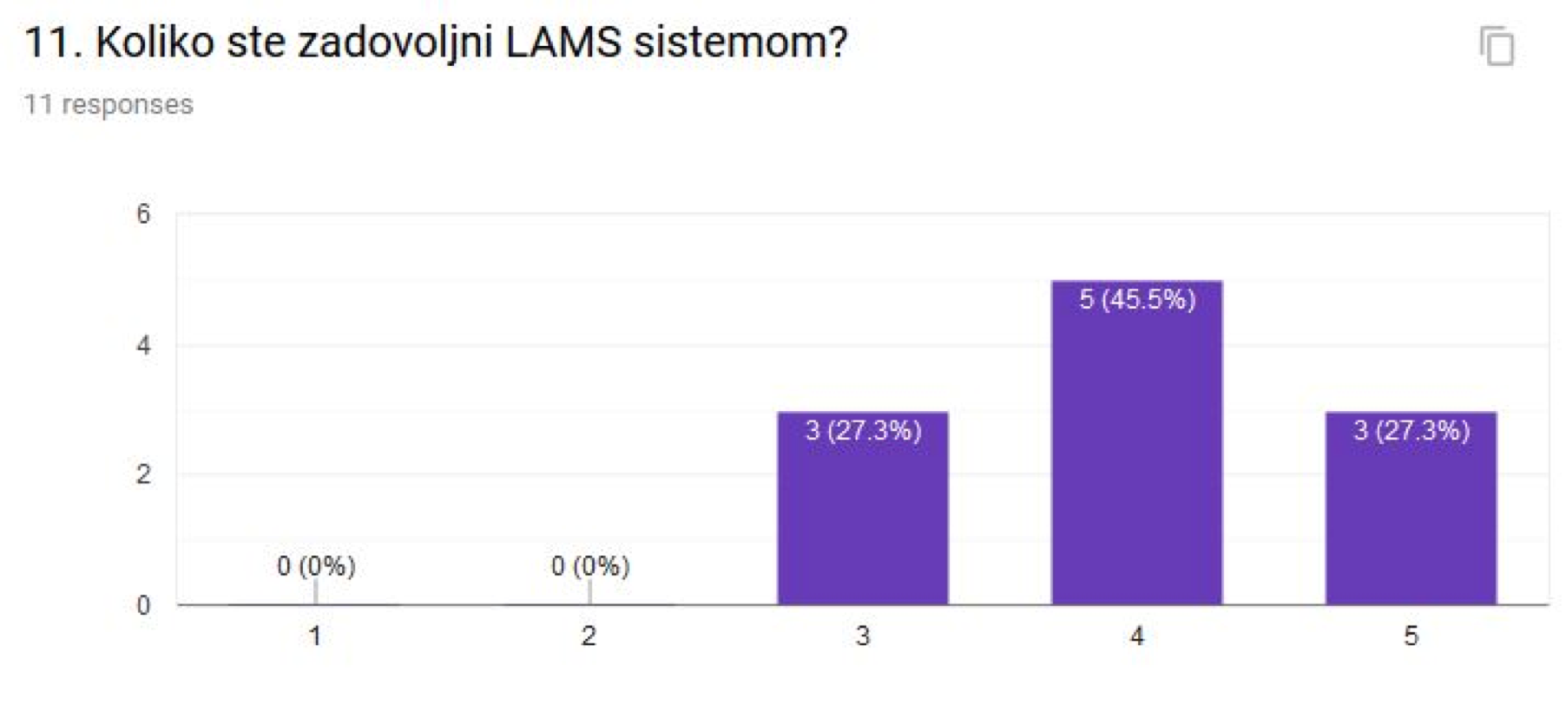
- How much are you satisfied with the Learning Activity Management System (LAMS)?
Figure 4.

Only four comments were given:
  - LAMS is working slowly. Its frame is small in relation to the screen. PDF version of the material is more convenient, but its format is not the best.
  - At the beginning of each semester the learning material is not provided. It should be prepared earlier and available to students at the start of the semester.
  - A user guide is missing.
  - There are no video materials for F2F lectures.
- What are shortcomings of the LAMS system?
7 answers:
  - Too slow. Lesson’s frame is small in relation to the space available.
  - I don’t like that tests are part of the lecture. It is better that they are separate from the lecture.
  - I haven’t noticed any shortcoming.
  - No shortcomings. The learning material is available, and that is important.
  - I haven’t noticed shortcomings.
  - The learning material is not accessible at the beginning of semester.
  - Additional material is separated from the PDF version of the lecture and I cannot print it or to download it. It is hard to read from the screen.
- How do you evaluate given examples? Are they corresponding to the presented theoretical concepts?
Only one answer is negative. Others are or mainly positive, or with some comments.
  - Partially.
  - I don’t know how to answer correctly
  - They are appropriate.
  - It depends on the courses. Mainly they are adequate.
  - To the great extent.
  - Not sufficiently.
  - As far as I noticed, most of the lectures have appropriate examples.
  - We can notice that a great effort was given for preparation of the learning materials and practical example are very appropriate.
  - They are OK.
  - There are sometimes significant differences between different courses.
  - I found many mistakes in exercises, so I had to use additional literature.
- Do you recommend extension of the learning material with the external recourses?
Five students think that the materials should be extended, while three of them think that it is not necessary, and the other three have different opinions:
  - Partially.
  - I don’t know to give adequate answer.
  - It is desirable for some of courses.
  - In case of programming courses, it would be nice to have resources that maps current market needs and more practical examples.
  - There is no need. If I need something more, I can easily find in on the Internet.
  - It is very necessary, especially with practical examples.
  - It would be useful if we could use the textbook from the library.
  - It would be sufficient to use video archive, as the lively word of the professor is irreplaceable.
  - I think that it is not necessary.
  - Probably a little more. It depends on each student.
- If you suggest the extension of the learning materials, can you propose such external recourses?
These are the given answers:
  - I have no answer.
  - I could not give any adequate answer.
  - In case of IT courses, it is desirable that a video clip with professors detailed explanations are attached to each lesson. Textual materials are not sufficient.
  - Additional materials are already available to those who want to learn more, for instance with MOOCS such as EdX, courser and similar. Probably some part of these materials could be used in our lessons.
  - It is not necessary.
  - More practical exercises.
  - More literature, more examples.
  - Video archive solves most of problems.
  - It is not necessary.
  - Video tutorials, for example.
- Are you satisfied with quality of consultations with professors and assistants?
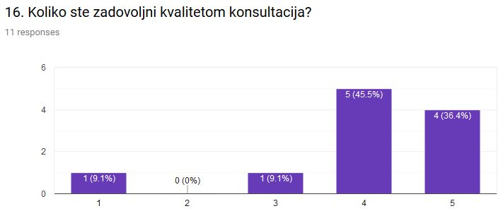
Figure 5.
Only two comments were given:
  - I had only few mails regard to some given problems that were not explained clearly. In general, I work all individually and alone.
  - Sometimes communications via mails are confusing. As I am living in Belgrade, I suppose that there is not a problem for us to come to professor’s office hours.
- Are you satisfied with the support of BMU administration and its services?
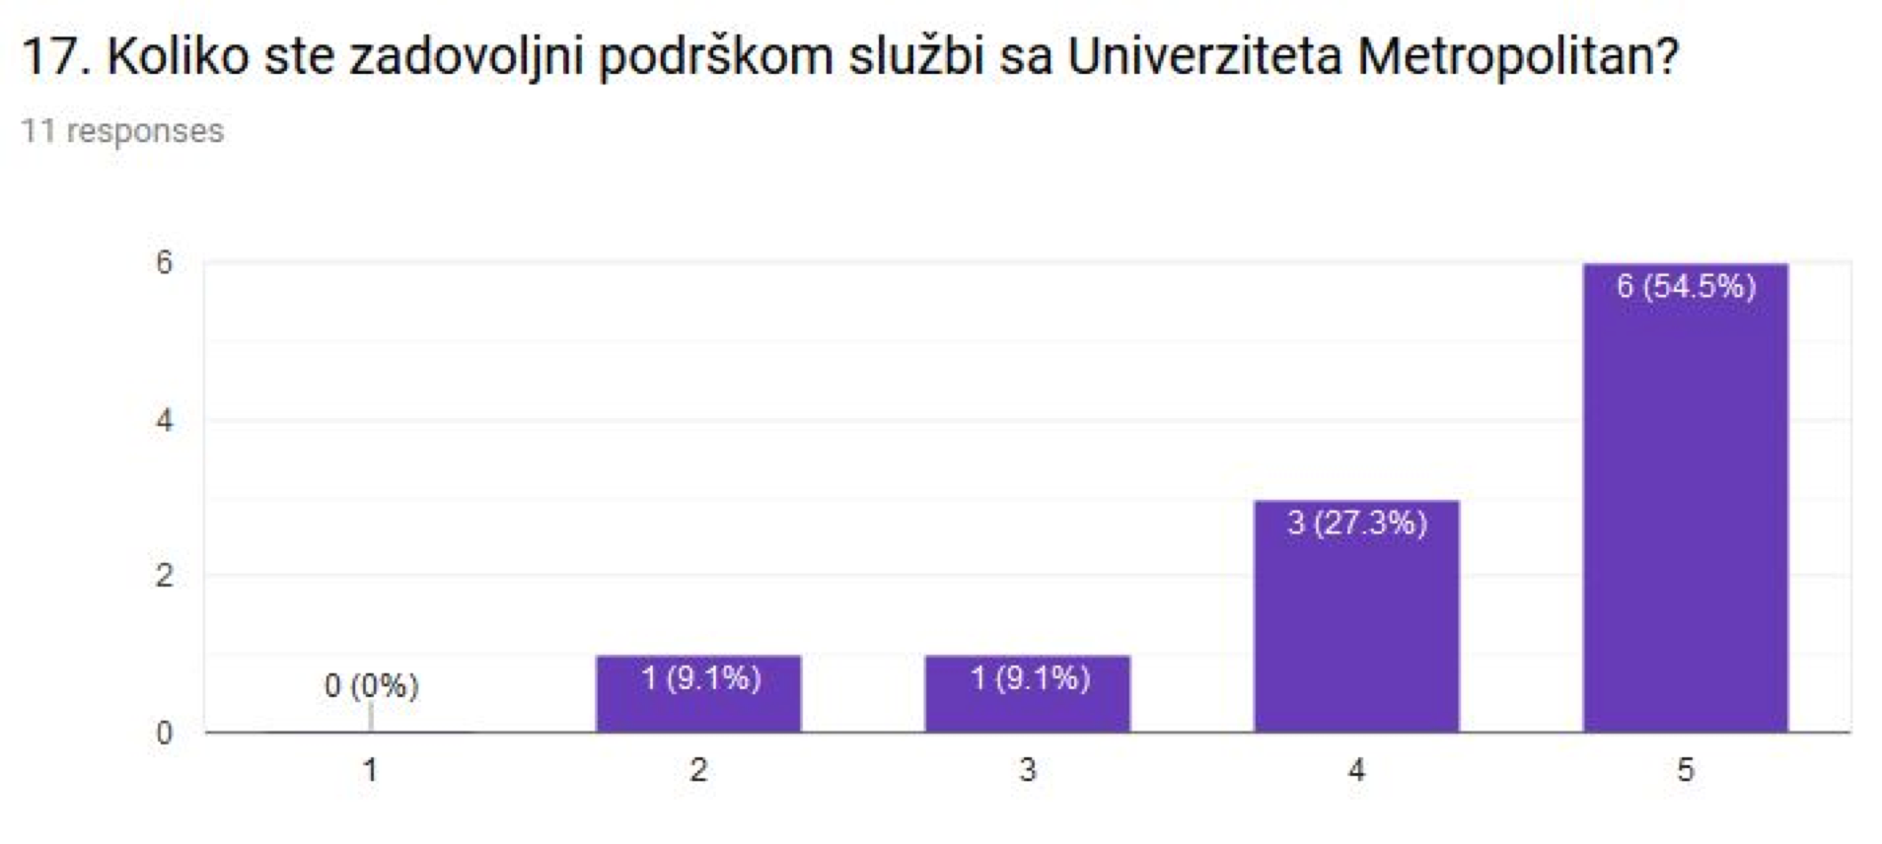
Figure 6.
Only one comment was given.
  - The Office of Student Affairs sometimes needs too long to respond to students’ mails. The procedure of registration of marks is too long and does not correspond to employees and students who live outside BG
- Please specify your suggestions, compliments or possible observations about the program.
  - .
There are too many assignments. Some of them require a lot of work and they bring us only one point. The program is officially prepared for employed students, but I really do not know where this person should be working and that he will get to do all that.

Conclusions

In general, employed students are very satisfied with the possibility to study while working. They prefer online mode of learning to F2F evening classes. Online learning gives them the flexibility to organize their time for learning. Extended duration of their studies, i.e. the requirement for 60 ECTS for two years, instead for one year, as it used to be, is very welcomed. There are proposals for implementation of some forms of blended learning, so that online students can attend also F2F regular lectures or to have some F2F classes during weekends. There is a proposal that an introduction of all courses should be organized F2F at the beginning of each semester.
Most of students complains are related to some aspects of the specific pilot program, and are not related to regulations for part-time studies. Typical complains are as follows:
- Too many assignments, requiring a lot of time
- Learning materials in some courses are of poor quality and need to be improved.
- More practical examples should be given and give exercises for individual work should have some explanations and instructions.
- Use of archive of recorded F2F regular lectures would help students to better understand some topics
- More interactions with professors and assistants, as well as with other students is recommended.
These are useful comments and recommendations, and BMU will try to implement some of the given proposals in order to adopt the program and learning process to be more suitable to employed students.
The evaluation of the pilot implementation of the part-time program confirms that the legislation of part-time studies as specified in Higher Education Act (2017) may be appropriate and suitable for part-time employed students, but it is not enough. Other preconditions must be accomplished. Achieved academic results of students in our pilot PT program are not satisfactory and further elaboration is necessary. Most of students showed no interest to study as expected.

References

- Higher Education Act (2017), “Higher Education Act”, Republic of Serbia, No. 88, 29.9.2017, Official Gazette of the Republic of Serbia, No. 88/2017
- Deliverable 5.1.2 (2017), “Development of curriculum of the pilot part-time online bachelor program in INFORMATION SYSTEMS”, Deliverable 5.1.2, Erasmus+ Project “Introduction of part-time and short-cycle studies in Serbia” (PT&SCHE), 11.07.2017, www.pt-sche.metropolitan.ac.rs

Deliverable 5.5.2
Report on pilot implementation of the part-time online bachelor program INFORMATION SYSTEMS

Introduction

Higher education institutions (HEIs) offer part-time programs to employed students who cannot attend regular face-to-face (F2F) lectures and tutorials. They usually offer evening or Saturday classes, or online courses. The major problem in Serbia was that employed students had no option to have special part-time programs, allowing them longer period for their studying. They had to get 60 ECTS per academic year as regular F2F students. Belgrade Metropolitan University (BMU) has been offering all its bachelor program in three learning modes:
- Traditional, F2F learning
- Online, or e-learning
- Blended learning (flipped classroom approach).
Online learning is the most appropriate and is used as the mode of learning by employed students. However, they complained that they couldn’t meet the requirements to earn 60 ECTS per year. In many countries, employed students have an option to choose part-time programs with 50% to 100% longer duration. The Government of Serbia agreed with the proposal of our PT&SCHE project to introduce part-time studies also in Serbia with the extended study period for employed students. Higher Education Act (2017) introduced for the first-time part-time studies to have only 30 ECTS or more per year. Thus, instead of studying 3 or 4 years in the first cycle (bachelor programs), part-time students now can study 6 or 8 years, if they are employed.
In order to evaluate effects of the introduction of part-time studies in Serbia, Belgrade Metropolitan University got the task within the PT&SCHE project to initiate the pilot implementation of part-time studies within its existing online bachelor program in Information Systems with 240 ECTS. In this paper we report our findings after the first year of program’s implementation.

List of Courses

The Bachelor of Science programme in Information Systems provides 240 ECTS and is now offered in two options regarding duration:
- Normal duration of 4 years (60 ECTS per year) for regular students and traditional learning mode (F2F).
- Extended duration (up to 8 years, min. 30 ECTS per year) for part-time and online students who are employed.
Table 2.1 shows the list of all core courses in this program, while Table 2 shows the list of ITS elective courses.

Table 2.1 : List of courses of BSc program Information Systems

Sem. | BSc INFORMATION SYSTEMS (240 ECTS, 4 YEARS) | ECTS | Lecture hours | Tutorial hours
1 | IS205 Information Systems Fundamentals | 6 | 2 | 2
 | IT101 IT Fundamentals | 8 | 2 | 3
 | MK150 Management Fundamentals | 8 | 3 | 2
 | OM100 Introduction to Operations Management | 6 | 2 | 2
 | NT111 English | 4 | 3 | 0
2 | IT120 Application Development | 6 | 2 | 3
 | OM110 Analysis and Design of Business Processes | 6 | 2 | 3
 | IT210 IT Systems | 8 | 2 | 3
 | MA100 Mathematics for Managers | 6 | 2 | 3
 | NT112 English 2 2 | 4 | 3 | 0
3 | IT350 Databases | 8 | 3 | 3
 | MK110 Business Economics | 8 | 3 | 3
 | MA272 Business Statistics with Probability | 8 | 2 | 3
 | NT213 English for IT | 4 | 3 | 0
4 | IT270 IT Infrastructure | 8 | 2 | 3
 | IT370 Human-Computer Interaction | 8 | 2 | 3
 | MG150 Business Finances with Accounting | 8 | 3 | 3
 | OM410 Business Process Management | 8 | 3 | 3
5 | OM323 Project Management | 8 | 3 | 3
 | IS280 Systems Analysis and Design | 8 | 3 | 3
 | IS250 Architecture of Organizational IT Systems | 6 | 2 | 2
 | IS345 Digital Content Management | 8 | 2 | 3
6 | IS310 Information Systems of Organizations | 8 | 3 | 2
 | IS330 Information Systems Management Strategy | 8 | 2 | 3
 | NT210 Business Ethics and Communication | 6 | 2 | 2
 | Elective Course 1 | 8
7 | IS360 IT Systems Auditing and Control | 8 | 3 | 3
 | Elective Course 2 | 8
 | Elective Course 3 | 8
 | Elective Course 4 | 8
8 | Elective Course 5 | 8
 | IS485 Development of Information System Project | 8 | 5 | 5
 | IS491 Internship in IS | 4 | 0 | 0
 | IS495 Capstone IS Project | 8 | 0 | 0

 | ELECTIVE COURSES
6 | CS324 Scripting Languages | 8 | 3 | 3
 | IT255 Web Systems 1 | 8 | 3 | 3
 | IT381 Information Security and Safety | 8 | 3 | 3
 | CS225 Operating Systems | 8 | 3 | 2
7 | CS322 Programming in C# | 8 | 3 | 3
 | IT375 Computer Control of Systems | 8 | 3 | 3
 | MG410 Organizational Change Management | 8 | 3 | 3
 | CS101 Introduction to OO Programming | 10 | 3 | 4
 | CS220 Computer Architecture | 8 | 2 | 3
 | OM240 Quality Management | 8 | 3 | 3
8 | IS335 Business Intelligence | 8 | 3 | 3
 | OM140 Supply Chain Management and Logistics | 8 | 3 | 3

The National Council of Higher Education of the Republic of Serbia accredited this program on 13/11/2016 for 40 F2F students and 16 online students. Sixteen online students were chosen and enrolled to this pilot PT program in academic year 2017/18. Regardless of the mode of delivery (F2F or online) and of the duration of studies, the curriculum is the same.
The syllabi of all courses of the program are presented in Deliverable 5.1.2 (2017). Students have the following typical assignments in most of courses (they are different in different courses):
- An online test after each online lesson
- A homework assignment after each online lesson
- One project assignment in almost each course.
They can obtain up to 70 points, but 35 is the minimum to acquire

Enrollment of Students

