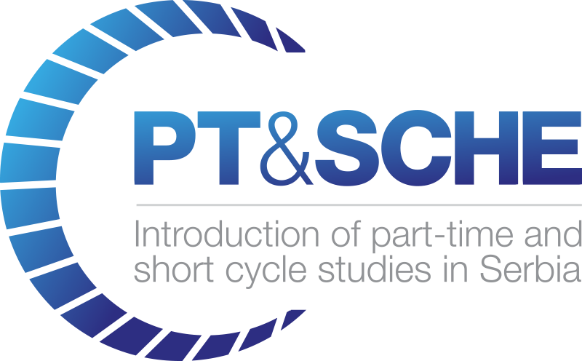

D9.3 Report on Local Committee Meetings

Project Acronym: | PT&SCHE
Project full title: | The Introduction of part‐time and short cycle studies in Serbia
Project No: | 561868-EPP-1-2015-1-EE-EPPKA2-CBHE-SP
Funding Scheme: | ERASMUS+
Coordinator: | Tallinn University, TLU
Project start date: | October 15, 2015
Project duration: | 36 months

Abstract | The document gives information on meetings of the Local Committee of PT&SCHE project.
"The European Commission support for the production of this publication does not constitute an endorsement of the contents which reflects the views only of the authors, and the Commission cannot be held responsi­ble for any use which may be made of the information contained therein."

DOCUMENT CONTROL SHEET

Title of Document: | D9.3 Report on Local committee meetings
Work Package: | WP9. Project management
Last version date: | 05/04/2019
Status : | Draft
Document Version: | v.01
File Name | Report on Local committee meetings
Number of Pages | 7
Dissemination Level | Public

VERSIONING AND CONTRIBUTION HISTORY

Version | Date | Revision Description | Responsible Partner
v.01 | 05.04.2019. | First draft version | Bojana Trebinjac, BMU

TABLE OF CONTENT:
1. Introduction 4
2. Local Committee Meetings....................................................................................................5
2.1. 1st Local Committee Meeting, University of Belgrade, Belgrade 4
2.2. 2nd Local committee meeting organized by Belgrade Metropolitan University 4
2.3. 3rd Local Committee Meeting organized by the University of Belgrade 4
2.4. 4th Local Committee Meeting organized by the University of Novi Sad 4
2.5. 5th Local Committee Meeting organized by the Belgrade Metropolitan Universety 5
2.6. 6th Local Committee Meeting organized by the Belgrade Metropolitan Universety 5
2.7. 7th Local Committee Meeting organized by the Belgrade Metropolitan Universety 5
2.8. 8th Local Committee Meeting and training for mDita editor organized by the Belgrade Metropolitan Universety 5
2.9. 9th Local Committee Meeting organized by the Belgrade Metropolitan Universety 5
2.10. 10th Local Committee Meeting organized by the Belgrade Metropolitan Universety 5
2.11. 11th Local Committee Meeting organized by the Belgrade Metropolitan Universety 6
2.12. 12th Local Committee Meeting organized by the Belgrade Metropolitan Universety 6
2.13. 13th Local Committee Meeting organized by the Belgrade Metropolitan Universety 6
3. Conclusion 7

Introduction

Local Committee Meetings
- 1st Local Committee Meeting, University of Belgrade, Belgrade
This meeting focused on preparation of part-time and short cycle studies in Serbia. Majority of the general activities for Serbian institutions are included in the WP2 (Development of legal frameworks for implementation for PT&SCHE). It is stated that Serbia already had experience in part-time studies (study programs before 1992), and that Serbian partners should analyze the past experience and prepare proposals to use benefit from modern technological features (on line learning, distance learning, combined learning) to make the results better and with higher quality. Also, the experience of foreign partners on these projects will be valuable. It is stated that current Law on higher education enables some type of part-time studies, but it is necessary to legally define the responsibilities of higher education institutions, that the process of organizing and adapt to different groups of students.

- 2nd Local committee meeting organized by Belgrade Metropolitan University
This meeting focused on clarifiying issues for the July 4-5 Conference, the coordination of activities of Serbian partner institutions and the planning of further study visits as well as financial issues and administrative questions.

- 3rd Local Committee Meeting organized by the University of Belgrade
The meeting was considered a working version of the draft of policies about part-time and short-cycle studies. Participants agreed on the aspects of PT and SC studies that will be presented at the Belgrade conference.

- 4th Local Committee Meeting organized by the University of Novi Sad
The meeting was considered a working version of the draft of policies about part-time and short-cycle studies, and other achievements in WP2. This meeting focused on clarifiying issues for the second Steering Committee Meating, scheduled for September 23, 2017.

- 5th Local Committee Meeting organized by the Belgrade Metropolitan Universety
The meeting was considered a working version of the draft of policies about part-time and short-cycle studies, and other achievements and adopitions of WP2 deliverables. This meeting focused on clarifiying issues of tendering procedure for technical equipment, as well as issues about the second Steering Committee Meating, scheduled for September 23, 2017.

- 6th Local Committee Meeting organized by the Belgrade Metropolitan Universety
The meeting outlined the WP2 documents and tendering procedure for technical equipment.

- 7th Local Committee Meeting organized by the Belgrade Metropolitan Universety
The meeting focused on discussion and adoption of WP2 documents. About divelabres and outputs in project activities for other working packages. This meeting focused on agreement on the futher tendering procedure and realization.

- 8th Local Committee Meeting and training for mDita editor organized by the Belgrade Metropolitan Universety
The meeting was considered a tender realisation, WP2 deliverables and presentation of the current work of Irvas partner.
Parallel to the meeting of the local committee, the representative of the Belgrade Metropolitan University, Nebojša Gavrilović, held the training for the mDita editor. Training focused on concept of flexible system for distance learning, presentation of main functionalities of mDita editor. The training was attended by 4 candidates.

- 9th Local Committee Meeting organized by the Belgrade Metropolitan Universety
The meeting was focused on adoption of document:
- Policy of Introduction of Part-Time and Short Cycle Studies in High Education in the Republic of Serbia
- Definition of accreditatio criteria for SCHE.

- 10th Local Committee Meeting organized by the Belgrade Metropolitan Universety
The meeting of the local committee was focused on discussion on the technical project implementation report. Base on the elements of the technical implementation report, to prepare a letter to be sent to the EACEA with clarifications in accordance with the objections to the implementation.

- 11th Local Committee Meeting organized by the Belgrade Metropolitan Universety
The leading partners of each work package presented the results and provided suggestions for the upcoming meeting of the Consortium of the project in Vrnjačka Banja. The external evaluation of the pilot program, conducted by the Metropolitan University and the College of Electrical Engineering and Computing of Vocational Studies in Belgrade, was also discussed. Representatives of the Belgrade Chamber of Commerce will also be in the team that will conduct an external check of the pilot study program in short cycles and studies.

- 12th Local Committee Meeting organized by the Belgrade Metropolitan Universety
The meeting focused on discussion about oganisation of the Final Conference. It was suggested that the conference be held on March 15th in Chamber of Commerce and Industry of Serbia, and on the 16th of March to be Steering Committee Meeting at Rectorate of University of Belgrade. How the partners MEST, NCHES and CONUS did not have any costs, it was agreed to ask for the allocation of funds for Staf Cost to VISER, UNIS and BMU.
One part of the meeting was dedicated to the financial audit. At the meeting, one of the topics discussed was about about an external evaluator. Because of the small response of the candidate it was decided to send another call.

- 13th Local Committee Meeting organized by the Belgrade Metropolitan Universety
The meeting of the local committee was focused on reviewing the results of all work packages and results reports. One part of the meeting was devoted to the consideration of the financial statements: the transfer of unspent funds for Staff Cost of Conclusion. The partners are informed of the amount to be allocated to BMU, VISER and UNS.

Conclusion
Local Committee was very active during the project, especially in WP2 where Serbian partners had long discussions about different proposals for legislation of PT studies and, especially od SCHE programmes. Partners sued Local Committee also to present their current work and other partners could give comments and proposals for further work. Unfortunately, two partners (National Council for Higher Education and CONUS - Conference of Universities of Serbia) were not active due to some formal and legal constrains.

