Reports on survey results on employer’s interest for flexible forms of education

Project Acronym: | PT&SCHE
Project full title: | The Introduction of part‐time and short cycle studies in Serbia
Project No: | 561868-EPP-1-2015-1-EE-EPPKA2-CBHE-SP
Funding Scheme: | ERASMUS+
Coordinator: | Tallinn University, TLU
Project start date: | October 15, 2015
Project duration: | 36 months

Abstract | Deliverable from activity 2.1.

"The European Commission support for the production of this publication does not constitute an endorsement of the contents which reflects the views only of the authors, and the Commission cannot be held responsi­ble for any use which may be made of the information contained therein."

DOCUMENT CONTROL SHEET

Title of Document: | WP 2.1. – Reports on survey results on employer’s interest for flexible forms of education within the PT&SCHE project
Work Package: | WP2 – Development of legal frameworks for implementation for PT&SCHE
Last version date: | 11/07/2017
Status : | Final
Document Version: | 1.0
File Name | Reports on survey results on employer’s interest for flexible forms of education - activity 2.1. - 2018
Number of Pages | 20
Dissemination Level

VERSIONING AND CONTRIBUTION HISTORY

Version | Date | Revision Description | Responsible Partner
1.0 | Maj .2016 | Izveštaj – srpska verzija | Chamber of Commerce University of Belgrade
1.0 | Novembar 2016 | Report – English transation | Chamber of Commerce University of Belgrade

Report
Survey results
on employer’s interest for flexible forms of education
within the PT&SCHE project

- INTRODUCTION

The official start of the project Introduction of part time and short cycle studies in Serbia” – PT&SCHE was in October, 2015. The project aims to establish a new model and methodology of study in higher education under the principle of studying alongside the work and/or through short cycles. Accordingly, it is necessary to define a legal framework that supports the development and implementation of study part-time through short cycles into the university studies. Also planned are the adoption and implementation of the most suitable online and traditional (face-to-face) learning methodologies.
The project is funded under the Erasmus + program, and actively involves 15 partners: 10 from the Republic of Serbia and 5 from the European Union (Estonia, Slovenia, Hungary, the Netherlands and the United Kingdom).
One of the first activities of the project was to examine the situation on the labor market and the needs of employers offered through new forms of education. Accordingly, Belgrade Chamber of Commerce conducted a survey among its members. The main objectives of this study were:
- Identify the real needs of employers in terms of defined profiles and competencies of staff,
- The establishment of real need and interest of employers for flexible forms of education and training.
The research on the interest of employers for flexible forms of education was conducted from March to May 2016, as online survey which was complited by 212 companies. The survey instrument was a questionnaire specifically designed for that study, which was divided into five parts:
I General information
II Studying while working (Part time study)
III Short cycle study
IV Development plan
V Specific competencies.
Dana analysis was conducted by the project team of Belgrade Chamber of Commerce, in cooperation with the project team at the University of Novi Sad. The results are presented in tables and graphs. We performed the analysis obtained by crossing the answer depending on:
- sectors to whom company belongs (business is divided into three main sectors - the sectors of high technology, manufacturing and services);
- the size of the company (small, medium, large);
- job position of the participant in business organization (top management, middle management, other).
  - General information
The answers to the first part of the questionnaire are presented graphically (charts 1-5) and tabular (Tables 1 and 2). The questions are designed to obtain basic information on the respondents, or on Companies representing.
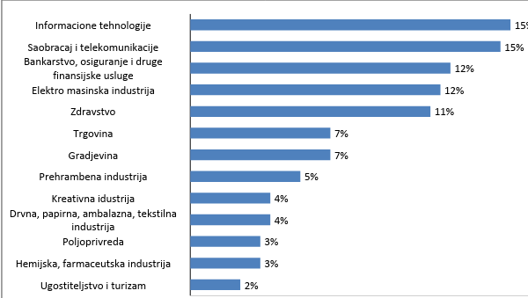
Information Technologies

Transport and Telecommunications

Financial

Electro-Mechanical

Health

Trade

Construction

Food

Creative

Wood, Paper, Packaging, Textile

Agriculture

Chemical, Pharmaceutical

Catering and Tourism

Graph 1. Which industry do you mainly represent?
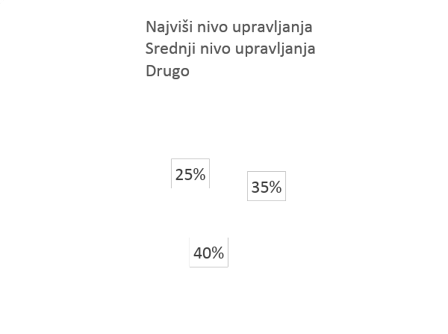
Top management
Middle management
Other

Graph 2. Level within the company

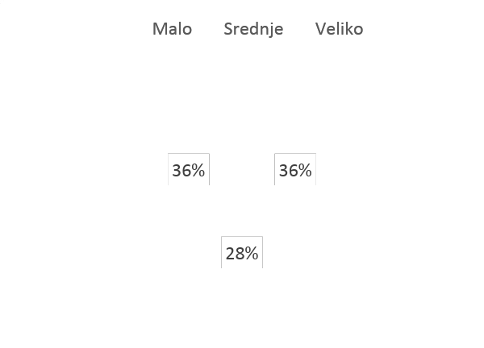
Large
Small
Medium
Graph 3. The size of your company

 |  | Level within the company |  |  |  |  | Total
 |  | Other | Top management |  | Middle management
The size of the company | Small | 9 |  | 51 |  | 17 | 77
 | Medium | 16 |  | 8 |  | 34 | 58
 | Large | 28 |  | 16 |  | 33 | 77
Total |  | 53 |  | 75 |  | 84 | 212
Table 1. Cross tab – size of the company and job position
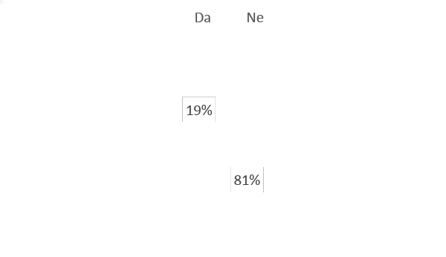
No
Yes
Graph 4. Does the labor market respond to all HR needs of your company?

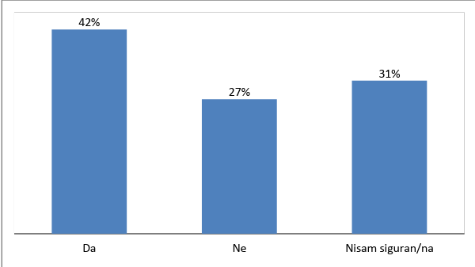
Yes
No
I`m not sure
Graph 5. Are there positions in your company that demand intermediate qualification level, i.e. a level between secondary and university education?

 |  | The size of the company |  |  | Total
 |  | Small | Medium | Large
Is there a need for new work profile of employees according to activities of your company? | Yes | 37.7% | 27.6% | 31.2% | 32.5%
 | No | 31.2% | 44.8% | 20.8% | 31.2%
 | I`m not sure | 31.1% | 27.6% | 48.0% | 36.3%
Total |  | 100.0% | 100.0% | 100.0% | 100.0%
Table 2. Is there a need for new work profile of employees according to activities of your company? Cross tab according to the size of a company

In relation to economic activity, which is core business in the company, the highest number of responses were obtained from the IT sector and transport and telecommunications, followed by the financial sector, the electro-mechanical industry and healthcare. Regarding the job position, most respondents belong to the middle level of management, followed by respondents from the highest levels of management, while the least responses were obtained from respondents who do not belong to the company’s management system. The study equally represented commercial companies of all sizes (small, medium and large).
To the question "Does adequate personnel for all job positions in your business enterprise exist on the labor market?" 81% of respondents gave a negative answer. The survey results show that the greatest need for personnel was reported in economic profession as well as personnel from the IT sector. On the other hand, 42% of respondents said that there are working positions for which the necessary knowledge is on the level between secondary and higher education. This kind of positions is primarily for IT professionals, as well as certain professions in engineering and construction industries.
Almost equal distribution of answers was obtained on the question whether there is a need for new profiles. Depending on the size of the company, it can be noted that less than half of respondents (44.8%) from medium size companies gave a negative answer to this question. Also, almost half of respondents (48.0%) of large companies could not give a concrete answer to this question.
  - Studying while working (Part time study)
The second part of the questionnaire was designed to provide answers of interest to "part time" studying or studying while working. At the beginning of the section a brief explanation was given what this kind of study involves. Answers to this part of the questionnaire are also given in graphic (Charts 6 and 7) and tables (Tables 3-5).
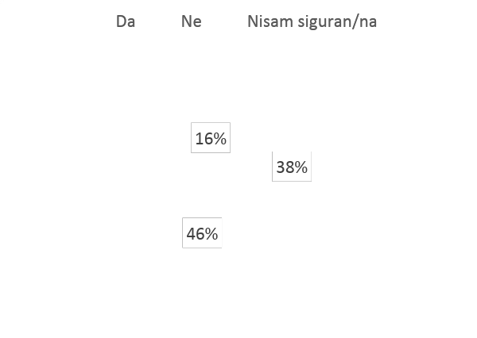
I`m not sure
No
Yes
Graph 6. Do your employees with a high school degree perform tasks that require university degree?

 |  | Sector (type of industry) |  |  | Total
 |  | Hi-tech | Production | Service
Do your employees with a high school degree perform tasks that require university degree? | Yes | 34.0% | 46.2% | 34.0% | 37.7%
 | No | 36.2% | 38.5% | 56.0% | 46.2%
 | I`m not sure | 29.8% | 15.4% | 10.0% | 16.0%
Total |  | 100.0% | 100.0% | 100.0% | 100.0%
Table 3. Cross tab according to the type of industry

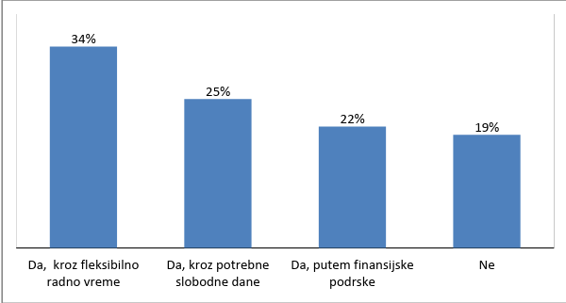
Yes, through flexible working hours
Yes, through necessary days off
Yes, through financial support
No
Graph 7. Would your company support employees to study alongside the work? In what way?

 | The size of the company |  |  | Total
 | Small | Medium | Large
Yes, through flexible working hours | 53.2% | 29.3% | 19.5% | 34.4%
Yes, through necessary days off | 20.8% | 31.0% | 26.0% | 25.5%
Yes, through financial support | 11.7% | 17.2% | 32.5% | 20.8%
No | 14.3% | 22.4% | 22.1% | 19.3%
Total | 100.0% | 100.0% | 100.0% | 100.0%
Table 4. Cross tab based on the size of company

 | Level within the company |  |  | Total
 | Other | Top management | Middle management
Yes, through flexible working hours | 26.4% | 48.0% | 27.4% | 34.4%
Yes, through necessary days off | 26.4% | 21.3% | 28.6% | 25.5%
Yes, through financial support | 18.9% | 12.0% | 29.8% | 20.8%
No | 28.3% | 18.7% | 14.2% | 19.3%
Total | 100.0% | 100.0% | 100.0% | 100.0%
Table 5. Cross tab according to the employer position

Nearly half of respondents (46%) believe that on the positions that require higher education diploma are placed people with adequate qualifications. A slightly smaller percentage (38%) has a different opinion - employees with secondary diploma perform tasks that require higher education diploma.
Further analysis revealed that almost equal percentage of affirmative answers was given according to the type of industry (slightly higher percentage in the manufacturing sector), while more than half of respondents (56%) in the services sector gave negative answer.
The majority of respondents (81%) believes that the company's management would support employer to study and work, through flexible working hours (34%) needed time off (25%), and even through the financial support (22%). Support for employer’s learning through flexible working hours is most pronounced among small companies, as well as persons representing the highest level of management, while large companies are primarily willing to segregate some funding for such activities.

  - Short cycle study
At the beginning of this survey part, a brief explanation about the short cycles in education was given. Answers to questions are presented in graphs 8 and 9, and tables 6 and 7.
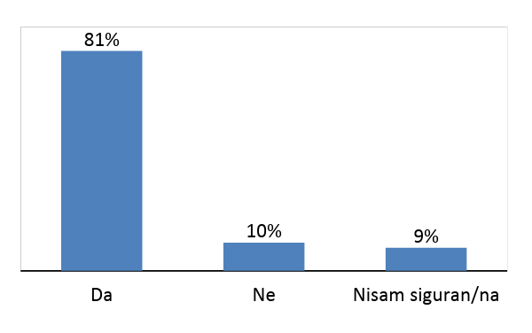
Yes
No
I am not sure
Graph 8. Are there working profiles in your company which require specialization within a field of knowledge?

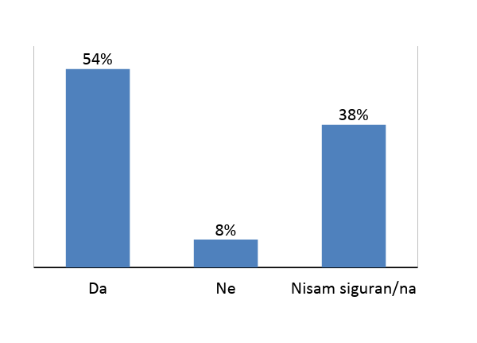
Yes
No
I am not sure
Graph 9. Would your company support short cycle studying?

 |  | The size of the company |  |  | Total
 |  | Small | Medium | Large
Would your company support short cycle studying? | Yes | 64.9% | 48.3% | 46.8% | 53.8%
 | No | 3.9% | 10.3% | 9.1% | 7.7%
 | I am not sure | 31.2% | 41.4% | 44.1% | 38.5%
Total |  | 100.0% | 100.0% | 100.0% | 100.0%
Table 6. Cross tab based on the size of company

 |  | Level within the company |  |  |  | Total
 |  | Other | Top management |  | Middle management
Would your company support short cycle studying? | Yes | 35.8% |  | 68.0% | 52.4% | 53.8%
 | No | 17.0% |  | 6.7% | 2.4% | 7.7%
 | I am not sure | 47.2% |  | 25.3% | 45.2% | 38.5%
Total |  | 100.0% |  | 100.0% | 100.0% | 100.0%
Table 7. Cross tab based on the job position of the respondents

Great need for highly specialized training is evident (81%). More than half of respondents (54%) believe that the acquisition of new knowledge through studying in short cycles would be supported by employers. The greatest need for highly specialized training is the areas of IT, finance, new technologies, and environmental protection. Further analysis revealed, that the most supporting enterprises for this kind of study were small businesses (64.9%), whereas the small (48.3%) and large enterprises (46.8%) have a similar approach to this issue. A large percentage of respondents belonging to the control system of companies, responded affirmatively to this question (the highest level of management 68.0%, middle level management 52.4%).
  - Development plan
This group of questions was designed to gain a better insight into the development capacities and plans of companies that participated in the survey. Answers to questions are presented graphically (Charts 10 and 11) and tabular (Tables 8-11).
Yes
No
I am not sure
Graph 10. Does your company plan the expansion of existing business program or the introduction of new types of work?

 |  | The size of the company |  |  | Total
 |  | Small | Medium | Large
Does your company plan the expansion of existing business program or the introduction of new types of work? | Yes | 55.8% | 32.8% | 37.7% | 43.0%
 | No | 36.4% | 34.5% | 32.5% | 34.4%
 | I am not sure | 7.8% | 32.7% | 29.8% | 22.6%
Total |  | 100.0% | 100.0% | 100.0% | 100.0%
Table 8. Cross tab based on the size of company
Yes
No
I am not sure
Graph 11. Does your company plant to recruit new employees?

 |  | Sector (type of industry) |  |  | Total
 |  | Hi-tech | Production | Service
Does your company plant to recruit new employees? | Yes | 51.0% | 44.6% | 42.0% | 44.8%
 | No | 21.3% | 27.7% | 41.0% | 32.5%
 | I am not sure | 27.7% | 27.7% | 17.0% | 22.7%
Total |  | 100.0% | 100.0% | 100.0% | 100.0%
Table 9. Cross tab based on type of industry

 |  | The size of the company |  |  | Total
 |  | Small | Medium | Large
Does your company plant to recruit new employees? | Yes | 55.8% | 41.4% | 36.4% | 44.8%
 | No | 29.9% | 31.0% | 36.4% | 32.5%
 | I am not sure | 14.3% | 27.6% | 27.2% | 22.7%
Total |  | 100.0% | 100.0% | 100.0% | 100.0%
Table 10. Cross tab based on the size of company

 |  | Level within the company |  |  | Total
 |  | Other | Top management | Middle management
Does your company plant to recruit new employees? | Yes | 34.0% | 58.7% | 39.3% | 44.8%
 | No | 34.0% | 30.7% | 33.3% | 32.5%
 | I am not sure | 32.0% | 10.6% | 27.4% | 22.7%
Total |  | 100.0% | 100.0% | 100.0% | 100.0%
Table 11. Cross tab according to the job (level) position
Almost half of respondents (43%) gave positive answer to the question about the existence of the plan of expanding the existing business program, as well as the introduction of new types of jobs, while less than a quarter of respondents (23%) gave negative answer. One-third of respondents (34%) do not know the company policy regarding this issue. A similar percentage of answers was obtained on the question of recruiting new employees, with slightly greater need for recruitment of new staff in the high tech sector and in small enterprises.
The need for business expansion is noticeable high in small enterprises, opposed to medium and large companies.
  - Specific competencies
The aim of this questionnaire part was to obtain information from the labor market on the needs for additional competencies of employees (foreign languages, computer competence, managerial and special skills). The answers are given in the graph (Charts 12-20) and tables (Table 12).
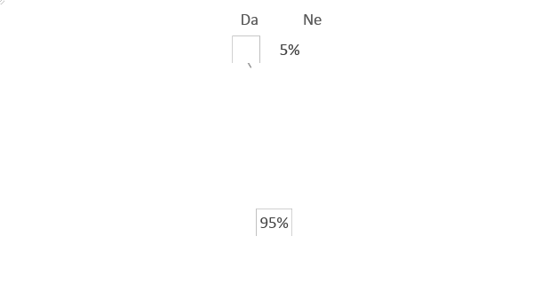
Yes
No
Graph 12. In addition to formal and vocational education, do you think that there is a need for the acquisition of some of the following competencies?
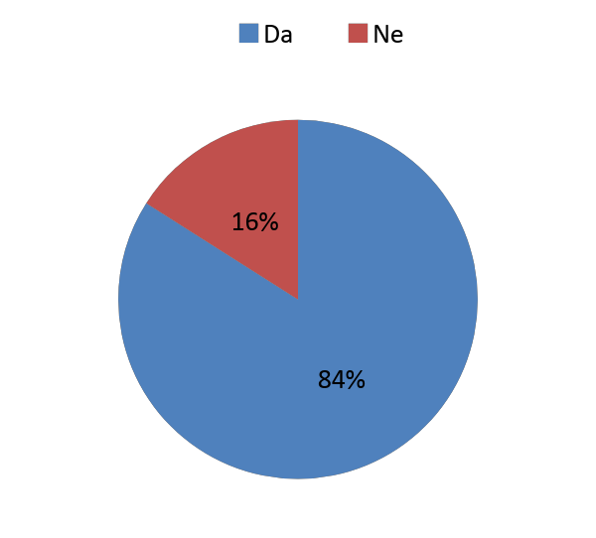
No
Yes
Graph 13. Foreign language

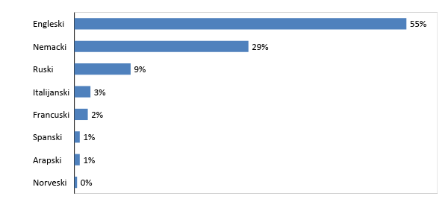
English

German

Russian

Italian

French

Spanish

Arabic

Norwegian
Graph 14. Which foreign languages?

 |  | Level within the company |  |  | Total
 |  | Other | Top management | Middle management
Is there a need for learning the foreign language? | Да | 90.2% | 88.9% | 75.3% | 84.0%
 | Не | 9.8% | 11.1% | 24.7% | 16.0%
Total |  | 100.0% | 100.0% | 100.0% | 100.0%
Table 12. Cross tab according to the job (level) position

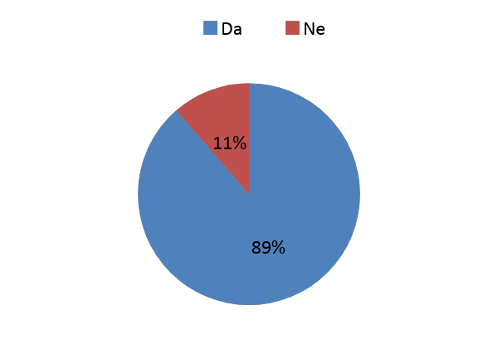
Yes
No
Graph 15. Computer skills

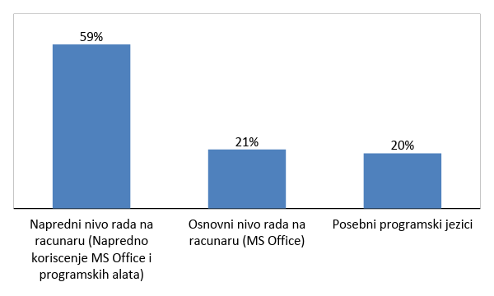
Advanced computer skills (advanced programming tools)
Programming language
Basic level
(MS Office)
Graph 16. Level of computer competencies

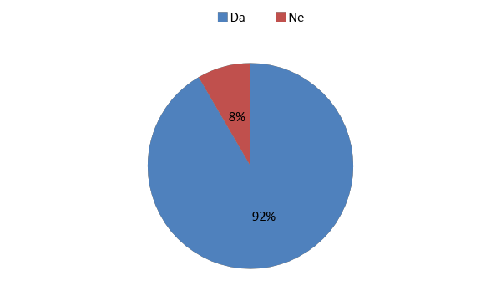
No
Yes
Graph 17. Management skills

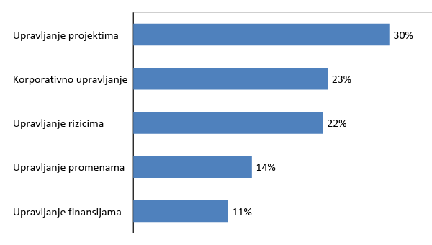
Project management

Corporate management

Risk management

Change management

Financial management

Graph 18. Which managerial skills need to be improved?

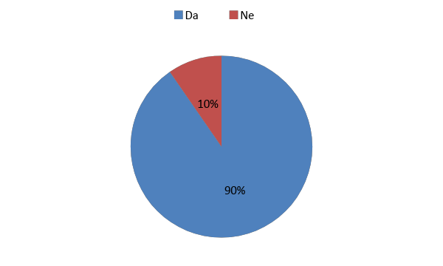
Yes
No
Graph 19. Special skills

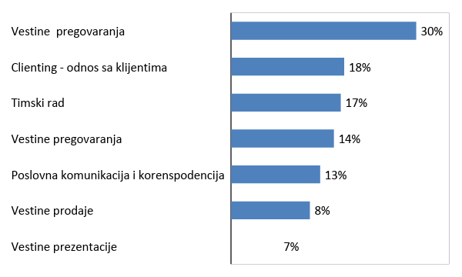
Negotiation skills

Client relationship

Teamwork

Negotiation skills

Business correspondence and communication

Selling skills

Presentation skills

Graph 20. Which special skills need to be improved?

- Conclusion
There is a clear need for additional training and/or retraining employees within the companies. Companies are ready to invest in the education of their employees and thus bridge the difference between classical education and the needs of the market. There are small differences in needs depending on the size of the company, as well as to the corporate sector. As an overall conclusion the economy is interested to the introduction of new studying models, and well to provide a support in various ways to encourage employees for further educat

