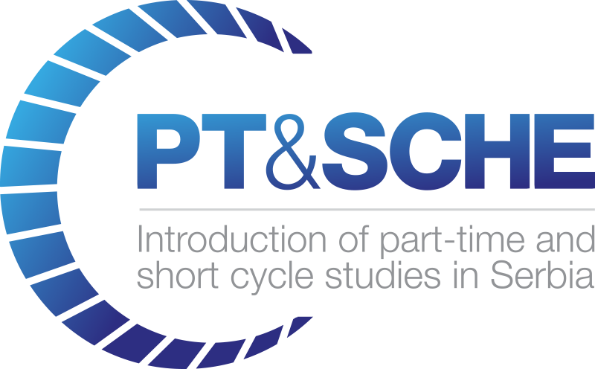

REPORT on Round table

Project Acronym: | PT&SCHE
Project full title: | The Introduction of part‐time and short cycle studies in Serbia
Project No: | 561868-EPP-1-2015-1-EE-EPPKA2-CBHE-SP
Funding Scheme: | ERASMUS+
Coordinator: | Tallinn University, TLU
Project start date: | October 15, 2015
Project duration: | 36 months

Abstract | Deliverable from activity 2.2.

"The European Commission support for the production of this publication does not constitute an endorsement of the contents which reflects the views only of the authors, and the Commission cannot be held responsi­ble for any use which may be made of the information contained therein."

DOCUMENT CONTROL SHEET

Title of Document: | WP2.2 – Reports on round table discussions
Work Package: | WP2 – Development of legal frameworks for implementation for PT&SCHE
Last version date: | March 2017
Status : | Final
Document Version: | 1.0
File Name | Reports on round table discussions - activity 2.2. - 2018
Number of Pages | 5
Dissemination Level

VERSIONING AND CONTRIBUTION HISTORY

Version | Date | Revision Description | Responsible Partner
1.0 | March 2016 | Izveštaj na srpskom jeziku | Chamber of Commerce University of Belgrade
2.0 | March 2017 | Report in English language | Chamber of Commerce University of Belgrade

REPORT
Round table held at Belgrade Chamber of Commerce within the
PT&SCHE project

In October 2015, the project ”Introduction of part time and short cycle studies in Serbia” – PT&SCHE” officially started. The aim of the project is the implementation of the new models and methodology of study in Higher Education under the principle of studying alongside the work and/or through short cycles. Accordingly, it is necessary to define a legal framework that supports the development and implementation of part-time study and short cycles studies. Also planned is the adoption and implementation of the most suitable online and traditional (face-to-face) learning methodologies.
The project is funded under the Erasmus+ program, and it actively involve 15 partners: 10 from the Republic of Serbia and 5 from the European Union (Estonia, Slovenia, Hungary, Netherlands and United Kingdom).
One of the first activities within the project was to examine the situation on the labour market and the needs of employers for the offered new forms of education. Based on that, Belgrade Chamber of Commerce conducted a survey (online) which was intended to recognize and determine the real needs of employers in terms of defined profiles and competencies of employees, as well as to determine the interest of employers for flexible working hours. In addition to the survey, the Belgrade Chamber of Commerce has also organized round tables which aim was to, through talks and discussions with the relevant stakeholders, receive direct opinions from employers, or from the industry. First round table (April 11th, 2016) was held with the Association secretaries and the managers of the Belgrade Chamber of Commerce centres representing the economic entities operating on the territory of Belgrade and who are distributed by branch. The aim of the second round table (May 13th, 2016) was a direct communication with the business community. Both roundtables have enabled an insight into the real state of the economy needs in order to make programs and education strategy that will enable increased competitiveness of economic subjects and higher level of employment in the economy, as end-user of learning outcomes.
To the business representatives were presented the aim of this project – to define a legal framework that supports the development and implementation of study while working and studying through short cycles in order to acquire interdisciplinary qualifications that are attractive to the market. These qualifications should supplement the qualifications which have already been acquired or their improvement and the development of five pilot program for classical and online study. In addition, the participants presented the current state of the education system, both secondary and higher education.
Also, to the participants of the round table were presented the results of a survey conducted in March-May. The survey was divided into: general questions, some questions for studying while working, the group of questions for the short cycles, as well as questions about the needs to acquire other skills. Most responses were gained from the IT sector, followed by transport, and then follow the electro-mechanical industry, banking and healthcare. According to the size of companies it is evident that there is equal representation of small and medium-sized and large companies. According to the management level in the company, the structure of the respondents was: the highest level of management, middle management level, as well as the perpetrators themselves, who do not belong to the management system. The largest number of responses was obtained by middle management levels, from the highest, and then the others. The survey results show that the greatest need for personnel reported the economics profession and personnel from the IT sector. The overall conclusion was that the economy is interested in introduction of new studying models, and that the economy is ready to support and encourage employees to further education. A more detailed analysis and interpretation of results is subject of a separate document/report.
The discussion that followed enabled the participants of round tables to gain a clearer and more realistic picture of the employer’s needs.
Suggestions and conclusions
Availability of information about the possible educational profiles. One of the conclusions was that during the project a web site should be formed that will give a detailed list of all courses that are "offered" with all the necessary information (where training takes place, who is offering training, what is the result of such training, what kind of certificate is acquired...). Market education exist and it should not be ignored and it is very important that there is a direct link between the service providers (educational institutions) and those who needed the service.
Better communication of all relevant stakeholders. It was concluded that there is insufficient correlation between the economy and education system. Mutual influence is necessary and strengthens the connection between the economy and business associations (chambers of commerce, employers' unions and other business and professional associations), education and training institutions and relevant ministries in order to harmonize educational programs with the needs of the economy. It is necessary to establish better communication between relevant ministries (Ministry of Education, Ministry of Finance, Ministry of Economy), higher education institutions and businesses. The economy must have a greater role in the development of curriculum.
National Qualifications Framework (NQF). It is essential during the development of education programs to clearly define the inputs and outcomes of learning. The national qualifications framework should balance the need with what the education system provides. NQF should be defined so that its structure will be formed primarily on the basis of information submitted by industry representatives. It will also allow institutions of higher education systems to define curricula based on real demands of the labor market.
Short courses. It was concluded that the introduction of educational programs through short cycles could solve some of the most acute problems in Serbia, such as lack of jobs (both for those with higher diploma and with a high school degree) and the lack of two-subject teachers. Shorter learning programs would allow the introduction into the real job more efficient.
Employers - opinions, experiences, problems. There is a clear company need for additional training and/or retraining of their employees. They are ready to invest in the education of their employees and thus bridge the difference between classical education and the needs of the market. Companies are willing to set aside certain funds for it, but very important is that this training is outside working hours. The labor market places emphasis on real knowledge and abilities, rather than formal education. Therefore, it is necessary to break the conservatism in education, because companies need knowledge and competence. There is a clear need and a request for an increase in the volume of practical training and the ability to practice with the employers, which in Serbia is not a legal obligation. On the other hand, in order to prevent the outflow of the labor force, it is necessary to devise a legal framework that would protect employers who invest financial resources or otherwise stimulates the further education of their employees (working hours, days off ...). Also, employers who are willing to provide their employees additional education and acquiring competences, should be given incentives through certain tax breaks.
The state of education system in Serbia. There is a need for additional education of teaching staff, and the compatibility of their knowledge and curriculum with the latest global trends in the certain field. Experience and good practices of other countries should be the basis for defining the necessary changes in the educational system of Serbia.
One of the problems of the education system in Serbia is the process of accreditation that can last for up to two or three years, which in the field of information technology is a major problem, as this is an area where changes occur almost on a daily basis. Because of all this, the main goal of the implementation of the results of this project is to establish a dynamic, flexible system that is not burdened by complicated accreditations and bureaucracy and to be guided by the needs of the market.

