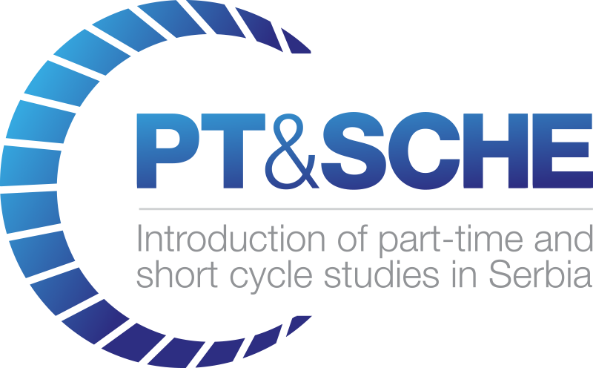

Short report from the Conference

Project Acronym: | PT&SCHE
Project full title: | The Introduction of part‐time and short cycle studies in Serbia
Project No: | 561868-EPP-1-2015-1-EE-EPPKA2-CBHE-SP
Funding Scheme: | ERASMUS+
Coordinator: | Tallinn University, TLU
Project start date: | October 15, 2015
Project duration: | 36 months

Abstract | Deliverable from activity 2.4.

"The European Commission support for the production of this publication does not constitute an endorsement of the contents which reflects the views only of the authors, and the Commission cannot be held responsi­ble for any use which may be made of the information contained therein."

DOCUMENT CONTROL SHEET

Title of Document: | WP 2.4. – Short report from the Conference
Work Package: | WP2 – Development of legal frameworks for implementation for PT&SCHE
Last version date: | July 2016
Status : | Final
Document Version: | 1.0
File Name | Short report from the conference - activity 2.4. - 2018
Number of Pages | 3
Dissemination Level

VERSIONING AND CONTRIBUTION HISTORY

Version | Date | Revision Description | Responsible Partner
1.0 | July 2016 | -Report in Serbian  -Short report in English | University of Belgrade

REPORT
Conference "Introduction of Part-Time and Short-Cycle Studies in Serbia"
July, 4-5th 2016 in Belgrade, Republic of Serbia
The conference, entitled "Introduction of Part-Time and Short -Cycle Studies in Serbia" was held on Monday, July 4th, 2016 in the rectorate building of the University of Belgrade.
Conference activities were divided into two sections (Presentation of EU countries experience program; The higher education in Republic of Serbia).
Legislative framework within the EU, as well as the national laws of countries from which the institutions are partners in the project (Legal Framework for Part-Time and Short-Cycle Higher Education - National and Institutional presentation) were presented in the first section.
In the second section the educational system in the Republic of Serbia and strategy of education development in the Republic of Serbia by 2020 were presented. Further, the results of a survey conducted by the Belgrade Chamber of Commerce among its members with respect to the flexible forms of education, has been reported. Also, a preliminary version of the draft positions on education through short cycle and part-time study has been discussed.
All activities were realized in accordance with agenda of conference.
The discussions were open and constructive. It represented the exchange of experiences and attitudes and confrontation of different opinions.
The conference was attended by 37 participants. In addition to representatives of partner institutions participating in the project, representatives of the universities Singidunum and Edukons, as well as of the Centre for Education Policy, were present.
The meeting started at 10 a.m. and it ended at 5 p.m.
On the second day on Tuesday, 5 July 2016 held the first Consortium meeting of the project.
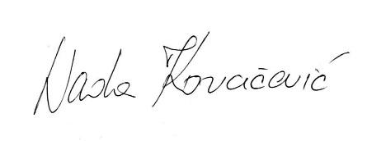
Prof. dr Nada Kovačević

