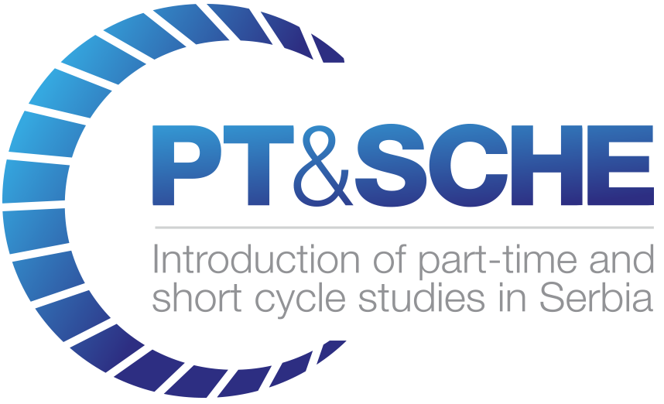
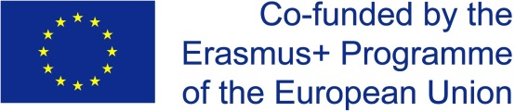

Act.WP2.7 Defined accreditation criteria

Draft
Definition of Accreditation Crieria for SCHE
(in English)

Project Acronym: | PT&SCHE
Project full title: | The Introduction of part‐time and short cycle studies in Serbia
Project No: | 561868-EPP-1-2015-1-EE-EPPKA2-CBHE-SP
Funding Scheme: | ERASMUS+
Coordinator: | Tallinn University, TLU
Project start date: | October 15, 2015
Project duration: | 36 months

Abstract | This working document is planned to propose criteria for accreditation if SCHE programmes in Serbia. It is one of the base documents to be used for development of the final deliverables for WP2..

"The European Commission support for the production of this publication does not constitute an endorsement of the contents which reflects the views only of the authors, and the Commission cannot be held responsible for any use which may be made of the information contained therein."

VERSIONING AND CONTRIBUTION HISTORY

Version | Date | Revision Description | Partner responsible
1.0 | 25.3.2017 | Initial version | BMU (D.Domazet)
2.0 | 30.4.2017 | Final proposal | BMU (D.Domazet)

2.7 Definition of Accreditation Criteria for SCHE
Short-Cycle Higher Education (SCHE) in Serbia is planned to offer short programs with courses aiming to educate, train and prepare students for a specific job, providing him/her appropriate competences. A SCHE program may last from 3 to 12 months, probably providing students from 30 to 90 ECTS. ECTS may be offered only in case that courses are mostly selected subsets of courses normally offered with BSc/BA and MSc/MA programs. If a student with a certificate of a SCHE program with ECTS, later decide to enroll a BSc/BA or MSc/MA program, some or all ECTS may be accepted. Figure 1 shows an example of acceptance of ECTS from a SCHE program with 60 ECTS for a student, who successfully completed this SCHE program, and is enrolling now a BSc program. When courses of a SCHE program are created, they are not copies of selected courses of a BSc program, as they have different focus (application oriented, less theory) and teaching methodology (less teaching hours per course, simpler explanations of implemented concepts, more examples and exercises). So, when a student wants to enroll a BSc program that was used for creation of the SCHE program, he has to learn parts of BSc course that were not covered by courses of a SCHE program.
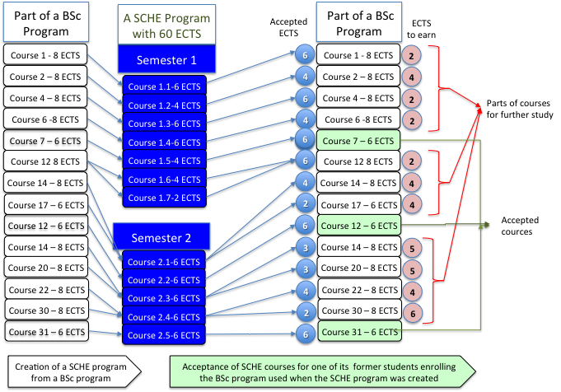
Figure 1: Acceptance of SCHE courses by a BSc program used for its creation
The PT&SCHE project team assumed that all SCHE programs are only extracts of some existing BSc/BA or MSc/MA programs, with some new contents and modifications. As BSc/BA or MSc/MA programs are accredited, the PT&SCHE project team concluded that there was no need for accreditation of SCHE programs if they are offered by accredited HEIs.
The PT&SCHE project team also recommends that
- only accredited HEIs may offer SCHE programs, and that
- HEIs my offer SCHE programs only if they offer BSc/BA or MSc/MA programs in same discipline.
If new legislation for HE in Serbia accepts and support these recommendations, the PT&SCHE project team concluded that there was no need for accreditation of SCHE programs in Serbia.
When generating the above recommendation, the PT&SCHE project team also had in mind the following facts:
- SCHE programs are market-driven and are created to educate, train and prepare students for a specific job required by the job market.
- Only employers can evaluate the value and the quality of a SCHE program, from employers point of view.
- HEIs need to react fast to new needs of the job market and usually there is no time for an accreditation process that is usually time consuming in Serbia (lasting at least one year).
- SCHE program providers may be only accredited HEIs with accredited BSc/BA and MSc/MA programs in the same discipline of the SCHE program.
The PT&SCHE project team also recommends that HEIs should be obliged to:
- prepare and offer SCHE programs according to general rules set by Ministry and HEI-specific rules and to be monitored by the authority (National Council for Higher Education or Ministry of education);
- provide support of employers for each of their SCHE programs and should have a written contract or commitment of at least one employer that intends to employ students with certificate of completion of the SCHE program, after testing their knowledge and skills;
- send information to the Registry of all SCHE programs offered by HEIs in Serbia and provide information the Registry of all holders of their SCHE certificates.
The ultimate indicator of quality of a SCHE program is employability of its former students. As SCHE programs are market-driven, their success and quality should be measured by market and not by any accreditation body. HEIs should offer SCHE programs according to the Low of Higher Education and national and HEIs specific rules. Accreditation Commission should monitor whether HEIs comply with these above rules and should be authorized to forbidden SCHE programs that prepared and offered against the legislation related to SCHE i Serbia.

Prepared by
Prof. dr Dragan Domazet, from BMU

Belgrad 30.4..2017

