Development of teaching and learning material

Project Acronym: | PT&SCHE
Project full title: | The Introduction of part‐time and short cycle studies in Serbia
Project No: | 561868-EPP-1-2015-1-EE-EPPKA2-CBHE-SP
Funding Scheme: | ERASMUS+
Coordinator: | Tallinn University, TLU
Project start date: | October 15, 2015
Project duration: | 36 months

Abstract | This document is short presentation about teaching and learning material that was used on pilot study programs at University of Novi Sad, where part-time studies were introduced.

"The European Commission support for the production of this publication does not constitute an endorsement of the contents which reflects the views only of the authors, and the Commission cannot be held responsi­ble for any use which may be made of the information contained therein."

DOCUMENT CONTROL SHEET

Title of Document: | Development of teaching and learning material
Work Package: | WP6. Pilot implementation of F2F PT & SCHE programs
Last version date: | 06/04/2019
Status : | Final
Document Version: | 1.0
File Name | WP6.2.- Development of teaching and learning material
Number of Pages | 7
Dissemination Level | Institutional

VERSIONING AND CONTRIBUTION HISTORY

Version | Date | Revision Description | Responsible Partner
1.0 | 06.04.2019. | Concept development | Mirko Savić (UNS)

Development of teaching and learning material
Changes in the teaching process were partly reflected also in the preparation of new teaching and learning materials. Several new approaches were developed during the piloting of the new methods.
The contents of all three pilot programs required the active involvement of students. It is almost impossible to master most of the items on their own using only prepared material. Namely, almost all courses require an appropriate previous knowledge of students in the field of mathematics and / or statistics. In case students do not have the appropriate knowledge, it is almost impossible to provide teaching materials from which they will be able to compensate the missing knowledge and skills. This applies particularly to studies of applied statistics because students have previously acquired a level of education on various study programs (economics, philosophy, mathematics, psychology, management ...). It was therefore necessary that the teacher that implement the program can help students and to give additional supplementary information (explanations) necessary for successful attendance of the course.

Below we present the teaching materials for two courses (Basics of probability and statistical conclusions (8 ECTS) and Complex linear models (8 ECTS)).

Basics of probability and statistical conclusion
The course is organized online, in the following way:
The teacher started teaching at the scheduled time using skype, and students were attending lectures online in real time. They were given the opportunity to ask questions at any time; the teacher also asked for feedback from students. This way of teaching was a successful imitation of F2F classes. A significant benefit of this approach is the material that was prepared during this type of lesson. The teacher used sharing of her screen with students. This implied, on the one hand, the preparation of presentations, and, on the other hand, use of an on-line table to clarify the necessary parts. In Figure 3 is an example of a "printed" table during online classes.

Each lesson was recorded and students are allowed to use the recording to prepare the exam. These materials represent a significant innovation in teaching materials. The use of recorded classes has proven to be very effective since the need for F2F consultations has significantly decreased.
Material for the entire course is given on the link
https://drive.google.com/open?id=0B2K_E0uhnjc0Tm43ZGpqZVpMZnc
Below we give some characteristics of the material developed and adjusted specially for part-time students and new developed methods of teaching.

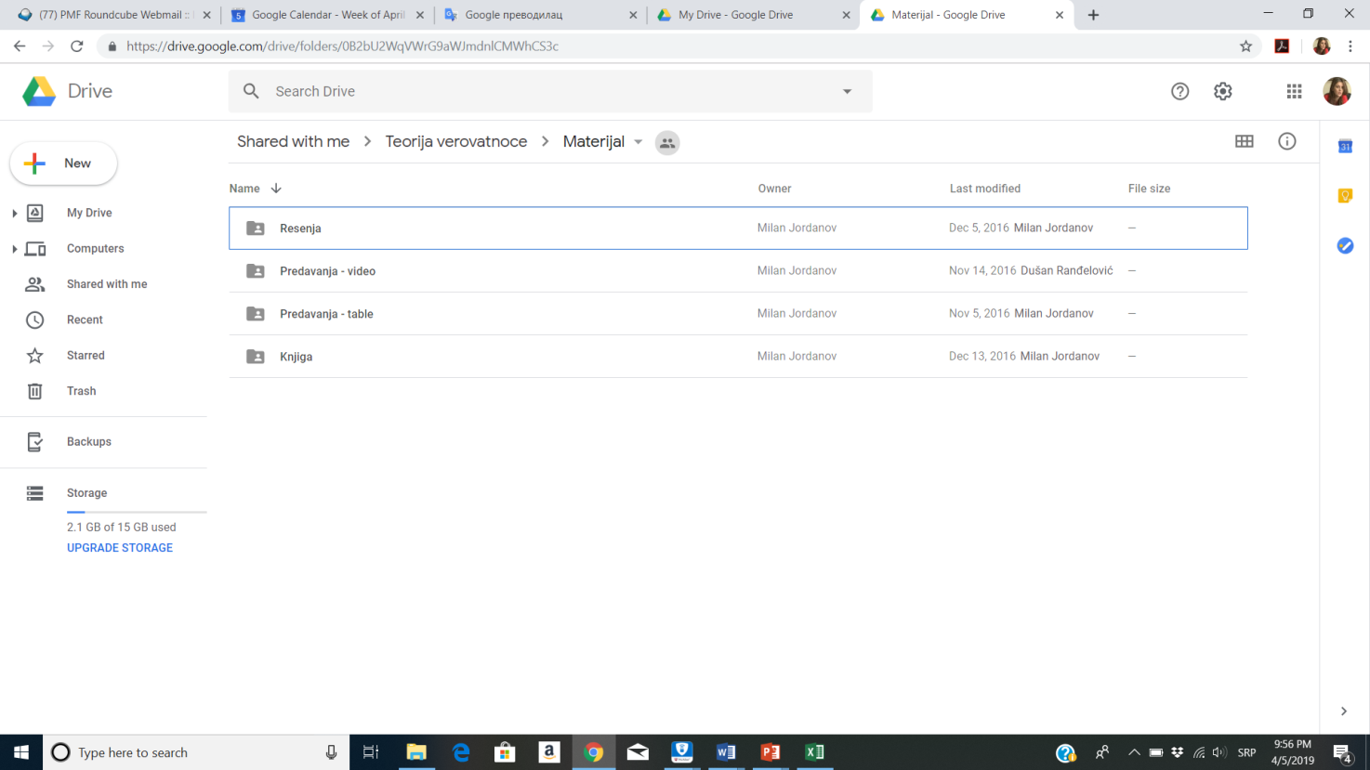
Figure 1: Teaching material is structured within four folders

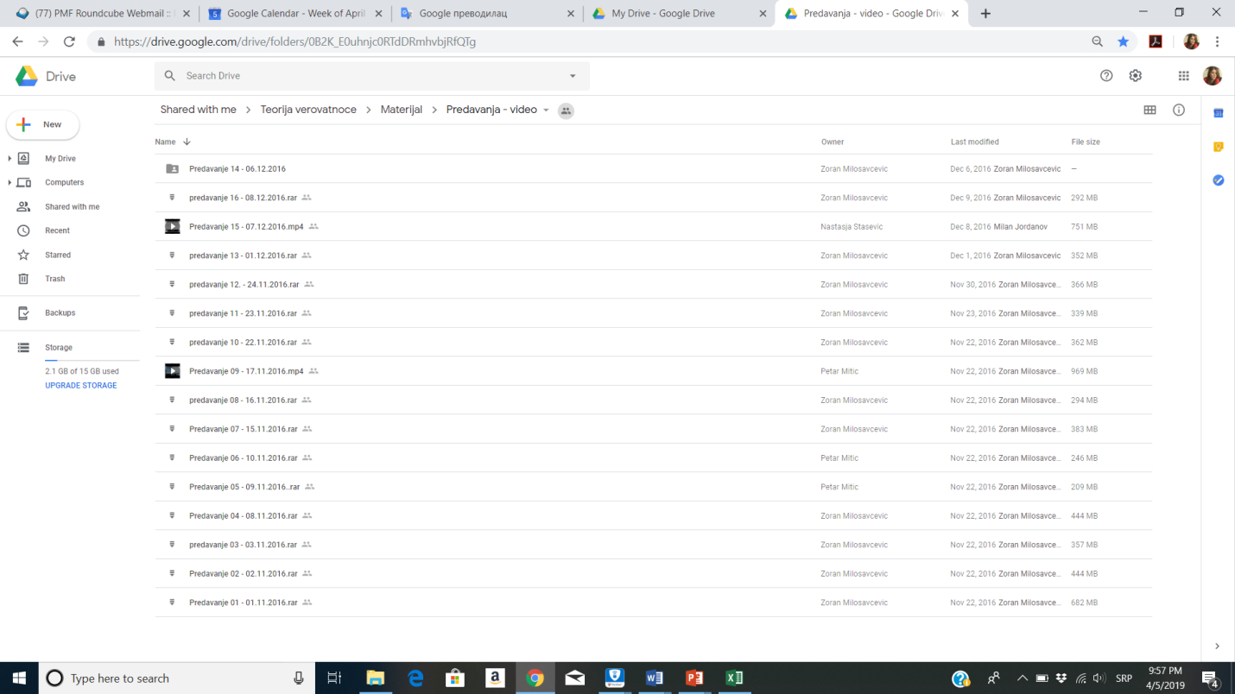
Figure 2: The folder with the highest capacity contains video recordings of all held appointments

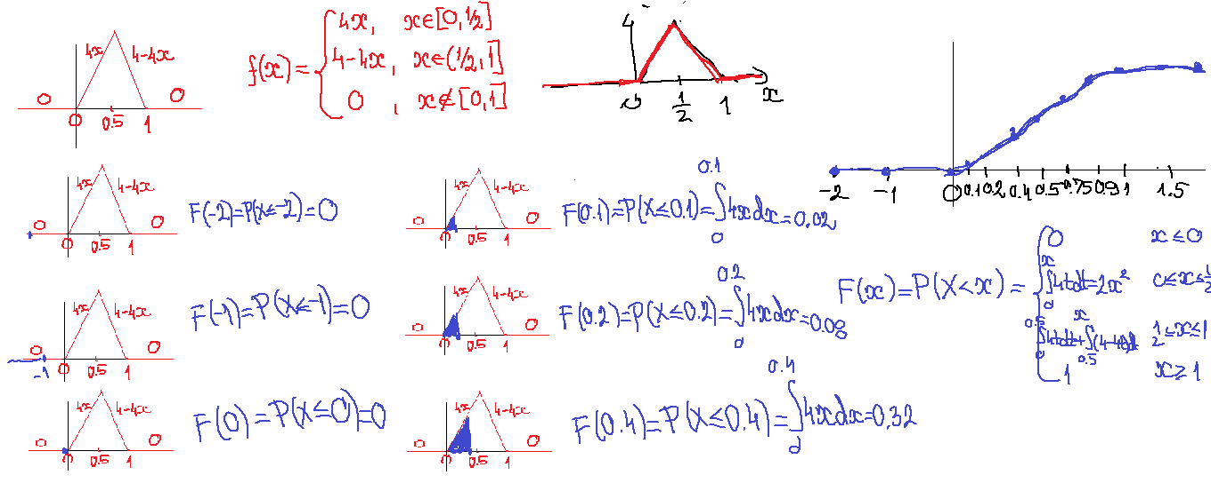
Figure 3: Photo of the example of a "printed" table from the Table folder

Course: Complex linear models
The realization of this course was through weekend F2F classes (for the lectures - the theoretical aspects) and on-line exercises (for solving specific problems / tasks).
The material was available to students on a common drive and was arranged by terms.

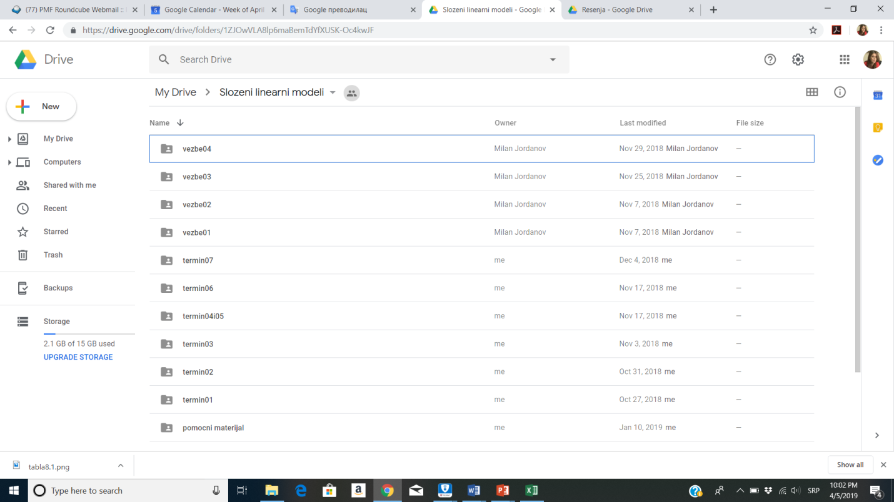
Figure 4: The study material is structured by terms
After each class, students were allowed to download materials that were processed in teaching, additional materials for interested students and practical / homework assignments. The following figure shows typical content for a single class.

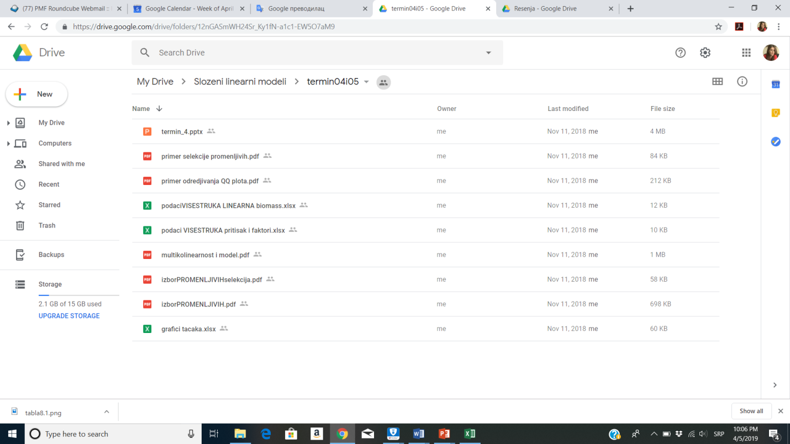
Figure 5: Typical content of a single class

Complete materials for this course are available at: https://drive.google.com/drive/folders/1ZJOwVLA8lp6maBemTdYfXUSK-Oc4kwJF?usp=sharing

