Implementation of Short cycle AND PART-TIME Pilot F2F programs IN VISER

Project Acronym: | PT&SCHE
Project full title: | The Introduction of part‐time and short cycle studies in Serbia
Project No: | 561868-EPP-1-2015-1-EE-EPPKA2-CBHE-SP
Funding Scheme: | ERASMUS+
Coordinator: | Tallinn University, TLU
Project start date: | October 15, 2015
Project duration: | 36 months

Abstract | VISER organized two pilot short cycle F2F programs: Professional development of professors and teachers and Vehicle diagnostics, and one part-time program Information Systems.
"The European Commission support for the production of this publication does not constitute an endorsement of the contents which reflects the views only of the authors, and the Commission cannot be held responsi­ble for any use which may be made of the information contained therein."

DOCUMENT CONTROL SHEET

Title of Document: | IMPLEMENTATION OF SHORT CYCLE AND PART-TIME PILOT F2F PROGRAMS IN VISER
Work Package: | WP6. Pilot implementation of F2F PT & SCHE programs
Last version date: | 03/04/2019
Status : | Final
Document Version: | 2.0
File Name | WP6.3.- Implementation of short cycle and part-time pilot F2F programs in VISER
Number of Pages | 67
Dissemination Level | Institutional

VERSIONING AND CONTRIBUTION HISTORY

Version | Date | Revision Description | Responsible Partner
1.0 | 12.07.2018. | Concept development | Svetlana Štrbac-Savić, VISER  Ivana Stefanovic, VISER
2.0 | 03.04.2019. | Final version | Svetlana Štrbac-Savić, VISER  Vera Petrovic, VISER  Ivana Stefanovic, VISER

TABLE OF CONTENT:
DOCUMENT CONTROL SHEET 2
VERSIONING AND CONTRIBUTION HISTORY 2
1. Introduction 4
2. Realization of short cycle program “Professional development of professors and teachers” 5
2.1 Enrollment process and enrolled students 8
3. Realization of short cycle program “Vehicle diagnostics” 13
4. Administration of short cycle programs 16
5. Learning materials 18
6. Exams 20
7. Survey 22
7.1 Questions in survey 22
7.2 Survey about short cycle studies in VISER - Professional development of professors and teachers – 24
7.3 Survey about short cycle studies in VISER - Vehicle diagnostics – 37
7.4 Average mark on short cycle program Vehicle diagnostics 50
7.5 Average mark on short cycle program Professional development of professors and teachers 51
8. Sertificate 52
9. Realization of pilot part-time program Information Systems 60
9.1 Teaching and learning materials 66
9.2 Exams 66
10. CONCLUSION 67

Introduction
The government of the Republic of Serbia adopted in September 2017 a change of the law on higher education, which legally enabled the organization of short cycle and part-time programs.
School of Electrical and Computer Engineering of Applied Studies in Belgrade, VISER, has organized two short cycle F2F programs:
- Professional development of professors and teachers
- Vehicle diagnostics
And one F2F part-time program Information Systems.

During the 2017/2018 school year short cycle program “Professional development of professors and teachers” was organized twice, first in the winter semester, and second on the summer semester of the school year 2017/2018. A total of 92 students were enrolled in this program. On first performance of the course 66, and on second 26 students. Enrolled students did not pay tuition fees.
Short cycle program “Vehicle diagnostics” was organized in the summer semester of 2017/2018 school year. 9 students were enrolled to this program, and they also didn’t pay tuition fees.
All students have previously finishes undergraduate studies, because the low demanded that enrolled students to short cycle program have already at least 180 ETS points on some accredited high education institution.
Lessons were held on weekends, since most students are employed, and some of them are not from Belgrade.
Information Systems is a program whose curriculum is developed within the project PT&SCHE. Tree students were enrolled to part-time study regime in school year 2018/2019. The enrollment of students in previous school year was impossible because the low was adopted after the enrollment process was finished in VISER for school year 2017/2018.

Realization of short cycle program “Professional development of professors and teachers”

Short cycle program “Professional development of professors and teachers“ is intended for people who want to work as professors or teachers in secondary or primary school in Republic of Serbia, and who do not have teaching license. In the Republic of Serbia, the person who teaches at school must finish appropriate studies, and have professional knowledge of the subject that the teacher teaches and they must pass exams in Pedagogy, Didactics, Psychology and Teaching Methodology and professional practice in teaching. This program gives necessary knowledge in these areas and allows candidates to be able to take a professional exam which enables them to get a teaching license in Republic of Serbia.
This program was organized twice in 2017/2018 school year. Program duration was one semester and 30ECTS. Four courses were organized:
- Pedagogy (8 ECTS),
- Didactics (8 ECTS),
- Psychology (8 ECTS), and
- Teaching Methodology (6 ECTS).
Course lessons were organized at VISER during weekends since most of the enrolled student work, and a lot of them were not from Belgrade (Fig.1.1). Of course, students had seminar papers, and workshops and they actively participated in lessons since some of them have teaching experience. At the request of students, professional practice has been organized for additional 6 ECTS. Student who already work in primary and secondary school finished professional practice in their school, and for other student VISER organized professional practice in primary and secondary schools. Professional practice was not obligatory, because in the syllabus of this program it was not planned, it was optional, but almost all of the students finished it and in the end they got 36 ECTS.
Learning Management System (LMS) Moodle was used for distribution of learning materials and for improvement of communicate with students.
All students enrolled to F2F program Professional development of professors and teachers had accounts and access to Moodle Learning Platform.

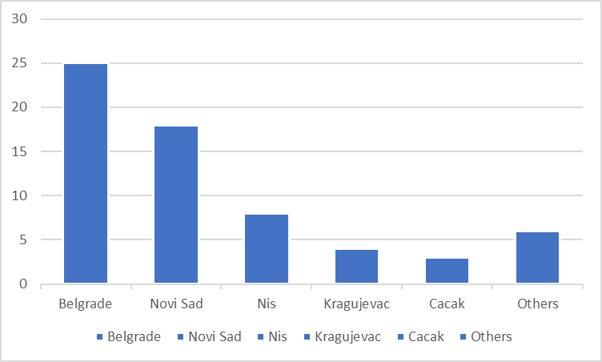
Fig.1.1 Palace of residence of enrolled students to short cycle program Professional development of professors and teachers
Fig.1.2 New category of courses was made for short cycle students
Username and password was assigned to each student for registration to courses.
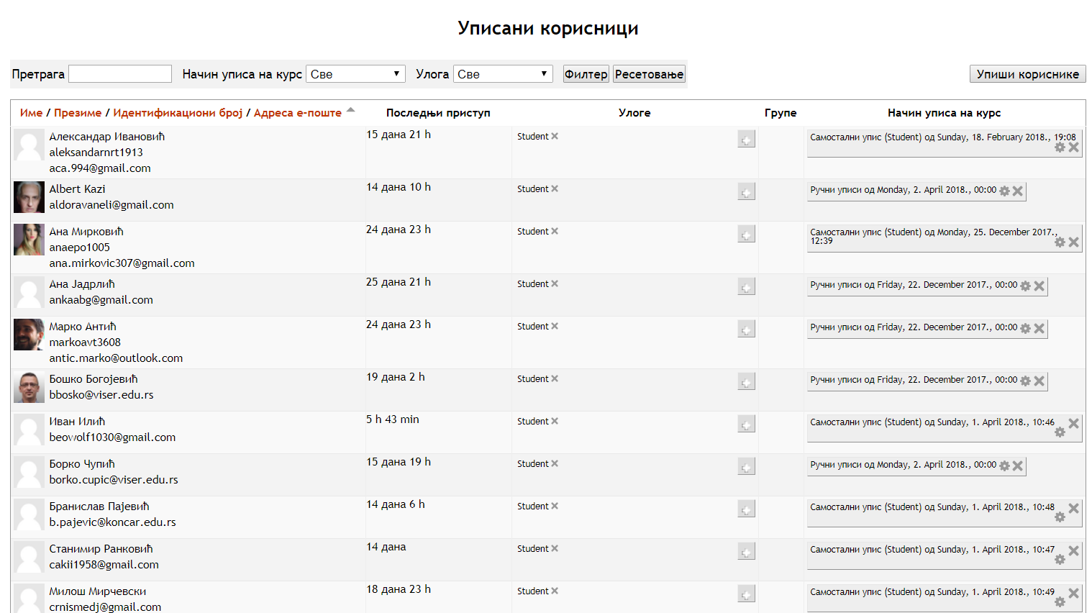
Fig.1.3. List of registered students on LMS Moodle
For F2F program Professional development of professors and teachers there are 4 courses, including Pedagogy, Didactics, Psychology and Teaching methods. On this program students have access to different types of teaching and learning materials, questionnaires, tests etc. In addition to these four courses, a Guide for students was created. Throughout the Guide students are informed about all important dates and events.
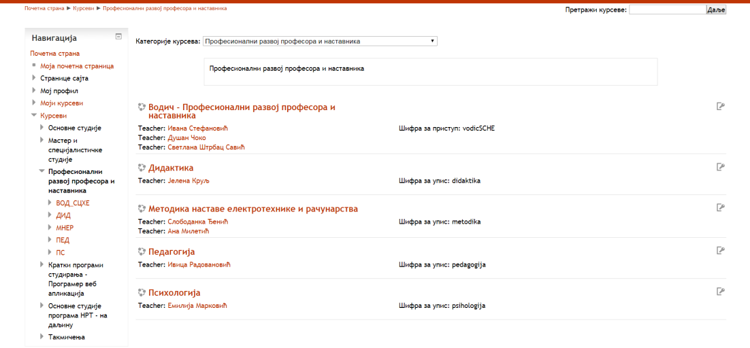
Fig.1.4 Program structure on LSD Moodle

Enrollment process and enrolled students
News about scholarship for part-time and short-cycle pilot studies was published on official project web site and VISER web site. News is still available on link:
http://pt-sche.metropolitan.ac.rs/2017/10/02/school-of-electrical-and-computer-engineering-of-applied-studies-in-belgrade-in-school-year-20172018-offered-scholarships-for-part-time-and-short-cycle-pilot-studies/
Fig.2.1 New on project website and VISER website
Candidate application for two short cycle F2F programs and one online short cycle program was published on VISER official web site and on project official web site. Data that was required from candidate was candidate name, phone number, institution on which candidate works (if he works) and data about completed studies. Candidate application was conducted by e-mail communication with potential candidates.
http://websrv3.viser.edu.rs/index.php?page=static&id=1035
VISER enrolled 92 students to F2F program Professional development of professors and teachers.
First enrolled was organized in October 2017 and 66 students were enrolled to Professional development of professors and teachers program. Second enrollment to the same program was organized in January 2018 and 26 students were enrolled to Professional development of professors and teachers program.
List of enrolled students is given in the Table 1.

No | List of enrolled students to F2F program Professional development of professors and teachers program on October 2017 | List of enrolled students to F2F program Professional development of professors and teachers program on February 2018
 | Aleksandar Petrović | Albert Kazi
 | Ana Jandrlić | Borko Čupić
 | Anes Hadžibegović | Branislav Pajević
 | Biljana Živković | Vladimir Jeger
 | Boban Ilić | Danijela Kuzminac
 | Boško Bogojević | Dragan Đorđević
 | Valentina Stoiljković | Dragana Lazarević
 | Vladimir Kukolj | Dušan Marinković
 | Vojin Savić | Ivan Ilić
 | Vojislav Vlašić | Ivana Kilibarda
 | Goran Krivačević | Irena Hribšek
 | Gordana Stanojević | Jasna Pantelić
 | Daniejla Atanacković | Jasna Ristić
 | Dejan Arsić | Jelena Lopičić
 | Dejan Piščević | Marijana Guguljan
 | Dejan Banković | Marijana Spasenić
 | Dijana Stefanović | Martina Jug
 | Dobrila Dedić | Milena Jašović
 | Dragan Kreculj | Miloš Mirčevski
 | Dragan Turajlić | Miloš Jelkić
 | Dragana Popović | Novica Gutović
 | Dragana Vesić | Radovan Ninković
 | Dragoljub Marjanović | Senka Kalember-Mihajlović
 | Dušan Grbić | Siniša Mijić
 | Željko Kljajić | Slavko Bjelović
 | Zoran Karadolamović | Stanimir Ranković
 | Zoran Tomić
 | Ivan Dobričanin
 | Ivana Selenić (Rajković)
 | Ivica Petrović
 | Jasmina Pavlović
 | Jelena Tomić
 | Jelena Ilić
 | Jelena Maletić
 | Jovan Mitrović
 | Jovana Vasilić
 | Julijana Ristić
 | Kristina Jovanović
 | Lela Rabrenović
 | Maja Đurđević
 | Maja Jovanović
 | Maja Martić
 | Marija Krpić
 | Marija Begović
 | Marijo Radić
 | Marko Antić
 | Milan Josipović
 | Milan Savić
 | Milan Devrnja
 | Milenko Mavrak
 | Milica Čolić Panić
 | Miloš Rogović
 | Miloš Marković
 | Nadica Milinković
 | Nataša Štrbac-Hadžibegović
 | Nemanja Ćevap
 | Petar Tepavac
 | Predrag Šubarević
 | Rada Marsenić
 | Radovan Đurić
 | Saša Đelević
 | Saša Rakić
 | Svjetlana Gavrilović-Janković
 | Slađana Vasilić
 | Snježana Dugandžić
 | Sonja Ljubojević
Table 1 – List of enrolled students to Professional development of professors and teachers F2F program
Lists of enrolled students to F2F program Professional development of professors and teachers program are available from the VISER site on links:
https://www.viser.edu.rs/download/2301
and also
https://www.viser.edu.rs/projekti/ptsche

All enrolled students have previous finished undergraduate studies. Fig. 2.2 shows their previous education.
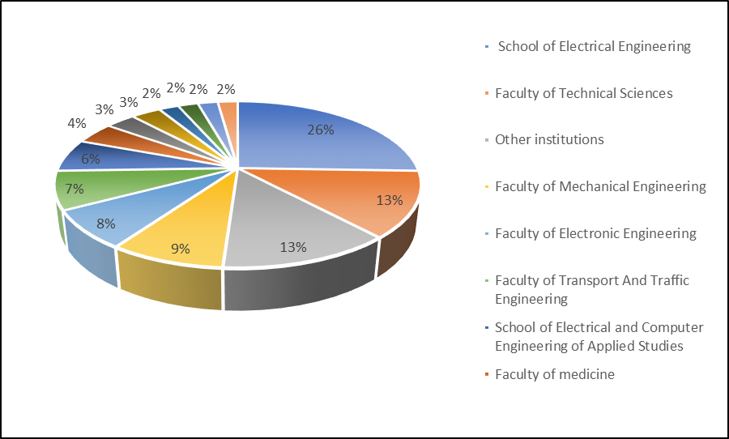
Fig.2.2 Previous education of enrolled students to short cycle program Professional development of professors and teachers

Realization of short cycle program “Vehicle diagnostics”
Short cycle program Vehicle diagnostics is intended to people who already work as technicians in car workshops and who want to improve their knowledge and other people who would like to adopt necessary theoretical and practical fundamentals from the field of vehicle diagnosis.
Modern motor vehicles cannot be imagined without sophisticated management system, which means large-scale use of electronic control units and electronic components in management systems of motor vehicles. Because of strong technological progress and the emergence of new technologies, maintenance and repair of motor vehicles require a new profile of professionals who possess multidisciplinary knowledge from mechanical engineering, electrical engineering and computer science. In order to solve complex diagnosis problems of motor vehicles, trained mechatronic professionals are required, capable for performing proper communication and oscilloscope measurements into vehicle systems by usage of modern diagnostic tools.
This program was organized summer semester in 2017/2018 school year. Program duration was one semester and 30 ECTS. Five courses were organized:
- Basics of Vehicle Diagnostics,
- Sensors and Actuators,
- Ignition and Injection Systems in Gasoline Engines,
- Injection Systems in Diesel Engines and.
- Systems of Vehicle Stability, Passenger Safety and Comfort.

All the courses have 6 ECTS. Teaching process was organized at VISER during weekends since most of the enrolled student work. The teaching contained both theoretical and practical parts. Practical teaching was held in VISER’s Training Centre for Automotive Diagnostics (equipped with following equipment: scissor lift with lifting table and front recesses for wheel alignment, wheel alignment gauge, roller brake tester, hybrid vehicle mustimeter, OBDII scanner device and other measurement tools)

No | List of enrolled students to F2F program Professional development of professors and teachers program on February 2018
 | Branislav Pajević
 | Goran Manojlović
 | Gradimir Filipović
 | Davor Čubrilo
 | Ivan Savić
 | Milan Vučić
 | Perica Lepović
 | Slađan Stojanović
 | Marko Đurović

Table 1 – List of enrolled students to Vehicle diagnostics F2F program

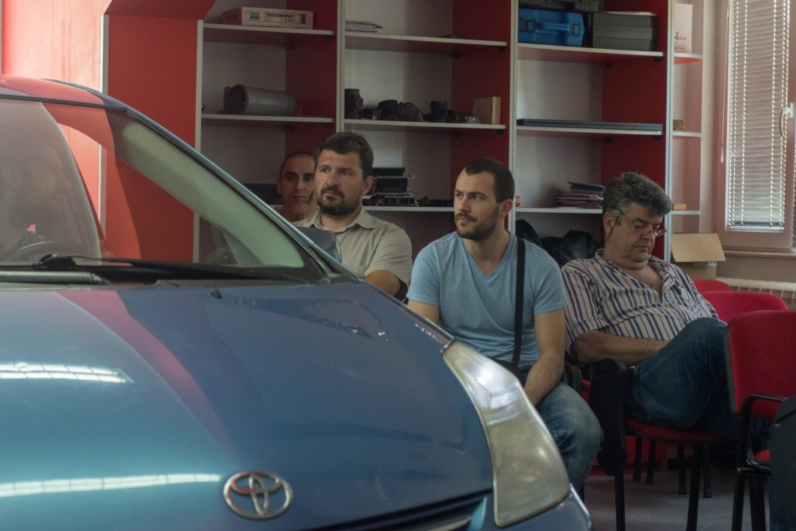.
Fig.4.1 Practical training in Training Centre for Automotive Diagnostics in VISER

Nine students were enrolled to short cycle program Vehicle diagnostics list of their manes is in Table 1. 7 of them were from Belgrade and 2 from Kikinda. Six students were already employed. Previous education of enrolled students to short cycle program Vehicle diagnostics is presented on Fig. 4.2
All 9 students enrolled to short cycle program Vehicle diagnostics successfully finished the programe.

Fig.4.2 Previous education of enrolled students to short cycle program Vehicle diagnostics

Administration of short cycle programs
All necessary documentation for student’s registration was collected at the time of enrollment and in additional terms envisaged for the submission of documents. After collecting paper documents, an electronic database was created exclusively for students enrolled to F2F and short online cycle programs. For each student, the following data is entered:
- first name,
- last name,
- unique personal number,
- completed studies,
- the institution on which student works,
- phone number,
- mail address,
- enrolled course,
- date of enrollment to course,
- user name and
- password.

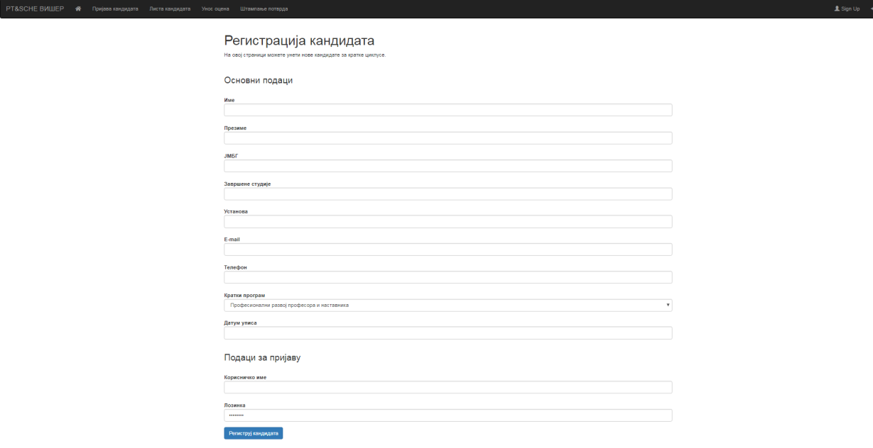
Fig.4.2 Registration of candidates

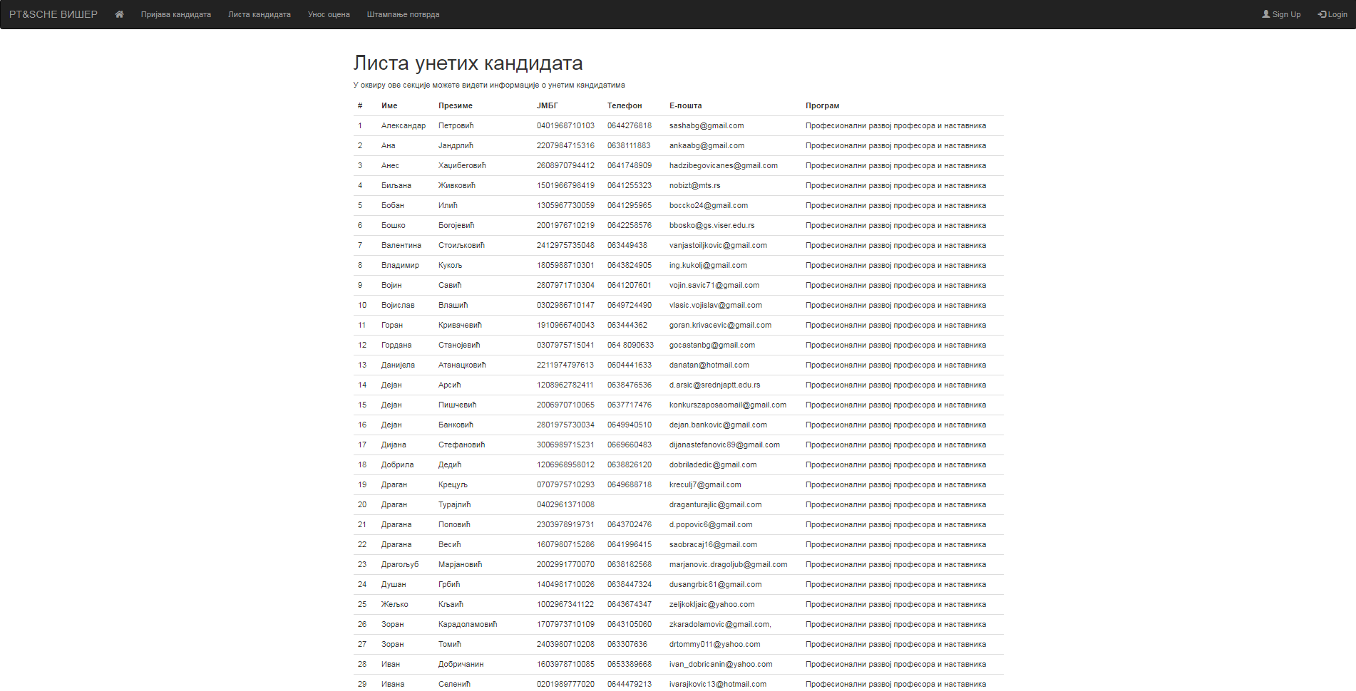
Fig.4.3 Report from application for registration of enrolled candidates
This electronic database beside student data also contains students’ marks and data for certificates.
Fig.4.4 Screenshot of form for entering data on exams on short cycle programs

Learning materials
Learning materials to F2F programs and online short cycle program was free of charge for the students.
Three types of learning materials were created:
- Printed materials,
- Online learning materials are available on Moodle Learning Platform http://lectio.viser.edu.rs/moodle/, and
- Multimedia materials recorded for short cycle program Vehicle diagnostics available on http://sche.viser.edu.rs/
Printed publications prepared for short-cycle program students are:
- Pedagogy Workbook
- Web design Workbook
- Ignition and injection systems in Internal combustion engines - Workbook
On Moodle Learning Platform for every course topic of short cycle programs Professional development of professors and teachers and Web application programmer the students have access to learning materials.
Fig.3.1 Online learning materials
Students also have access to Interactive materials, questionnaires and tests.
Fig.3.2 Test on LSD Moodle

Exams
Students of short cycle programs take exams at the same time as other students of VISER. All exams on short cycle F2F programs were organized on weekends. Students of F2F programs and online short cycle program have the right to take the exam free at any exams period without registering. Paper registration was prepared for each student in each exams period. Paper registration for each student contain name of student, name of professor, exams period and date of exams, course code and number of ESPB point. Paper registration and list of students was given to professors for each exam. After exams professors return fulfill paper exams registration (Fig 6.1).
Fig.6.1 Paper exams registration
Information on the terms of the exams and results of the exams was available on VISER website and emails were sent to students using Moodle platform information tools.
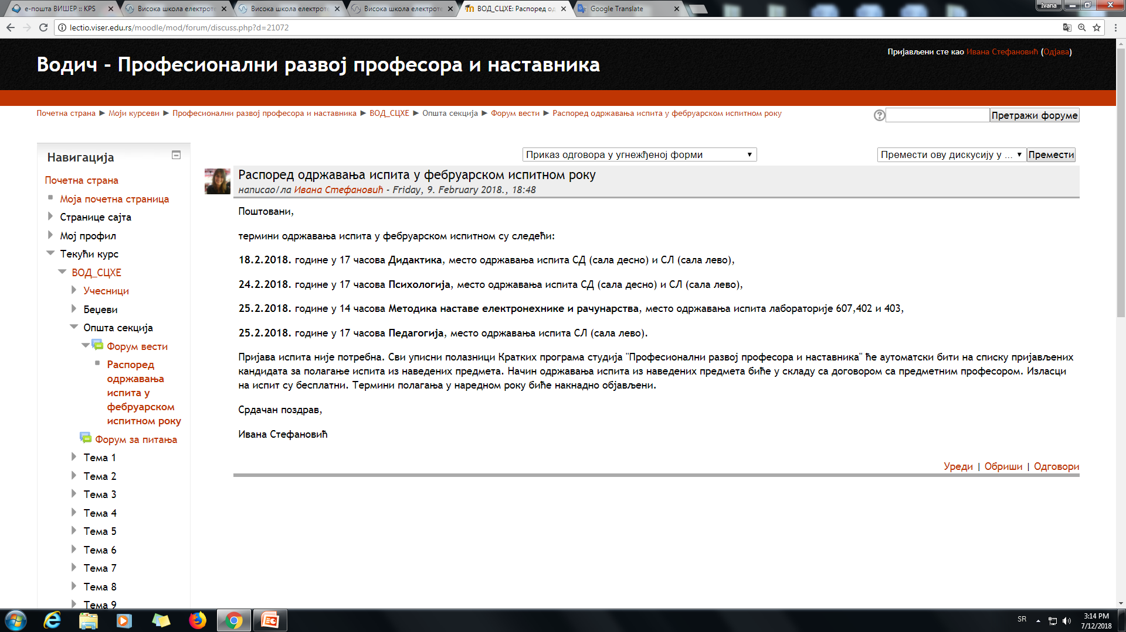
Fig.6.2 Information on Moodle about the examination schedule
Beside paper documentation all exams marks and data are entered and saved in electronic database fig. 6.3
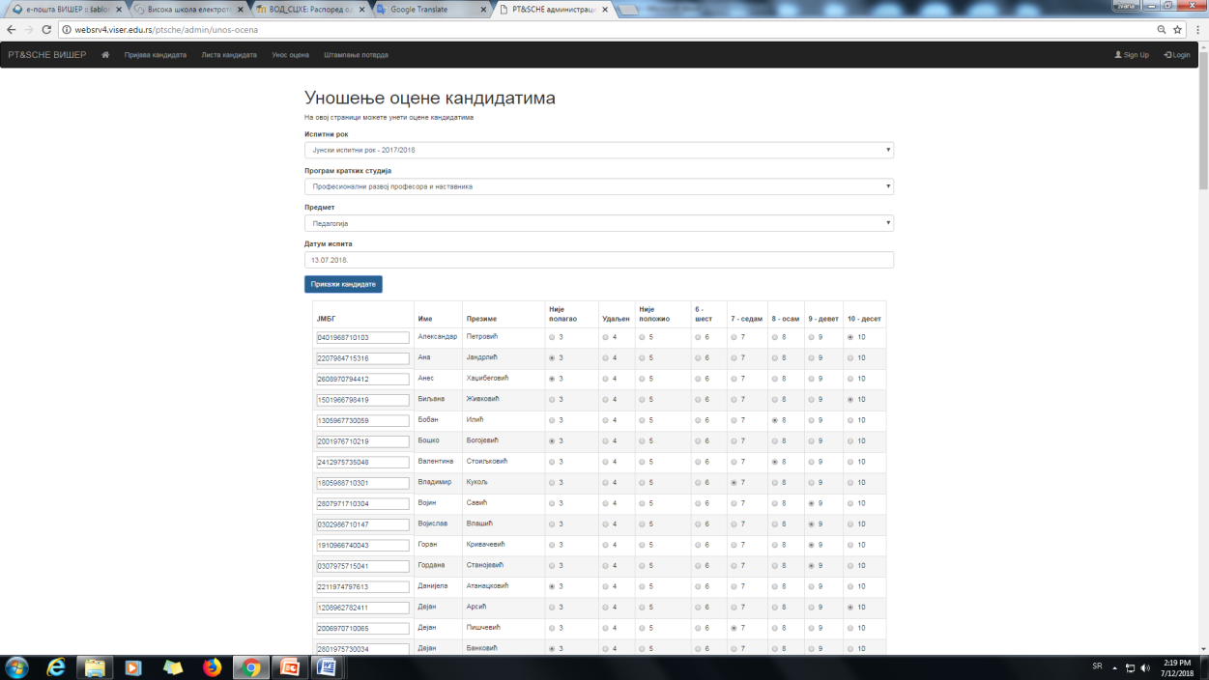
Fig.6.3 Screenshot of application for registering students' activities

Survey
During 2018 the survey about short cycle studies was conducted in School of Electrical and Computer Engineering of Applied Studies. In total 83 candidates took the survey. 63 candidates are from Professional development of professors and teachers short cycle studies, 9 from Vehicle diagnostics and 11 from Web application programmer short cycle studies.

Questions in survey
About short cycle studies in VISER

- Which short cycle studies did you enrolled:
- Professional development of professors and teachers
- Vehicle diagnostics
- Web application programmer

- Mark the quality of lectures held on shoгt cycle studies:
None 1 2 3 4 5

- Mark the consultation and relationship professor, student of shoгt cycle studies:
None 1 2 3 4 5

- Mark work conditions on shoгt cycle studies:
None 1 2 3 4 5

- Mark learning materials on shoгt cycle studies:
None 1 2 3 4 5

- In your opinion are shoгt cycle studies adequate type of professional development:
None Yes No

- Mark organization of shoгt cycle studies:
None 1 2 3 4 5

- Whether teaching has fulfilled your expectations:
None 1 2 3 4 5

- Knowledge gained from shoгt cycle studies while by useful in future work:
None 1 2 3 4 5

- Remarks and suggestions about this shoгt cycle studies:

Survey about short cycle studies in VISER - Professional development of professors and teachers –

- Which short cycle studies did you enrolled

 | Number of answers
Professional development of professors and teachers | 63
Vehicle diagnostics | 9
Web application programmer | 11

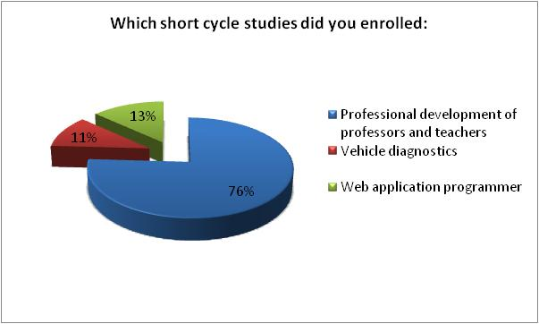

- Mark the quality of lectures held on short cycle studies

Mark | Number of  answers
mark 5 | 49
mark 4 | 9
mark 3 | 4
mark 2 | 0
mark 1 | 0
none | 1
average mark: | 4.65

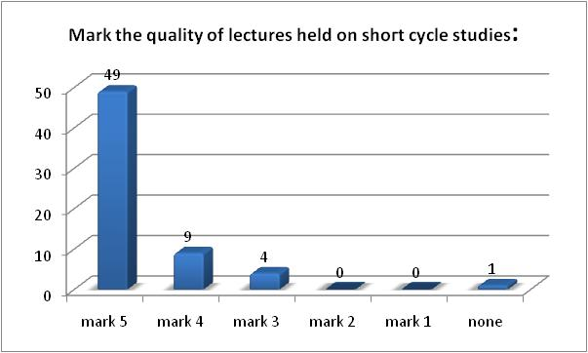

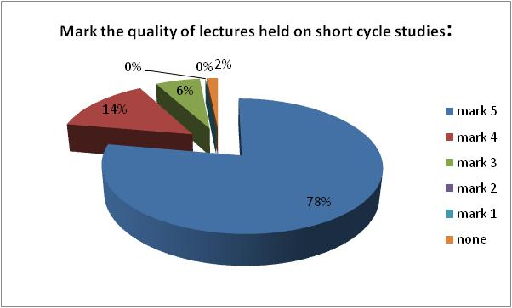

- Mark the consultation and relationship professor, student of short cycle studies

Mark | Number of answers
mark 5 | 45
mark 4 | 10
mark 3 | 5
mark 2 | 0
mark 1 | 0
none | 3
average mark: | 4.67

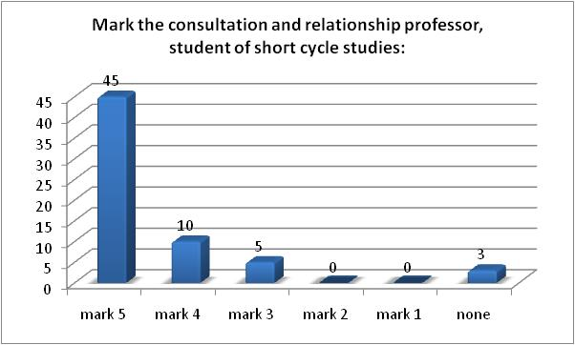

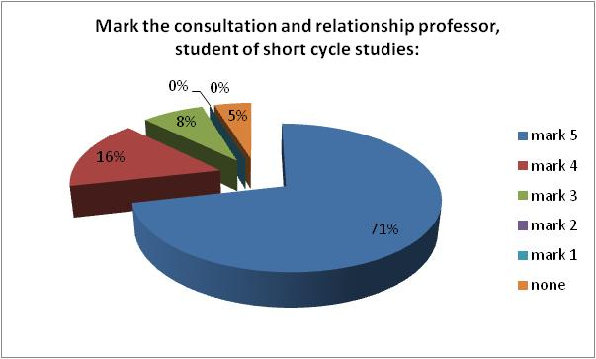

- Mark work conditions on short cycle studies

Mark | Number of answers
mark 5 | 52
mark 4 | 7
mark 3 | 2
mark 2 | 1
mark 1 | 0
none | 1
average mark: | 4.77

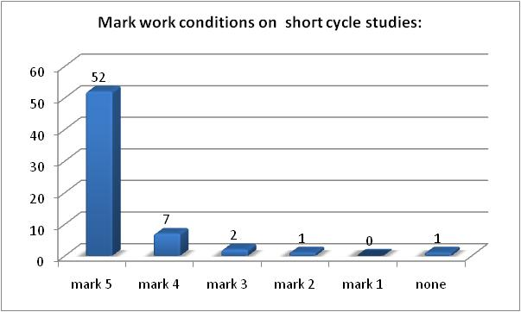

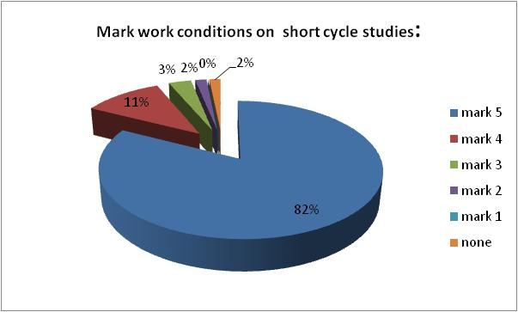

- Mark learning materials on short cycle studies

Mark | Number of answers
mark 5 | 41
mark 4 | 13
mark 3 | 5
mark 2 | 1
mark 1 | 0
none | 1
average mark: | 4.57

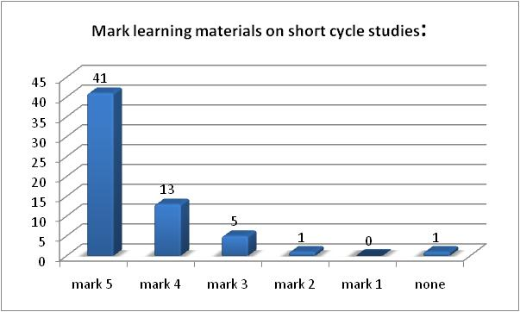

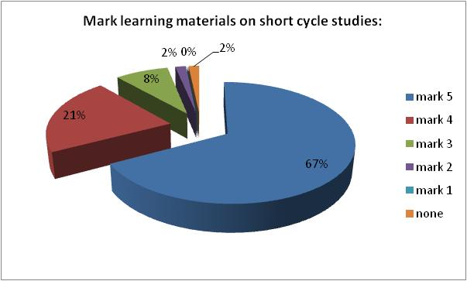

- In your opinion are short cycle studies adequate type of professional development

Mark | Number of answers
Yes | 48
No | 9
None | 6

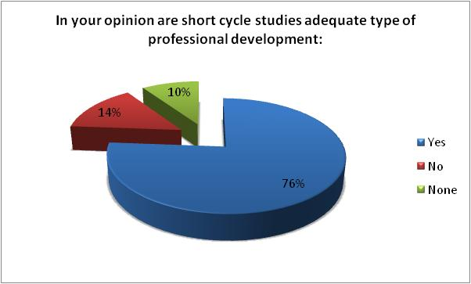

- Mark organization of short cycle studies

Mark | Number of answers
mark 5 | 43
mark 4 | 15
mark 3 | 4
mark 2 | 1
mark 1 | 0
none | 0
average mark: | 4.59

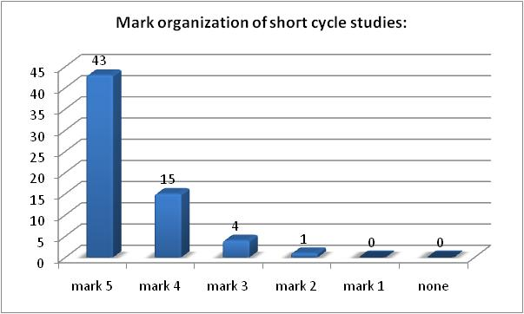

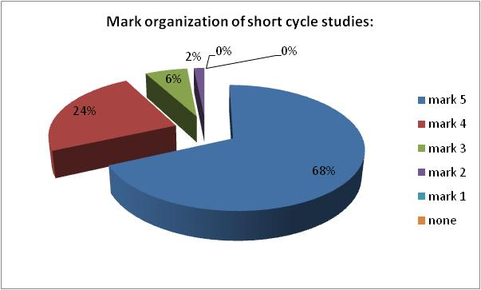

- Whether teaching has fulfilled your expectations

Mark | Number of answers
mark 5 | 42
mark 4 | 14
mark 3 | 2
mark 2 | 1
mark 1 | 0
none | 4
average mark: | 4.64

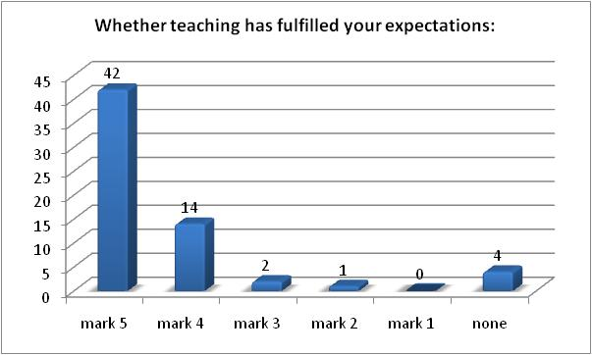

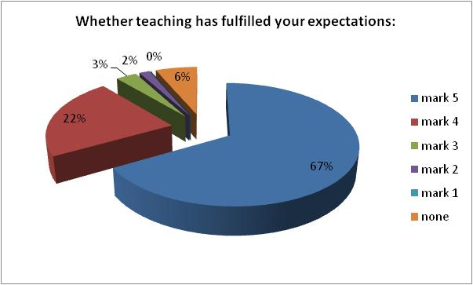

- Knowledge gained from short cycle studies while by useful in future work

Mark | Number of answers
mark 5 | 50
mark 4 | 9
mark 3 | 2
mark 2 | 1
mark 1 | 0
none | 1
average mark: | 4.74

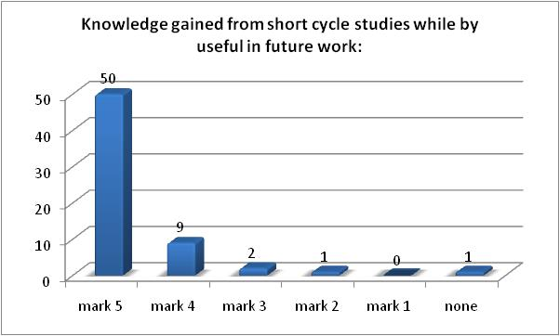

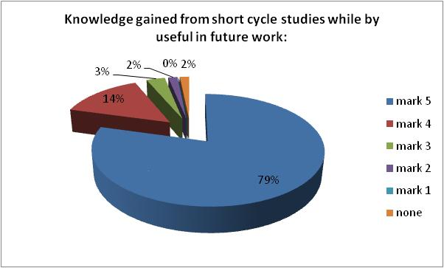

10. Remarks and suggestions about this short cycle studies

None

Survey about short cycle studies in VISER - Vehicle diagnostics –

- Which short cycle studies did you enrolled

 | Number of answers
Professional development of professors and teachers | 63
Vehicle diagnostics | 9
Web application programmer | 11

- Mark the quality of lectures held on short cycle studies

Mark | Number of answers
mark 5 | 8
mark 4 | 1
mark 3 | 0
mark 2 | 0
mark 1 | 0
none | 0
average mark: | 4.89

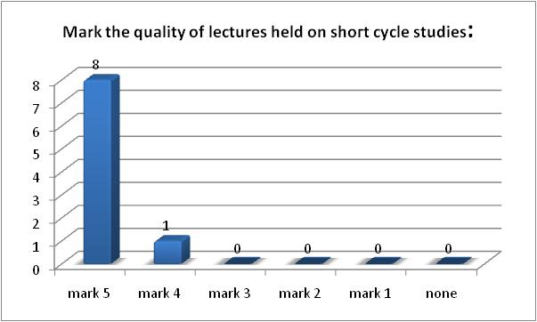

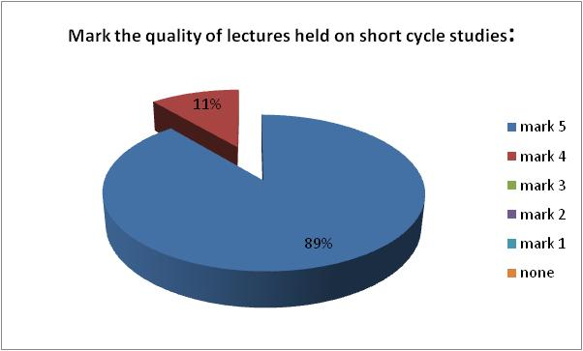

- Mark the consultation and relationship professor, student of shoгt cycle studies

Mark | Number of answers
mark 5 | 7
mark 4 | 1
mark 3 | 1
mark 2 | 0
mark 1 | 0
none | 0
average mark: | 4.67

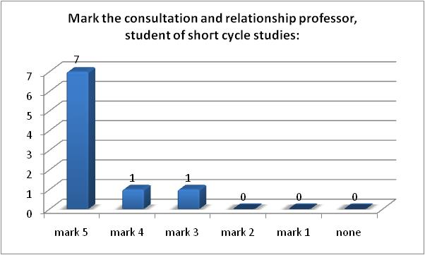

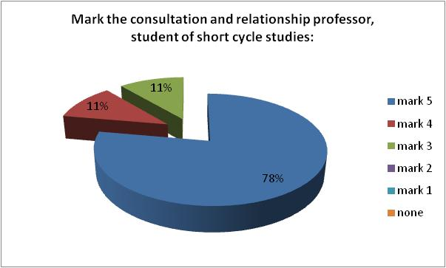

- Mark work conditions on shoгt cycle studies

Mark | Number of answers
mark 5 | 9
mark 4 | 0
mark 3 | 0
mark 2 | 0
mark 1 | 0
none | 0
average mark: | 5.00

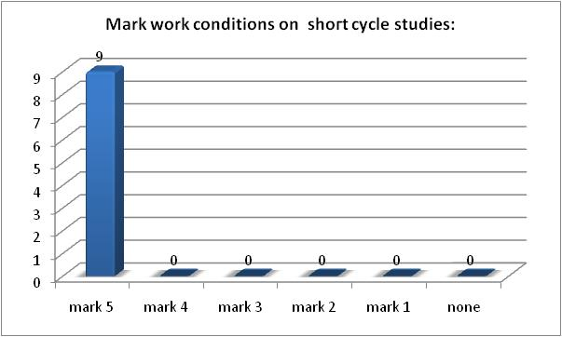

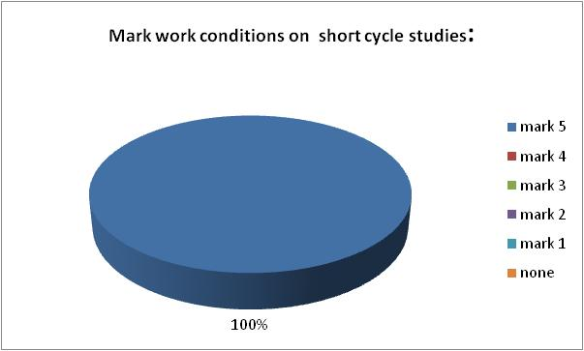

- Mark learning materials on shoгt cycle studies

Mark | Number of answers
mark 5 | 6
mark 4 | 2
mark 3 | 1
mark 2 | 0
mark 1 | 0
none | 0
average mark: | 4.56

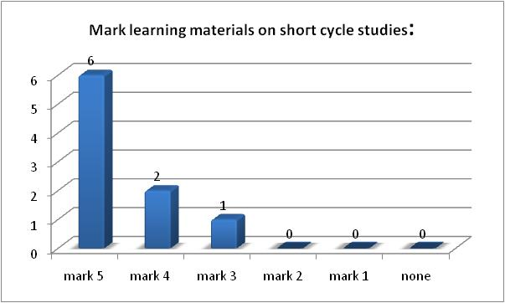

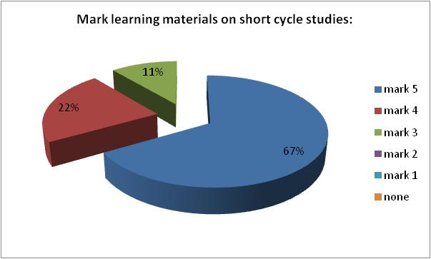

- In your opinion are shoгt cycle studies adequate type of professional development

Mark | Number of answers
Yes | 7
No | 0
None | 2

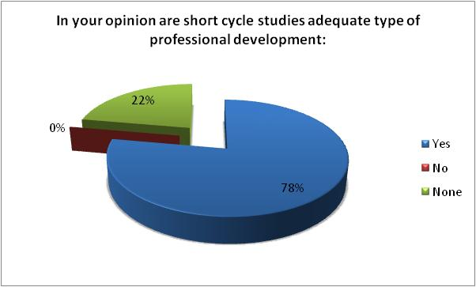

- Mark organization of shoгt cycle studies

Mark | Number of answers
mark 5 | 7
mark 4 | 1
mark 3 | 1
mark 2 | 0
mark 1 | 0
none | 0
average mark: | 4.67

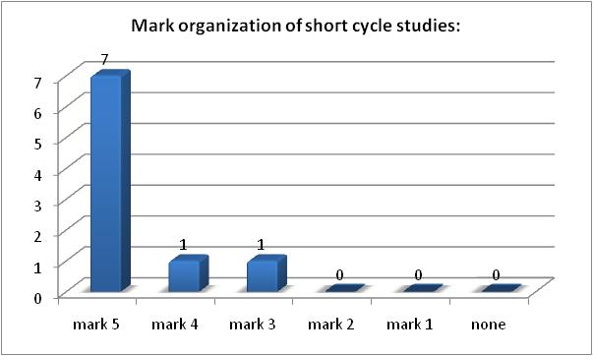

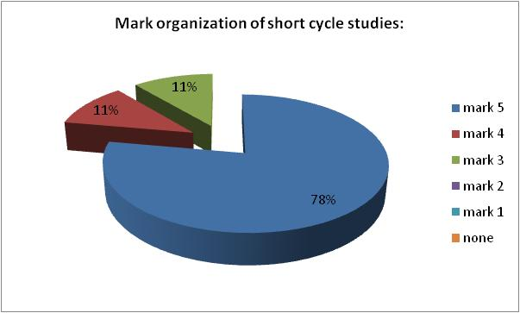

- Whether teaching has fulfilled your expectations

Mark | Number of answers
mark 5 | 6
mark 4 | 2
mark 3 | 1
mark 2 | 0
mark 1 | 0
none | 0
average mark: | 4.56

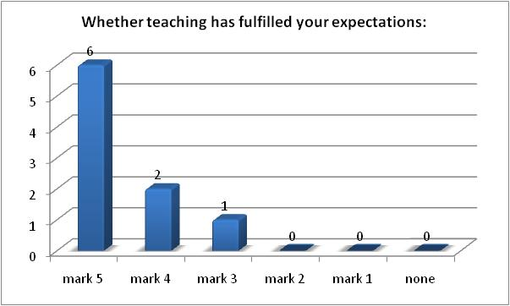

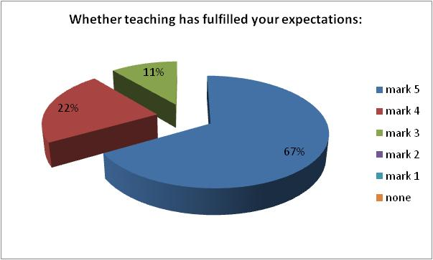

- Knowledge gained from shoгt cycle studies while by useful in future work

Mark | Number of answers
mark 5 | 6
mark 4 | 1
mark 3 | 0
mark 2 | 0
mark 1 | 0
none | 2
average mark: | 4.86

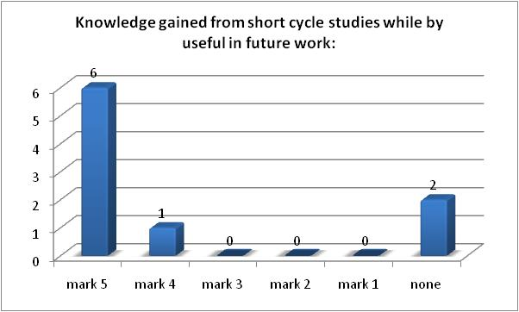

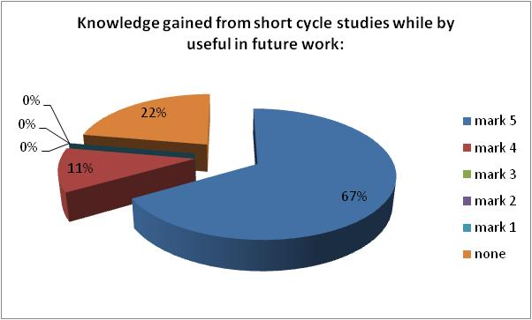

- Remarks and suggestions about this shoгt cycle studies

None

Average mark on short cycle program Vehicle diagnostics

Question number | Question | Mark
Question 2. | Mark the quality of lectures held on shoгt cycle studies: | 4.89
Question 3. | Mark the consultation and relationship professor, student of shoгt cycle studies: | 4.67
Question 4. | Mark work conditions on shoгt cycle studies: | 5.00
Question 5. | Mark learning materials on shoгt cycle studies: | 4.56
Question 7. | Mark organization of shoгt cycle studies: | 4.67
Question 8. | Whether teaching has fulfilled your expectations: | 4.56
Question 9. | Knowledge gained from shoгt cycle studies while by useful in future work: | 4.86
 | average mark: | 4.74

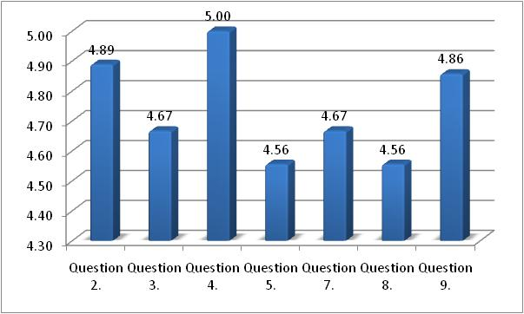

Average mark on short cycle Vehicle diagnostics studies is 4,74.

Average mark on short cycle program Professional development of professors and teachers
Question number | Question | Mark
Question 2. | Mark the quality of lectures held on shoгt cycle studies: | 4.65
Question 3. | Mark the consultation and relationship professor, student of shoгt cycle studies: | 4.67
Question 4. | Mark work conditions on shoгt cycle studies: | 4.77
Question 5. | Mark learning materials on shoгt cycle studies: | 4.57
Question 7. | Mark organization of shoгt cycle studies: | 4.59
Question 8. | Whether teaching has fulfilled your expectations: | 4.64
Question 9. | Knowledge gained from shoгt cycle studies while by useful in future work: | 4.74
 | average mark: | 4.66

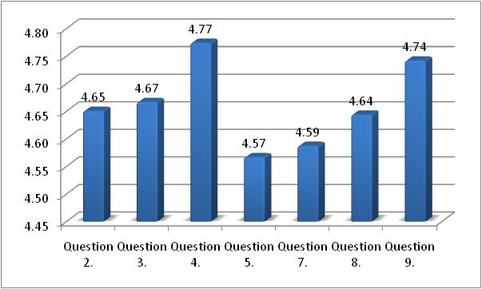
Average mark on short cycle Professional development of professors and teachers studies is 4,66.

Sertificate
Official certificates for completed short programs are not yet defined by the Ministry of Education of the Republic of Serbia. The issue of official certificates should be resolved by sub-legal acts which are not yet published.
VISER has made a certificate for all the students who successfully completed short cycle program (Fig. 8.1 and Fig. 8.3). Certificate includes basic information on the student, and finished short cycle program, number of ECTS of the program, and an attachment to certificate which includes marks and number of ECTS for every course on the program (Fig. 8.2 and Fig. 8.4).
So far, a total of 88 students have finished short Cycle programs organized by VISER:
- 70 students finished short cycle F2F program Professional development of professors and teachers Table 8.1.
- 9 students finished short cycle F2F program Vehicle diagnostics Table 8.2.
- 9 students finished online short cycle program Web application programmer Table 8.3.
 | Презиме и име | Didactics | Methodology of teaching | Pedagogy Psychology
1 | Кази Алберт | 7 | 8 | 9 | 7
2 | Петровић Александар | 8 | 10 | 10 | 9
3 | Живковић Биљана | 7 | 8 | 10 | 6
4 | Илић Бобан | 6 | 8 | 8 | 6
5 | Стоиљковић Валентина | 7 | 10 | 8 | 6
6 | Јегер Владимир | 9 | 9 | 7 | 8
7 | Кукољ Владимир | 6 | 7 | 7 | 6
8 | Савић Војин | 6 | 7 | 9 | 7
9 | Влашић Војислав | 7 | 10 | 9 | 8
10 | Кривачевић Горан | 7 | 10 | 9 | 8
11 | Станојевић Гордана | 8 | 9 | 9 | 7
12 | Атанацковић Данијела | 7 | 8 | 7 | 6
13 | Кузминац Данијела | 8 | 9 | 7 | 8
14 | Арсић Дејан | 6 | 10 | 10 | 6
15 | Банковић Дејан | 7 | 8 | 7 | 7
16 | Пишчевић Дејан | 7 | 10 | 7 | 6
17 | Стефановић Дијана | 7 | 9 | 9 | 6
18 | Дедић Добрила | 7 | 9 | 10 | 8
19 | ЂорђевићДраган | 8 | 7 | 9 | 8
20 | Крецуљ Драган | 9 | 9 | 9 | 8
21 | Турајлић Драган | 6 | 9 | 8 | 9
22 | Лазаревић Драгана | 10 | 10 | 10 | 6
23 | Поповић Драгана | 10 | 10 | 9 | 6
24 | Маринковић Душан | 8 | 8 | 8 | 9
25 | Кљаић Жељко | 6 | 8 | 9 | 9
26 | Карадоламовић Зоран | 6 | 8 | 7 | 7
27 | Добричанин Иван | 6 | 9 | 8 | 7
28 | Илић Иван | 8 | 7 | 6 | 10
29 | Килибарда Ивана | 8 | 9 | 6 | 6
30 | Селенић Ивана | 8 | 9 | 10 | 9
31 | Петровић Ивица | 6 | 7 | 6 | 7
32 | Павловић Јасмина | 6 | 9 | 10 | 7
33 | Илић Јелена | 6 | 9 | 9 | 6
34 | Лопичић Јелена | 8 | 9 | 7 | 10
35 | Малетић Јелена | 7 | 8 | 9 | 7
36 | Митровић Јован | 8 | 8 | 8 | 7
37 | Василић Јована | 8 | 8 | 8 | 7
38 | Ристић Јулијана | 7 | 6 | 9 | 6
39 | Рабреновић Лела | 8 | 9 | 10 | 6
40 | Ђурђевић Маја | 7 | 7 | 9 | 9
41 | Јовановић Маја | 10 | 9 | 10
42 | Беговић Марија | 6 | 9 | 9 | 8
43 | Крпић Марија | 9 | 10 | 9 | 8
44 | Гугуљан Маријана | 10 | 9 | 10 | 9
45 | Спасенић Маријана | 10 | 10 | 10 | 10
46 | Радић Маријо | 7 | 9 | 10 | 7
47 | Деврња Милан | 6 | 8 | 7 | 8
48 | Јосиповић Милан | 8 | 8 | 6 | 6
49 | Савић Милан | 6 | 9 | 10 | 9
50 | Маврак Миленко | 6 | 8 | 8 | 6
51 | Чолић-Панић Милица | 8 | 10 | 10 | 7
52 | Јелкић Милош | 8 | 10 | 9 | 6
53 | Роговић Милош | 6 | 8 | 8 | 6
54 | Милинковић Надица | 7 | 9 | 10 | 6
55 | Штрбац-Хаџибеговић Наташа | 6 | 10 | 9 | 8
56 | Ћевап Немања | 6 | 8 | 8 | 6
57 | Гутовић Новица | 8 | 9 | 9 | 6
58 | Шубаревић Предраг | 7 | 7 | 7 | 6
59 | Марсенић Рада | 10 | 9 | 10 | 8
60 | Ђурић Радован | 6 | 9 | 9 | 8
61 | Нинковић Радован | 7 | 10 | 9 | 6
62 | Ђелевић Саша | 10 | 10 | 10 | 6
63 | Ракић Саша | 8 | 9 | 10 | 9
64 | Гавриловић-Јанковић Свјетлана | 9 | 6 | 6 | 7
65 | Бјеловић Славко | 10 | 10 | 10 | 10
66 | Василић Слађана | 7 | 7 | 7 | 7
67 | Дуганџић Сњежана | 7 | 9 | 10 | 9
68 | Љубојевић Соња | 9 | 10 | 8 | 9
69 | Ранковић Станимир | 8 | 8 | 9 | 7
70 | Миљковић-Станојевић Тамара | 10 | 9 | 7 | 10
Table8.1 List of students who fineshed SCHE Professional development of professors and teachers

 | Student’s name
1 | Branislav Pajević
2 | Goran Manojlović
3 | Gradimir Filipović
4 | Davor Čubrilo
5 | Ivan Savić
6 | Milan Vučić
7 | Perica Lepović
8 | Slađan Stojanović
9 | Marko Đurović
Table8.2 List of students who fineshed SCHE Vehicle diagnostics

 | Student’s name
1 | Almaši Jasmina
2 | Karić Nevenka
3 | Njegomir Milan
4 | Pastor Zagorka
5 | Petrović Nenad
6 | Simović Slaviša
7 | Simonović Dejan
8 | Takov Marina
9 | Ćurčin Relja
Table8.3 List of students who fineshed SCHE Web application programmer

Fig.8.1 Certificate of completed Vehicle diagnostics program
Fig.8.2 Attachment to certificate of completed Vehicle diagnostics program
Fig.8.3 Certificate of completed program Professional development of professors and teachers
Fig.8.4 Attachment to certificate of completed program Professional development of professors and teachers

Realization of pilot part-time program Information Systems
Information Systems is an accredited bachelor studies program at VISER. Program has 180 ECTS and its duration is three years. The the list of courses is given in Table 9.1 along with the number of the semester and the number and type of classes in the course.by week. a detailed description of the curriculum is provided in the separate report of the activity 6.1. All the courses are elective except:
- Mathematics in Engineering
- Electrical Engineering
- Foreign language (English Language or German Language)
- Internship
- Information systems, and
- Final Thesis
First generation of students was enrolled to this program in school year 2017/018. In June 2017 the low on high education didn’t allow part-time studies, that is why first part-time students were enrolled to this study regime in school year 2018/2018. In Republic of Serbia part-time study is recognized as “studying and working”, and only employed students can be part-time students.

No | Subject Name | Sem. | Number of classes | ESPB
1. | Mathematics in Engineering | 1. | 3+3+0 | 7
2. | Electrical Engineering | 1. | 3+3+0 | 7
3. | English Language | 1. | 2+1+0 | 4
4. | German Language | 1. | 2+1+0 | 4
5. | Management | 1. | 2+3+0 | 6
6. | Introduction to Cloud Computing | 1. | 2+3+0 | 6
7. | Application Software | 1. | 2+3+0 | 6
8 | Internet Marketing | 2. | 2+3+0 | 6
9. | Basics of Informatics and Computing | 2. | 2+3+0 | 6
10. | Internet Services | 2. | 2+3+0 | 6
11. | Sales Management | 2. | 2+3+0 | 6
12. | Introduction to Object Programming | 2. | 2+3+0 | 6
13. | E-Business | 2. | 2+3+0 | 6
14. | Business plan | 3. | 2+3+0 | 6
15. | Probability and Statistics | 3. | 2+3+0 | 6
16. | Introduction to Internet Technology | 3. | 2+2+1 | 6
17. | Database programming | 3. | 2+2+1 | 6
18. | Projects Management | 3. | 2+3+0 | 6
19. | Web Design | 3. | 2+3+0 | 6
20. | Е-Commerce | 4. | 2+3+0 | 6
21. | Object Oriented Design | 4. | 2+2+1 | 6
22. | Operating Systems 1 | 4. | 2+2+1 | 6
23. | Social Networks Analysis | 4. | 2+3+0 | 6
24. | Computer networking | 4. | 2+2+1 | 6
25. | Business Communication | 4. | 2+3+0 | 6
26. | E – Banking | 5. | 3+2+0 | 6
27. | Information Systems Security | 5. | 3+0+2 | 6
28. | Web Applications programming | 5. | 3+0+2 | 6
29. | Business Software | 5. | 2+3+0 | 6
30. | Internet Programming | 5. | 3+0+2 | 6
31. | Internship | 5. |  | 4
32. | Internet of Things | 6. | 3+2+0 | 6
33. | Mobile devices programming | 6. | 3+0+2 | 6
34. | Data Analysis | 6. | 3+2+0 | 6
35. | Entrepreneurship | 6. | 3+2+0 | 6
36. | Information systems | 6. | 3+2+0 | 6
37. | Final Thesis | 6. |  | 8
Table 9.1 The curriculum of Information Systems

The information on part-time study was published on VISER website (fig.9.1) and on Facebook and Instagram profiles of VISER. On the ceremony of reception of first year students of Information Systems the possibility of part-time study and the benefits that this type of study were explained to students.
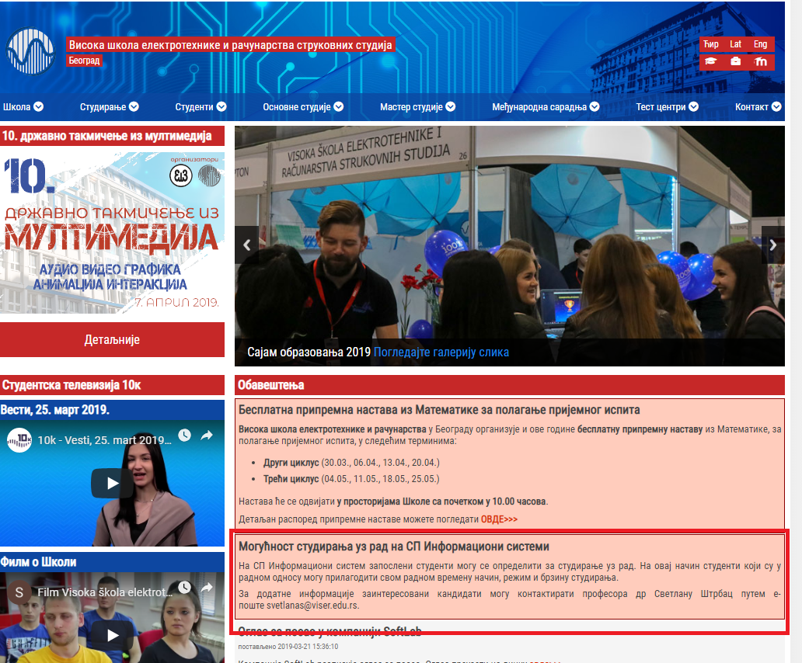
Fig. 9.1 Information about the part-time program Information Systems on the home page of VISER website https://www.viser.edu.rs
Although a large number of students were interested in this mode of study, 3 students are enrolled to part-time study:
- Aleksa Mirković IS-10/18
- Ranko Stefanović IS-5/18
- Sava Djordjević IS-58/18

The low on high education has allowed part-time students to choose from 30 to 60 ECTS per year. Reducing the number of points is not what attracted students to apply for this regime of studies, but the flexibility in fulfilling the obligations and teaching terms.
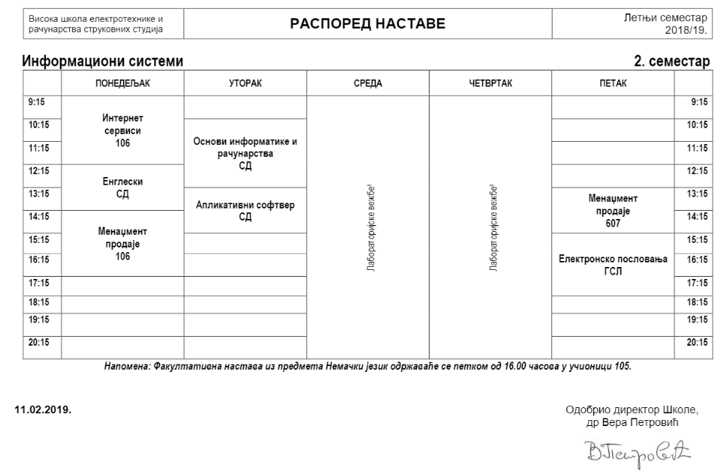
Fig. 9.2 Schedule of classes for regular students in the Information Systems study program https://www.viser.edu.rs/raspored-nastave

The problem is how to organize teaching classes (Fig.9.2) when all the enrolled students are employed and they have different working hours. Some of students work on Saturdays, some work in the afternoon. Considering that it was decided not to organize classes in the afternoon or weekends, but to organize mentoring classes of theoretical teaching. Students of part-time program are given the opportunity to earn points during classes, in the manner in which the professor determines it (seminar work, homework, etc.). All the teaching and learning materials are available for part-time students mostly by Moodle platform, and professors who do not have Moodle course had the obligation to provide student with all the learning materials as well as with terms for mentorship classes. For each course, students had to have consulting appointments in the course of the week before noon and in the afternoon, as some who students change shifts at work can come to consultation.

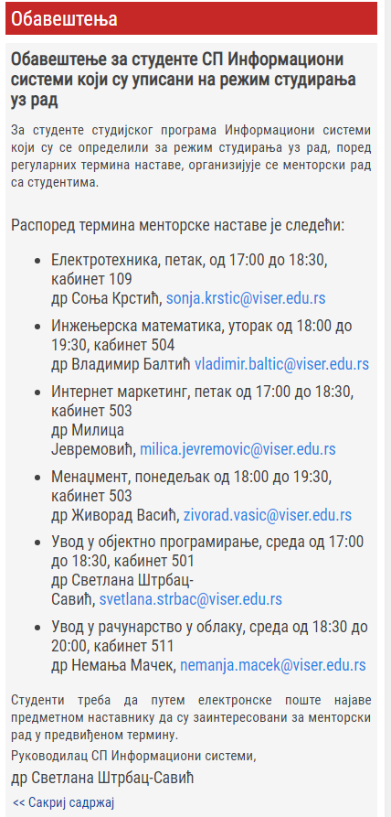
Fig. 9.3 Information of consulting appointments for part-time students https://www.viser.edu.rs/projekti/ptsche

In VISER practical classes, on the majority of courses usually organized as laboratory exercises are obligatory. Since VISER is high institution of applied studies, and practical training is very important for our students, it was necessary to find a way for part-time students to attend practical lessons. The solution to this demand is that students can customized dynamic of the laboratory exercises by choosing the appropriate existing group of exercises for regular students or by arrangement with associates on subjects. Unlike regular students who have one exercise by week, part-time students can have more exercises in one week. This is good for them because if they have a free day from work, they can come to school and do more exercises from one subject per that day. It was also allowed on some subjects that students work on exercises at home and then to demonstrate they work to professors and assistants at a time that corresponds to students and professors, and the agreement is reached by email.
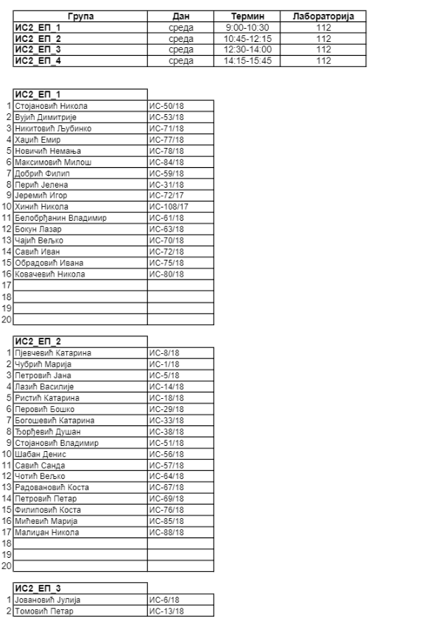
Fig. 9.4 Schedule of laboratory exercises on the Information Systems study program https://www.viser.edu.rs/raspored-nastave

Teaching and learning materials
All the courses on Information Systems program performted for the part-time studens (fiest year of study) have adequate learning and teaching materials. For all the courses on Information Systems new presentations for theoretical classes have been developed, and they are avalible on www.viser.edu.rs website. Presentation for thesoretical teaching classes and supplementary learning materials are avelible on web locations listed in the table 9.1 and also in LMS Moodle https://lectio2.viser.edu.rs/.
No | Course | Web location of the course
1. | Mathematics in Engineering | https://www.viser.edu.rs/predmet/110/1891
2. | Electrical Engineering | https://www.viser.edu.rs/predmet/110/1867
3. | English Language | https://www.viser.edu.rs/predmet/110/297
4. | German Language | https://www.viser.edu.rs/predmet/110/2217
5. | Management | https://www.viser.edu.rs/predmet/110/2233
6. | Introduction to Cloud Computing | https://www.viser.edu.rs/predmet/110/2234
7. | Application Software | https://www.viser.edu.rs/predmet/110/1731
8 | Internet Marketing | https://www.viser.edu.rs/predmet/110/2336
9. | Basics of Informatics and Computing | https://www.viser.edu.rs/predmet/110/288
10. | Internet Services | https://www.viser.edu.rs/predmet/110/1888
11. | Sales Management | https://www.viser.edu.rs/predmet/110/2190
12. | Introduction to Object Programming | https://www.viser.edu.rs/predmet/110/1289
Table 9.1 Web locations of courses of first year study program Information Systems
For realization of teaching in laboratory exercises printed publications (workbooks) have been prepared for courses:
- Introduction to Object Programming
- Internet Marketing
- Application Software
- Basics of Informatics and Computing
- Mathematics in Engineering
- Internet Services

Exams
The exams for part-time students are in the same term as for regular students. Since the beginning of pilot part-time F2F program only two exam terms were organized. Part-time students didn’t ask for additional exam terms.

CONCLUSION
In the time required by the Lifelong Learning program, short cycle programs organization is an efficient way to gain useful knowledge from the area where the student is already engaged or for retraining.
The implementation of the pilot programs has shown that this method of education, though new in our country, is recognized as beneficial. This is indicated by the number of interested candidates, who are also asked about short programs upon completion of the pilotage.
On the other hand, surveys of students attending the programs organized by VISER show that students' expectations were fulfilled and that these programs were well organized and implemented.
Based on students' success, it can be concluded that F2F programs have a greater success in terms of lower student dropouts and faster ending of the program. This is because F2F teaching in some way binds a student and demands that the obligations meet a certain dynamic. On the other hand, it is a problem for busy students to attend regular short classes even if organized on a weekend, so the best way to organize short programs is to use blended models.
Part-time regime of study in also new in our country, and since in VISER it is a bachelor program, it is too early to say anything about the success of students enrolled to this regime of study.

