Implementation of online pilot short cycle program Web application programmer
svetlana Štrbac-Savić
School of Electrical and Computer Engineering of Applied Studies in Belgrade, svetlanas@viser.edu.rs
Vera petrović
School of Electrical and Computer Engineering of Applied Studies in Belgrade, verap@viser.edu.rs

Abstract: Short cycle programs are a new form of study in higher education system of the Republic of Serbia. The realization of such programs is a great challenge because the curriculum and teaching methods of such programs must be adjusted with the goal and the duration of study that is in this case much shorter than in regular study. This paper describes the implementation of the pilot online short cycle program Web application programmer in School of Electrical and Computer Engineering of Applied Studies in Belgrade.
Keywords: Short cycle program, teaching of Web programming, E-Learning, online

1. INTRODUCTION
Technological advancement has caused changes in the way people live. In the past, the learning process was preparation for professional work and took place during a period of life before employment. However, today, people have to improve throughout their entire life, and often re-qualify because the labor market changes rapidly, with some jobs completely disappearing, or the number of needed people dropped in some fields, while new jobs appear in some other areas. In addition to the changes that are caused by the labor market, it is often necessary that people in the same workplaces have to be trained to use new technologies. So lifetime learning is really necessity for most people.
In response to these needs, the Law on Higher Education of the Republic of Serbia, adopted in September 2017, envisioned short cycle study programs. This form of study aims to enable re-qualification of people who have completed studies (have 180 ECT or more) and can’t find a job in their profession or have completed studies in the field of short cycle program a long time ago but they do not manage to apply new technologies in their field. The point is to enable people in short time to learn necessary skills. To make this possible, the short cycle program must be well designed and implemented.
The School of Electrical and Computer Engineering of Applied Studies in Belgrade has created four short cycle programs. Two online programs in the field of computing: Web application programmer and Computer Programmer/Analyst, and two face to face programmes: Vehicle diagnostics and Professional development of professors and teachers. In this paper the implementation of online short cycle program Web application programmer is described.
The goal of this program is to train a student to master and implement web technologies in order to create web applications. This short cycle program has five courses: Web Design, Standard User Interfaces, Object Programming, Internet Programming and Visual Programming Techniques.

2. Organization of the programme
School of Electrical and Computer Engineering of Applied Studies in Belgrade has an extensive experience in distance learning. Since 2012/13 school year our school has a distance learning study program The New Computer Technologies. A lot of learning materials were developed for the realization of online teaching, and during the years those materials were changed and adjusted to online learning along with improvement of the whole teaching process. More details about this program can be found in [1].
This experience helped a great deal implementation of the program. Of course a lot of changes had to be made because courses in the short cycle program had to be more practical, and performed in shorter time then the courses for regular students. In preparing materials for short cycle programs and in general in their organization, it should be taken into consideration that program participants have different backgrounds, as some of the students are from technical professions and have previous knowledge, while some students have previous education in other areas. That is why it is difficult to make a choice of courses and make the syllabus of courses so that all students can successfully prevail the program. Also, emphasis on these courses had to be on the practical work of students, while the theoretical aspects were reduced to a minimum. That is why new syllabus and learning materials had to be created for realization of each course according to this demands.
Short cycle program Web application programmer was organized at School of Electrical and Computer Engineering of Applied Studies in Belgrade in 2017/18 school year. A lot of people were interest in this program, and we received in just three days three times more applications of candidates than we could enroll. It was not easy to choose between registered candidates, so as we thought that a more uniform level of knowledge of the received candidates would be the best criteria for selection. Image 1 shows that all selected candidates have completed some of the technical faculties or the Faculty of Mathematics, and they all have some basic knowledge of working with computers.
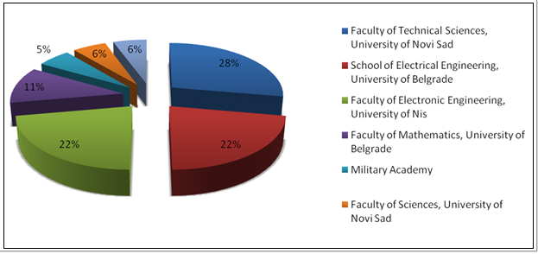
Image 1: Previous education of enrollment of students
Eighteen students from the all over Serbia were enrolled to short cycle program Web application programmer Image 2. Students did not pay tuition fee.

Image 2: Place of residence for enrollment of students
In the Introduction of this paper the list of courses was given. The goal of this selection, and of the program in general, is to prepare students step by step to develop web application starting with creations of static web sites, then making dynamic websites. Course Object Programming serves as an introduction for more advanced courses. In course Internet programming students develop complete web applications using Java technologies. The course Visual Programming Techniques trains students to use Microsoft tools to create web applications.
The program was organized so the courses were sequential. First course was Web Design that does not require any special previous knowledge. Then Standard User Interfaces, Object Programming, Internet Programming and Visual Programming Techniques in given order because student had to master the knowledge of previous course to follow next course. Every course had the same dynamics. Four days in the week teachers posted learning materials on Moodle platform with an explanation of what students are expected to master in that lesson or in which order to use the material if they were placing more files in the one lesson. Friday was reserved for consultations both electronic and consultation in School. Of course every day students could communicate with teachers or other participants via private messages or forums (Image 3). Every week students had assignments which they had to complete during the weekend. Those assignments were web applications were student applied knowledge acquired in lessons from the previous week.

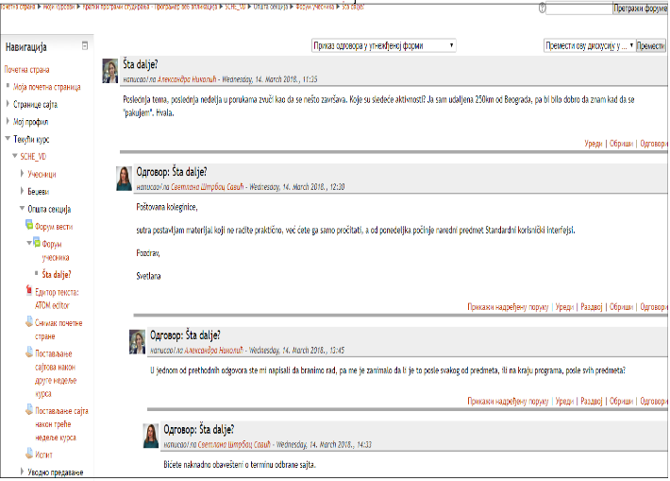
Image 3: Example of online discussion via forum of participants
All the courses were held online, only first workshop was organized at the School. This workshop has been organized before program started. Students were informed of the organization of courses, and they got their accounts on both Moodle and Odoo platform and they got a brief training of using of both platforms. They were offered to attend to workshops or consultation in School but since most of them work and some of them are not from Belgrade we had no such demands.
3. technical realization of the programme
One of the prerequisites for the realization of the program was the choice of Learning Management System (LMS) to be used. Within the framework of Erasmus + project "Introduction of Part-Time and Short Cycle Studies in Serbia", a LMS Odoo has been developed and installed on School server, but it was not completely finished and adjusted to needs of teachers and student until the beginning of the program. For this reason, LMS Moodle was used, although all the learning materials are also posted on Odoo LMS. LMS Moodle has been and still is used in our school since the beginning of the school year 2007/8, when school had provided Learning Management System (LMS) server and opened its website at LMS Moodle [2]. Since that year, the school has been continuously working on the administration and updating of this site. LMS Mooodle is used on the program for regular lessons, exercises, consultations and assessment test over the Internet. For more comprehensive audio-video teaching materials, LMS Moodle system allows links to YouTube and other pre-reserved addresses on the Internet, with the previously developed and set audio-video lessons / instructions for exercises. Moodle system tools also have integration with blog tools, current social networks and other Web tools, which are given to students for working on their homework and seminar papers. In addition to its built-in and integrated Web tools and other multimedia content, Moodle system contains a database of students, teachers, classes of objects, their topics, activities and resources, and its user Web portal [3].
On the first workshop students were trained to use LMS Moodle, and they all got their accounts on the platform. One of the advantages of using Moodle was that some students were already familiar with using Moodle.
For every course on the program new course was opened in LMS Moodle. In image 4 the structure of the course Web Design is visible.
As it was mentioned earlier in the paper new materials were created for every lesson of all five courses. The template of developed learning material was the same for all courses. All the lessons have as least one pdf document in a specific template, and some lessons have other additional learning materials: demonstrations, examples etc.
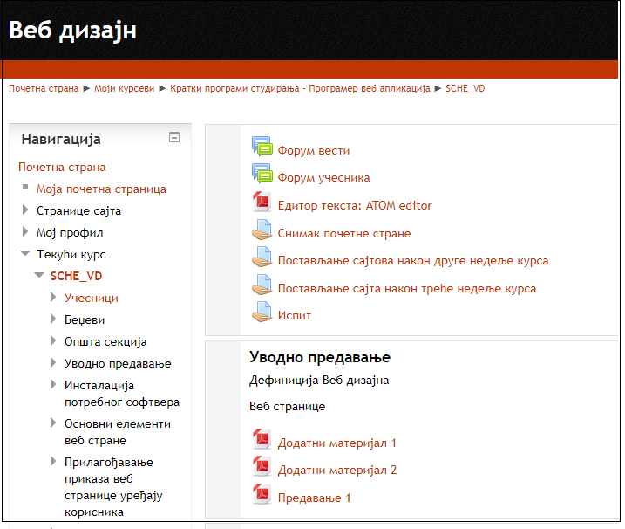
Image 4: Screen shot of course Web design

4. knowledge tests
Every course of the program had assignments every week. Those assignments were practical mostly, depending on the subject, creation of web applications. Assignments were reviewed and evaluated by teachers. Students got comments on their application, and recommendations for their improvement. Of course students could ask teachers or other students for help on some issues while they worked on the assignment. During the course students got points, but whey had to take exam for getting a grade of the subject. Every subject on the program had different number of points that students could get during the realization of the course. Teachers insisted that student respect deadlines because as it was previously mentioned it would be very difficult to keep up with next demands on the same course or the following course. Of course some flexibility existed. Because almost all the students of the program are employed.
Some courses included online tests. On Image 5 is one example of online test on Object programming course. Exams for each course were held at School and each student had to come to School and do the exam on every course of the program. All the exams were practical demonstrations of knowledge through creation of appropriate web applications and a discussion with the professor.

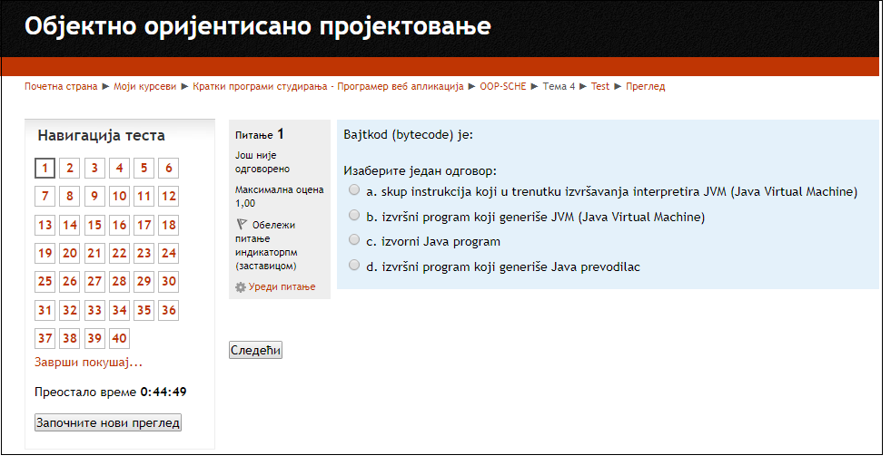
Image 5: Example of online test
Students are allowed to take the exams in every examination period. Number of times for student to take an exam is not limited. For students who are not from Belgrade special exam schedule was made so they didn’t have to travel to Belgrade more times in one exam period. Of course all students could choose if they want to take exams in regular exam period or in the exclusive term.
Until this moment eight students have successfully finished the program and they already have certificate of successful completion of the program. Twelve students, including eight students who finished the program, were active during the whole program, and we expect that they will pass the rest of the exams in October exam term. Some of those four students have already passed few exams. One student dropped out on during the second course. Other nine students were not constantly active, but they still want to finish the program. Most important is that they are satisfied with the knowledge they got, but they all think that it was very hard for them to do the assignments every week the whole semester with no beak between the courses. Most of them thing that the program should last longer because it is very demanding.
5. CONCLUSION
Shot cycle program Web application programmer provides rapid adoption of knowledge in web programming. The program is very demanding and students must be very motivated and disciplined to follow the dynamics of the program. Based on the experience acquired during the pilot program, analyzes and improvements will be made considering learning materials and some organization issues.
Web application programmer successfully preformed pilot short cycle program. After finishing this program, students get one set of Web programming skills that gives them a lot of options to find a job, and gives them the basis for further improvement.

REFERENCES
[1] D. Prokin, V. Petrovic, S. Strbac-Savic, S. Djenic, A. Miletic, “Learning and teaching methodologies and multimedia in distance study programme,” presented at the 11th INTED2017. Valencia, Spain, Mar. 6-9, 2017.
[2] J. Cole and H. Foster, Using Moodle: Teaching with the Popular Open Source Course Management System, O Reilly Community Press, Sebastopol, 2007.
[3] S. Đenić, V. Vasiljević, D. Prokin and A. Miletić, “E - Learning in Distance Study Programme The New Computer Technologies,” INFOTEH, vol. 12, pp. 757-761, 2013.

