WP 7 DISSEMINATION AND SUSTAINABILITY REPORT - VISER

Project Acronym: | PT&SCHE
Project full title: | The Introduction of part‐time and short cycle studies in Serbia
Project No: | 561868-EPP-1-2015-1-EE-EPPKA2-CBHE-SP
Funding Scheme: | ERASMUS+
Coordinator: | Tallinn University, TLU
Project start date: | October 15, 2015
Project duration: | 36 months

Abstract | VISER has organized various events to promote the activities of the project. For the purposes of those events we designed and made promotional material. Pictures from events published on social networks and on the VISER official website and of the page of PT&SCHE project.
"The European Commission support for the production of this publication does not constitute an endorsement of the contents which reflects the views only of the authors, and the Commission cannot be held responsi­ble for any use which may be made of the information contained therein."

DOCUMENT CONTROL SHEET

Title of Document: | WP 7 DISSEMINATION AND SUSTAINABILITY REPORT - VISER
Work Package: | WP 7 DISSEMINATION AND SUSTAINABILITY REPORT- VISER
Last version date: | 12/04/2019
Status : | Draft
Document Version: | 3.0
File Name | WP 7 DISSEMINATION AND SUSTAINABILITY REPORT- VISER
Number of Pages | 22
Dissemination Level | Institutional

VERSIONING AND CONTRIBUTION HISTORY

Version | Date | Revision Description | Responsible Partner
1.0 | 10.07.2017. | Concept development | Vladimir Cerić, VISER
2.0 | 07.11.2018. | Concept development | Milica Jevremović  Svetlana Štrbac-Savić, VISER  Vera Petrović, VISER
3.0 | 12.4.2019 | Final version | Milica Jevremović  Svetlana Štrbac-Savić, VISER  Vera Petrović, VISER

Introduction

This document is a report of the School of Electrical and Computer Engineering of Applied Studies (VISER) on dissemination of the PT&SCHE project, it consists of:
- Print publications
- Dissemination on website
- Dissemination on social networks
- Production of short social media videos
- Print roll-up and flyer
- Presentation of the Project
- Dissemination Questionnaire (Dissemination Questionnaire, filled for the University of Szeged that leads WP7).

PRINT PUBLICATIONS
VISER’s students’ magazine WE SHARE, No. 3
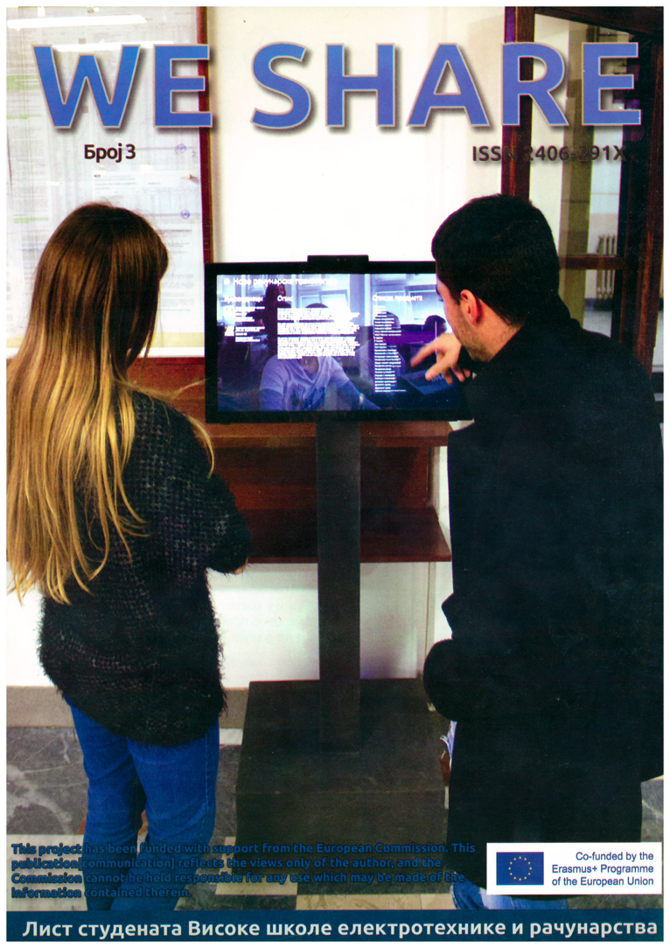
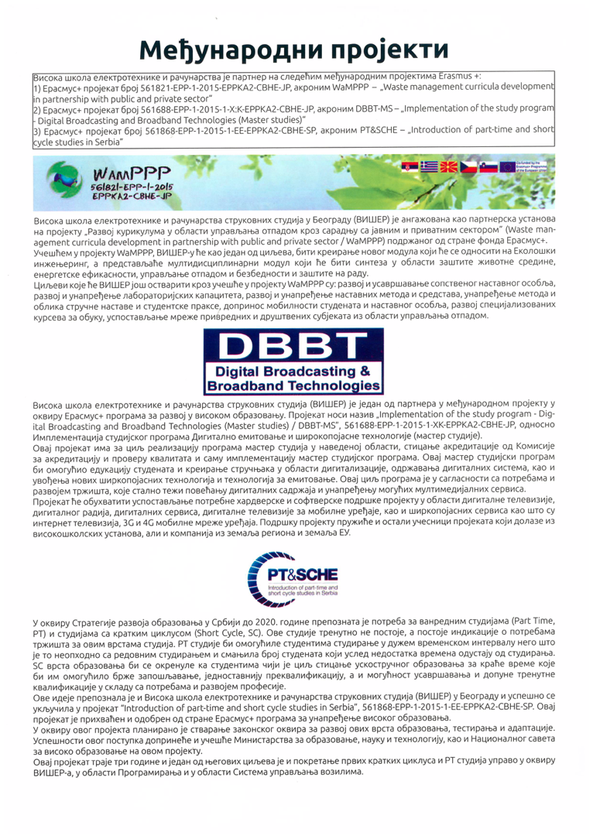
Figure 1: VISER’s students’ magazine WE SHARE
https://www.dropbox.com/s/hn6mf8oau26exzv/WeShare%20No3%202016.pdf?dl=0

In September 2017. We made flyer in order to present a short cycle studies in which are presented short cycle programs and the area covered by short programs of study.
Figure 2: Flyer printed for presentation of short cycle studies

We prepared T-shirt for all candidates who become a student of VISER in July 2018. On the T-shirt we printed project acronym and project logo.
Figure 3, 4: School Enrollment in July 2018.
More pictures can be find at link https://www.viser.edu.rs/mediji/album/1717402325010286/1717403601676825

For the purposes of project advertising promotional material was created: T-shirt with project acronym and project logo, bags, calendar, watch and gloves for snow with project logo were produced by VISER.
Gloves for snow cleaning | Wall clock
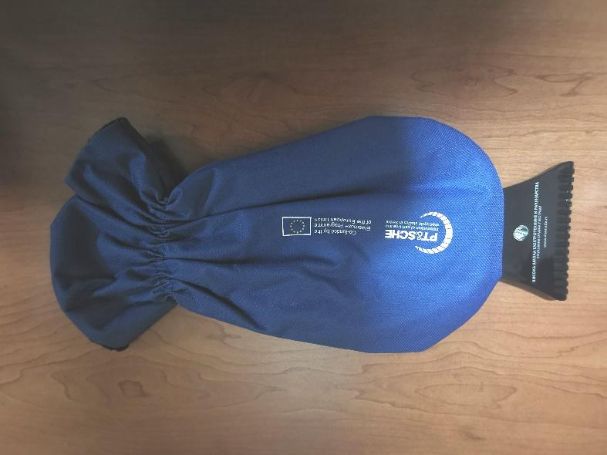 | 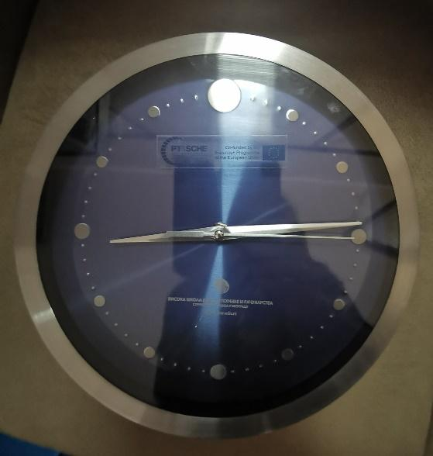
Bag | Handset
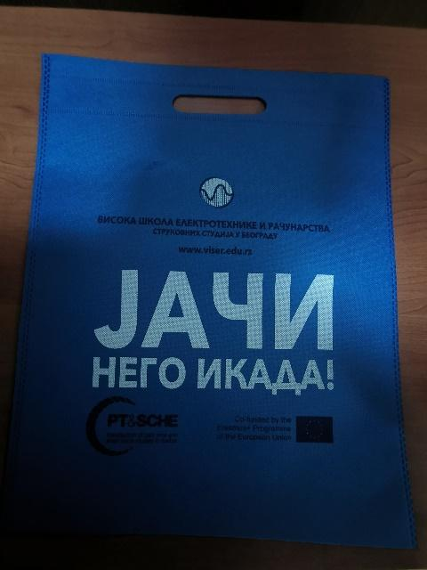 | 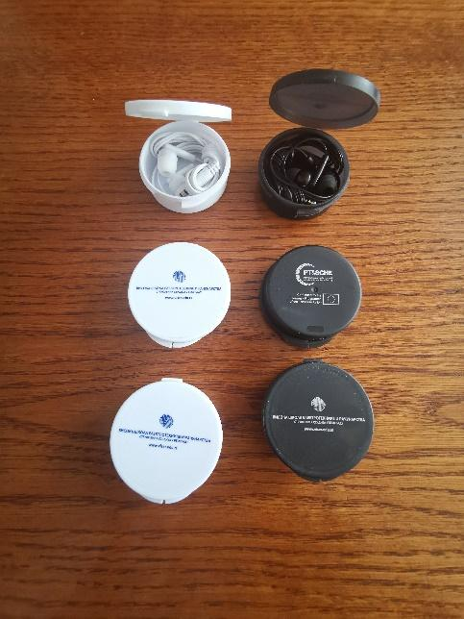
Figure 5: Project advertising promotional material
Publications:
Svetlana Strbac-Savic and Vera Petrovic: Implementation of On-line Pilot Short Cycle Program – Web Application Programmer. In: e-Learning Conference Proceedings [2018]. Belgrade Metropolitan University. pp. 101-104.
.
Final conference publications:
Strbac-Savic S. and Petrovic V.: Implementation of Online Pilot Short Cycle Program: WEB Application Programmer. In: Part Time and Short Cycle Studies in Serbia. Proceedings of Final Conference. Publ. by University of Kragujevac. ISBN 978-86-7776-232-2 [2019]. pp. 163-168.

3. Dissemination on website
Special webpage on institution’s website in Serbian.
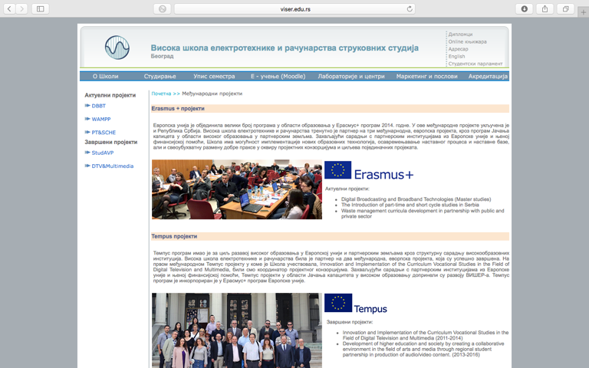
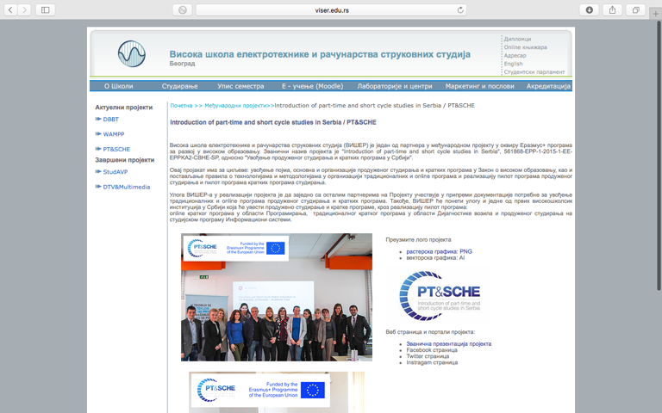
Figure 6: Special webpage on institutions’ website in Serbian
http://websrv3.viser.edu.rs/index.php?page=static&id=181
http://websrv3.viser.edu.rs/index.php?page=static&id=1813

As the project evolved so there was a need to redesign the site VISER, as well as the site of the project PT&SCHE. The new site consists of the following parts:
- Intгoduction of paгt-time and shoгt cycle studies in Sегbia
- Project objectives
- Role of VISER on project
- Main result of project for VISER
- Events
- Galery
- News

For students participating in the pilot project, all necessary information is placed through News on the official website of VISER, as well as a special part News on the project page.
Figure 7: Special webpage on institutions’ website in Serbian
https://www.viser.edu.rs/projekti/ptsche

In the part on the page where are explained the main result of project for VISER we developed 3 separate pages for 3 different areas of short circle studies:
1. Page for professional development of teachers and professors
Figure 8 Page for professional development of teachers and professors https://www.viser.edu.rs/stranica/profesionalni-razvoj
2. Page for Web Application Developer
Figure 9: Page for Web Application Developer
https://www.viser.edu.rs/stranica/programer-veb-aplikacija

3. Page for Vehicle diagnostics

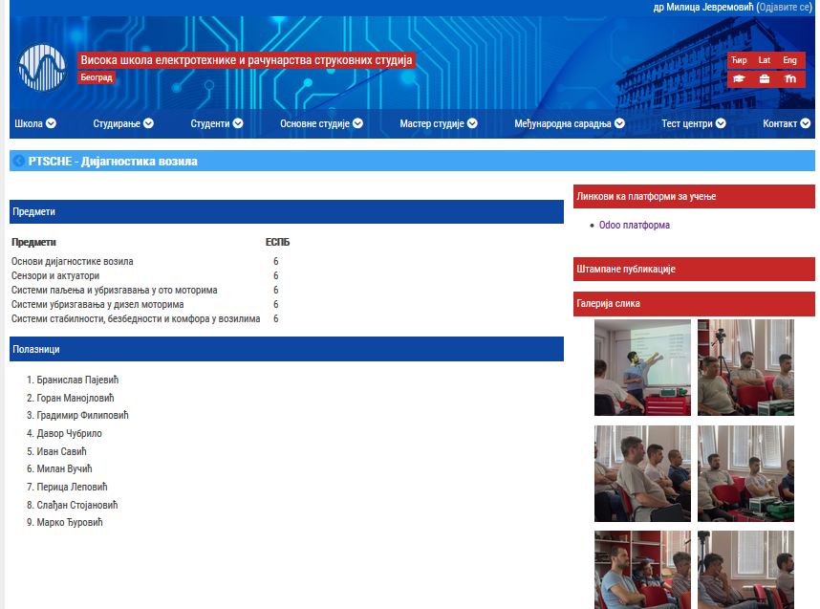
Figure 10: Page for Vehicle diagnostics
https://www.viser.edu.rs/stranica/ptsche-dijagnostika-vozila

4. Dissemination on Social Networks
News on Instagram: Promotion of PT&SCHE project on community of high school of electrical engeneering in VIŠER, 17.4.2018
Figure 11: Promotion of PT&SCHE project
News on Facebook: Promotion of PT&SCHE project on VISER official Facebook page. On this way we inform audience about the benefits of part-time studies and short cycle studies in higher education in Serbia, 27.7.2018
Figure 12: Promotion of PT&SCHE project

PRODUCTION OF SHORT SOCIAL MEDIA VIDEOS
For the purpose of Part-Time and Short Cycle studies program of VISER, and overall project dissemination, currently 15 videos short (up to 40 seconds videos) are in preproduction and production phase.
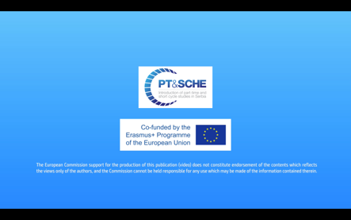
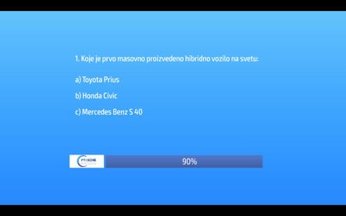 | 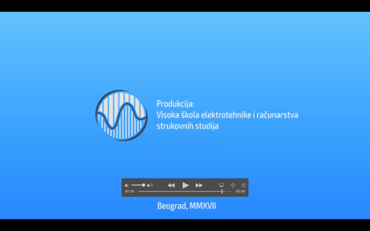
Figure 13: Short video form prepared by VISER

Print roll-up and flyer
For the purpose of Part-Time and Short Cycle studies program of VISER, and overall project dissemination, we prepared roll-up and flyer.
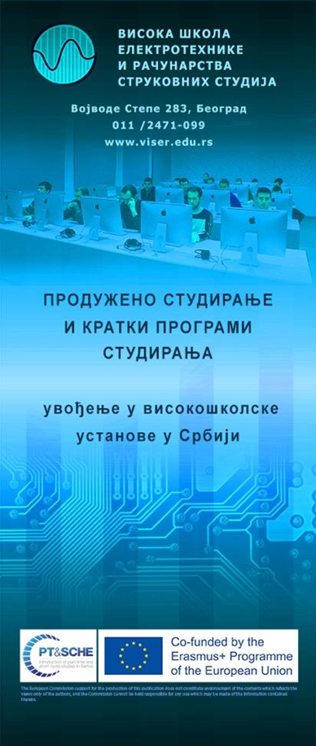 | 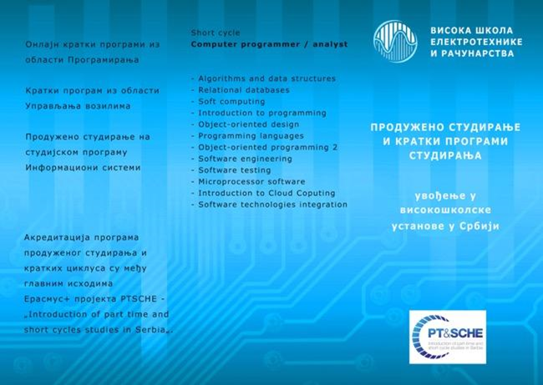
 | 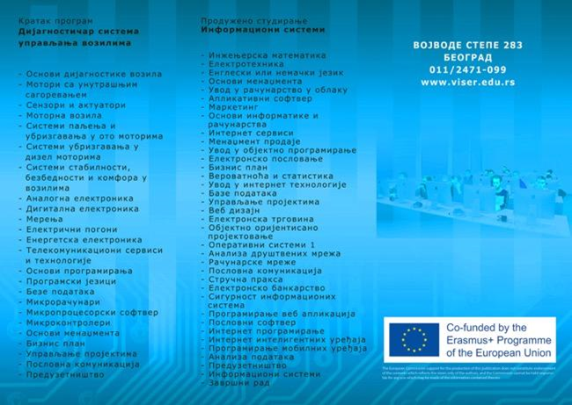
Figure 14: Roll-up and flyer

Dissemination Events organized by VISER

Presentation of the project to School Council
During the meeting of Teaching and Professional Council of VISER, the presentation of PT&SCHE objectives were presented to professors, teaching assistants an students’ representatives, VISER, Belgrade, 18.05.2017.
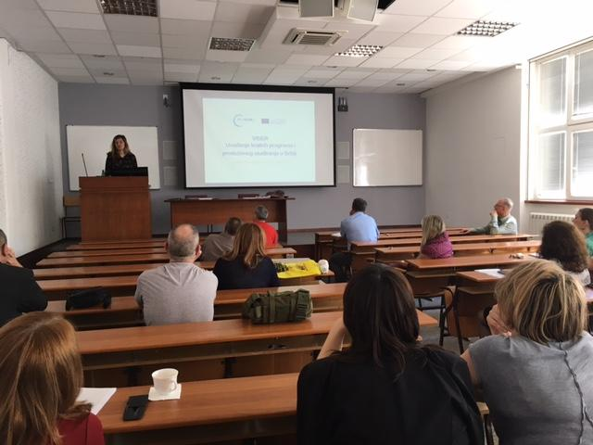
Figure 15: Presentation to school council
Promotion of SCH&PT programs organized by VISER on meeting of the Association of electrical engineering schools, VISER, Belgrade, 17.04. 2018
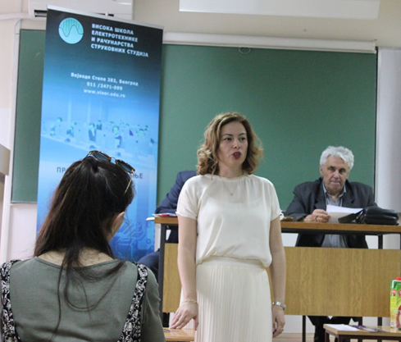 | 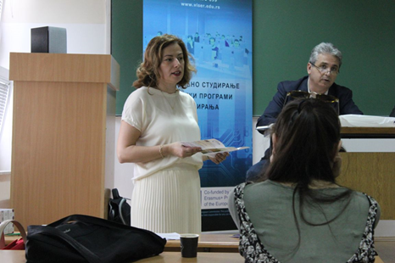
Figure 16: Presentation of Project on meeting of the Association of electrical engineering schools

In November 2018., we visited the Electrical Engineering School “Nikola Tesla”, Technical Schools “Zmaj” and “Zemun” and IX Belgrade gymnasium, in order to present final grade pupils the opportunity to study alongside work and short circle studies. In December 2018. we visited Electrical School “Stari grad” and Gymnasium in Pozarevac, from the same reason, also talked with pupils and presented them the opportunity of studing in our school, giving advertising material.
Dissemination event and presentation of PT&SCHE pilot programs performed by VISER, Faculty of Technical Sciences Čačak, University of Kragujevac, 29.1.2019.
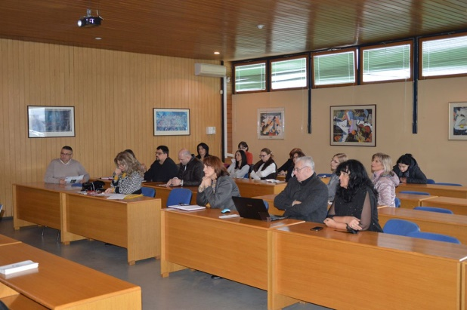 | 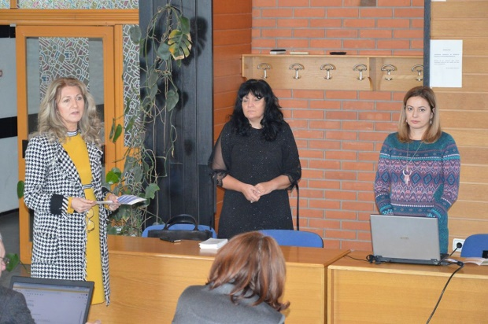
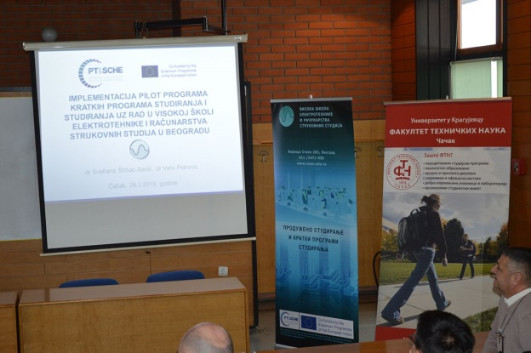 | 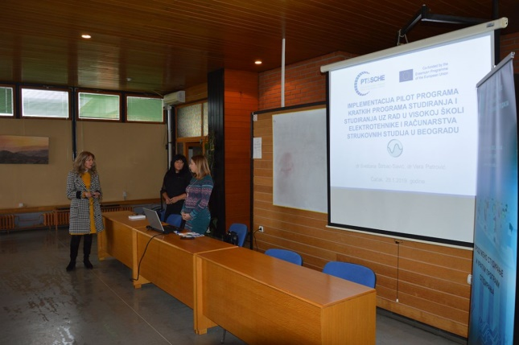
Figure 17: Dissemination event and presentation of PT&SCHE pilot programs

Dissemination event and presentation of PT&SCHE programs organized at VISER, Education Fair in Čačak, 21.2.2019
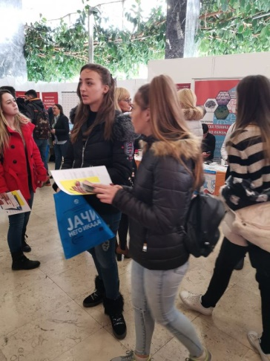 | 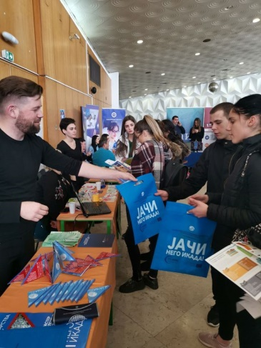
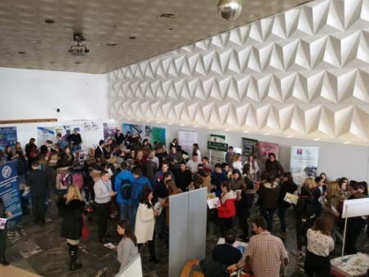 | 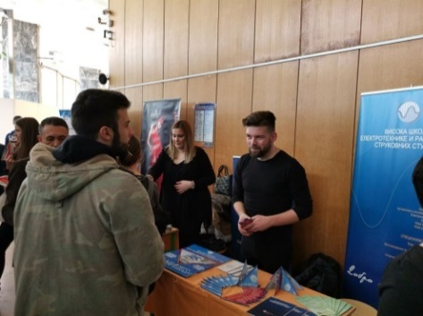
Figure 18: Dissemination event and presentation on Education Fair in Čačak
Final Conference of PT&SCHE project, Chamber of Commerce Republic of Serbia , March 2019.
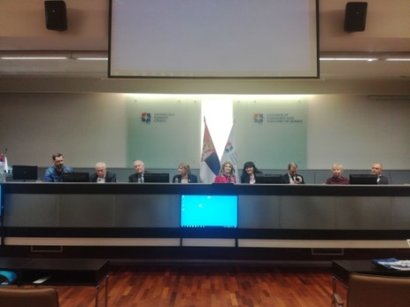 | 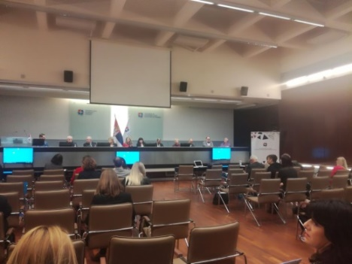
Figure 19: Final Conference of PT&SCHE project, Chamber of Commerce Republic of Serbia

- DISSEMINATION QUESTIONNAIRE

Question | yes | no | Remarks
1. Does project information appear on your institution’s website in your national language? If yes, give its availability. | Y |  | Web page:  https://www.viser.edu.rs/projekti/ptsche
2. Do you give project info at your institution? If yes, give details (frequency, events) in the Remarks section. | Y |  | Presentation at the meeting of School Council.  News on official social networks of VISER:  https://www.facebook.com/Visoka.Skola.Elektrotehnike.Racunarstva/photos/pcb.1866701533413697/1866701443413706/?type=3&theater  https://www.facebook.com/Visoka.Skola.Elektrotehnike.Racunarstva/photos/a.323235957760270/1883674138383103/?type=3&theater  https://www.facebook.com/Visoka.Skola.Elektrotehnike.Racunarstva/photos/a.323235957760270/1925379850879198/?type=3&theater  https://www.viser.edu.rs/projekti/ptsche  https://www.instagram.com/p/Bo84aNhl1Li/  https://www.instagram.com/p/BhqkOHFlmaF/
3. Do you cooperate with other faculties/units of your institution in project work? If yes, give details in the remarks section. | Y |  | Institution is divided into 8 departments. Four departments cooperate in project work: Information systems – part-time program, New Computer Technologies for PT course, Automatics and Vehicle Control Systems for SC, Computer Science for SC.  Department for Audio and Video Technologies is included for project dissemination.
4. Have your reached external stakeholders? If yes, give details in the Remarks section. (occasion, organization, means of communication) | Y |  | Event was held by the Serbian Chamber of Commerce.
5. Do you have online or printed project-related publication? If yes, please give details in the Remarks section. | Y |  | Text related to the project in school’s magazine WeShare. https://www.dropbox.com/s/hn6mf8oau26exzv/WeShare%20No3%202016.pdf?dl=0  Flyer in order to present a short cycle studies in which are presented programs of the course and the area covered by short programs of study.
6. Have you participated in study trips? If yes, why were they useful for dissemination purposes? Give your ideas in the Remarks section. | Y |  | We have participated in training session for Mdita software where goal was for us to learn how to create multimedia materials specific for the platform.
7. Have you organized study trips? If yes, why were they useful for dissemination purposes? Give your ideas in the Remarks section. |  | N | Promotion of SCH&PT programs organized by VISER on meeting of the Association of electrical engineering schools  During the visit of high schools in order to present final grade pupils the opportunity to study alongside work and short circle studies..
8. Do you regularly visit Google drive? If yes, give details in the remarks section. (frequency, purpose, reading or uploading info etc.) | Y |  | Google Drive is visited frequently for reading, writing and uploading information about the project.
9. Have you had any conference presentation on a project-related topic? If yes, give details in the remarks section. | Y |  | Svetlana Strbac-Savic and Vera Petrovic: Implementation of On-line Pilot Short Cycle Program – Web Application Programmer. In: e-Learning Conference Proceedings [2018]. Belgrade Metropolitan University. pp. 101-104.  Final conference publications:  Strbac-Savic S. and Petrovic V.: Implementation of Online Pilot Short Cycle Program: WEB Application Programmer. In: Part Time and Short Cycle Studies in Serbia. Proceedings of Final Conference. Publ. by University of Kragujevac. ISBN 978-86-7776-232-2 [2019]. pp. 163-168.
10. Were there other dissemination occasions at your institution? If yes, give details in the remarks section. | Y |  | Dissemination events were organized at VISER. More details are given in section 5 of this report.
11. Were there any project-related printed materials at your institution? If yes, give details in the remarks section. | Y |  | For the purposes of project advertising promotional material was created: Roll-up poster and flyer, T-shirt with project acronym and project logo, bags, calendar, watch and gloves for snow with project logo were produced by VISER.
12. Please, share your institution’s dissemination ideas/ proposals for the future. | Y |  | Short videos about project-related topics made for social networks sharing

